A TRUST REGION AGGRESSIVE SPACE MAPPING TECHNIQUE
FOR EM OPTIMIZATION

M.H. Bakr, J.W. Bandler, R.M. Biernacki,
S.H. Chen and K. Madsen

SOS-98-15-V

June 1998

© M.H. Bakr, J.W. Bandler, R.M. Biernacki, S.H. Chen and K. Madsen 1998
No part of this document may be copied, translated, transcribed or entered in any form into any machine without written permission. Address inquiries in this regard to Dr. J.W. Bandler. Excerpts may be quoted for scholarly purposes with full acknowledgment of source. This document may not be lent or circulated without this title page and its original cover.

A TRUST REGION AGGRESSIVE SPACE MAPPING ALGORITHM FOR EM OPTIMIZATION

M.H. Bakr, J.W. Bandler, R.M. Biernacki, S.H. Chen
and K. Madsen

Simulation Optimization Systems Research Laboratory
and Department of Electrical and Computer Engineering
McMaster University, Hamilton, Canada L8S 4L7

bandler@mcmaster.ca
soya.sos.mcmaster.ca

presented at

1998 IEEE MTT-S Int. Microwave Symposium, Baltimore, MD, June 1998
Basic Concepts

it is assumed that the circuit under consideration can be simulated using two models: a fine model and a coarse model

the fine model is accurate but is computationally intensive

$x_{\text{em}}$ is the vector of fine model parameters

the coarse model is a fast model but it is less accurate than the fine model

$x_{\text{os}}$ is the vector of coarse model parameters

Space Mapping (SM) aims at avoiding the computationally intensive direct optimization of the fine model

Comments on the Parameter Extraction Step

the parameter extraction step aims at finding a point x_{os} whose coarse model responses match corresponding fine model responses

the extracted coarse model parameters may be nonunique

nonuniqueness of the parameter extraction step hinders the convergence of the Aggressive Space Mapping technique
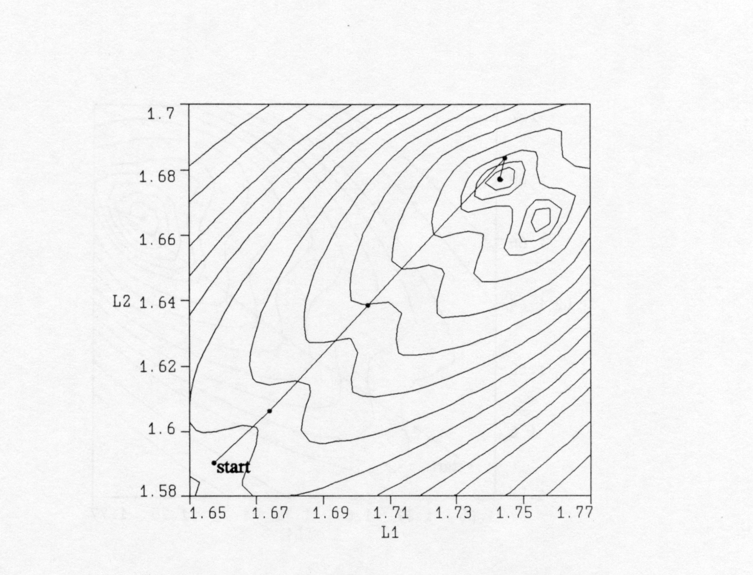
contours of the parameter extraction objective function
(Bandler et al., 1996)

The Multi-Point Parameter Extraction

to overcome problems caused by nonuniqueness of the parameter extraction step a multi-point parameter extraction step was suggested (Bandler et al., 1996)

the step aims at matching not only the response but also the first-order derivative of the two models

the extracted coarse model point $x_{\text{os}}$is obtained by solving

$$\underset{x_{\text{os}}}{\text{minimize}}\left\|R_{\text{os}}(x_{\text{os}}+Dx)−R_{\text{em}}(x_{\text{em}}+Dx)\right\|$$
simultaneously for a set of perturbations Δx

this step is more likely to improve the uniqueness of the parameter extraction step

Questions Regarding the Original Multi-Point Extraction

the original multi-point parameter extraction (Bandler et al., 1996) suffers from two main drawbacks

the first drawback is that the fine model points were arbitrarily selected

the second drawback is the assumption that a perturbation of Δx
in the fine model space corresponds to an equal perturbation in the coarse model space

in the ith iteration, the most recent information about the mapping between the two spaces is given by the matrix $B^{(i)}$, which should be integrated with the multi-point parameter extraction step
Trust Region Aggressive Space Mapping Algorithm

using $f^{(i)}=P(x_{\text{em}}^{(i)})−x_{\text{os}}^{}$
solve ${(B^{(i)T}B}^{(i)}+λI)h^{(i)}\text{=-}B^{(i)T}f^{(i)}$ for $h^{(i)}$

this corresponds to minimizing ${\left\|f^{(i)}+B^{(i)}h^{(i)}\right\|}_{2}^{2}$ subject to
${\left\|h^{(i)}\right\|}_{2}^{}≤d$ where $d$ is the size of the trust region

$λ$, which correlates to δ, can be determined (Moré et al., 1983)

single point parameter extraction is performed at the new point $x_{\text{em}}^{(i+1)}=x_{\text{em}}^{(i)}+h^{(i)}$ to get $f^{(i+1)}$

if $f^{(i+1)}$ satisfies a certain success criterion for the reduction in the l₂ norm of the vector f, the point $x_{\text{em}}^{(i+1)}$is accepted and the matrix $B^{(i)}$ is updated using Broyden’s update

otherwise a temporary point is generated using $x_{\text{em}}^{(i+1)}$and$f^{(i+1)}$ and is added to the set of points to be used for multi-point parameter extraction

a new $f^{(i+1)}$is obtained through multi-point parameter extraction
Trust Region Aggressive Space Mapping Algorithm

the last three steps are repeated until a success criterion is satisfied or the step is declared a failure

step failure has two forms

(1) f may approach a limiting value without satisfying the success criterion or
(2) the number of fine model points simulated since the last successful step reaches n+1

Case (1): the parameter extraction is trusted but the linearization used is suspect; the size of the trust region is decreased and a new point $x_{\text{em}}^{(i+1)}$ is obtained

Case (2): sufficient information is available for an approximation to the Jacobian of the fine model responses w.r.t. the fine model parameters used to predict the new point $x_{\text{em}}^{(i+1)}$

the mapping between the two spaces is exploited in the parameter extraction step by solving

$$\underset{x_{\text{os}}}{\text{minimize}}\left\|R_{\text{os}}(x_{\text{os}}+B^{(i)}(x−x_{\text{em}}^{(i+1)}))−R_{\text{em}}(x))\right\|$$

simultaneously for a set of points x

Flow Chart
The Current Implementation

The algorithm is currently implemented in MATLAB

OSA90 is used as a platform for the multi-point parameter extraction and for the fine model simulations

TRASM

Algorithm
(MATLAB)
Parameters

Responses

OSA90
Responses
HP HFSS

Maxwell

Eminence
Sonnet’s em

Empirical Models

Extracted
Parameters

Parameter
Extraction

Fine Model

Simulation

TRASM : Trust Region Aggressive Space Mapping
Double-Folded Stub Microstrip Filter
(Rautio, 1992)

W₂
S
L₁
W₁

L₂

passband specifications:⏐S₂₁⏐≥ -3 dB for f ≤ 9.5 GHz and 16.5 GHz ≤ f

stopband specifications:⏐S₂₁⏐≤ -30 dB for 12 GHz ≤ f ≤14 GHz

designable parameters: L₁, L₂ and S; W₁=W₂=4.8 mil

substrate thickness is 5 mil and the relative dielectric constant is assumed to be 9.9

coarse model: a coarse grid Sonnet em model with Δx = Δy = 4.8 mil

fine model: a fine grid Sonnet em model with Δx = Δy = 1.6 mil

final design is obtained in 2 TRASM iterations, requiring 5 fine model points

OSA’s Empipe linear interpolation is used to simulate off-grid points
Double-Folded Stub Microstrip Filter Responses

the optimal coarse model (⎯) response and the fine model
response (ο) at the initial and final designs

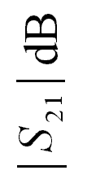

High-Temperature Superconducting Filter
(Westinghouse, 1993)
L₀
L₁
L₂
L₃
L₂
L₁
L₀
S₁
S₂
S₃
S₂
S₁
W

y

x

20 mil thick substrate

the dielectric constant is 23.4

passband specifications:⏐S₂₁⏐≥ 0.95 for f ≤ 3.967 GHz and 4.099 GHz ≤ f

stopband specifications:⏐S₂₁⏐≤ 0.05 for 4.008 GHz ≤ f ≤4.058 GHz

designable parameters L₁, L₂, L₃, S₁, S₂ and S₃; L₀ and W are kept fixed

coarse model exploits the empirical models of microstrip lines, coupled lines and open stubs available in OSA90/hope

High-Temperature Superconducting Filter Fine Model

the fine model employs a fine-grid Sonnet em simulation

the x and y grid sizes for em are 1.0 and 1.75 mil

100 elapsed minutes are needed for em analysis at single frequency on a Sun SPARCstation 10

final design is obtained in 5 TRASM iterations, requiring 8 em simulations

15 frequency points are used per em simulation

High-Temperature Superconducting Filter Responses

the optimal coarse model (⎯) response and the fine model
response (ο) at the initial and final designs

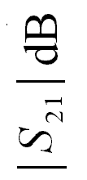

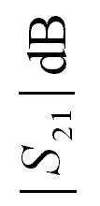

Passband Details for the High-Temperature
Superconducting Filter

Three-Section 3:1 Microstrip Transformer
(Bandler et al., 1994)

source and load impedances 50 Ω and 150 Ω

design constraints ⏐S₁₁⏐≤ 0.11 for the frequency range 5 GHz ≤ f ≤ 15 GHz.

designable parameters: W₁, W₂, W₃, L₁, L₂ and L₃

coarse model: ideal transmission-line model supplied by OSA90/hope

fine model exploits microstrip and microstrip step models supplied by OSA90/hope

the final solution is obtained in 2 TRASM iterations, requiring 6 fine model simulations
Three-Section 3:1 Microstrip Transformer Responses

the optimal coarse model (⎯) response and the fine model
response (ο) at the initial and final designs

| S₁₁|
| S₁₁|
Two-Section Waveguide Transformer
(Bandler et al., 1996)

design specifications: VSWR ≤ 1.01 for 5.8 GHz ≤ f ≤ 6.6 GHz

optimizable parameters: length and height of each waveguide section

coarse model: an analytical model that neglects junction discontinuity

fine model exploits the 3D solver Maxwell Eminence

the optimal design is obtained in 3 TRASM iterations requiring 5 Maxwell Eminence simulations
Two-Section Waveguide Transformer Responses

the optimal coarse model (⎯) response and the fine model
response (ο) at the initial and final designs

VSWR

VSWR

Three-Section Waveguide Transformer
(Bandler et al., 1996)

design specifications: VSWR ≤ 1.04 for 5.7 GHz ≤ f ≤ 7.2 GHz

optimizable parameters: length and height of each waveguide section

coarse model: an analytical model that neglects junction discontinuity

fine model exploits the 3D solver Maxwell Eminence

the optimal design is obtained in 2 TRASM iterations requiring 9 Maxwell Eminence simulations

Three-Section Waveguide Transformer Responses

the optimal coarse model (⎯) response and the fine model
response (ο) at the initial and final designs

VSWR
VSWR

Seven-Section Waveguide Transformer
(Bandler et al., 1996)

design specifications: VSWR ≤ 1.01 for 1.06 GHz ≤ f ≤ 1.8 GHz

optimizable parameters: length and height of each waveguide section

coarse model: an analytical model that neglects junction discontinuities

fine model : an analytical model that considers junction discuntinuities

the optimal design is obtained in 3 TRASM iterations requiring 6 fine model simulations

21 frequency points were used per simulation

Seven-Section Waveguide Transformer Responses

the optimal coarse model (⎯) response and the fine model
response (ο) at the initial and final designs

VSWR

VSWR
Three-Section Waveguide Transformer, Rounded Corners
(Empipe3D manual, 1997)

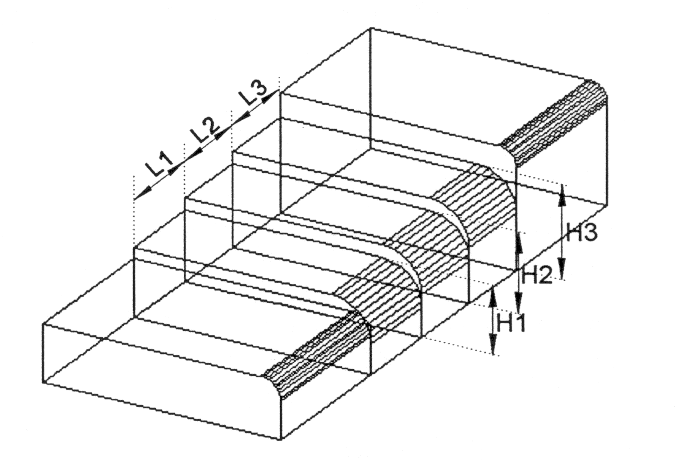
design specifications: $\left|S_{\text{11}}\right|≤−\text{30}\text{dB}$ for 9.5 GHz ≤ f ≤ 15 GHz

impedance matching between WR-75 half height and WR-75 full height waveguides

designable variables: the height and length of each section

fine (EM) model: HP HFSS Version 5.0

coarse model: ideal analytical model (Bandler, 1969)

the optimal design was obtained in 1 TRASM iteration,
requiring 7 fine model simulations by HP HFSS

Three-Section Waveguide Transformer, Rounded Corners

the optimal coarse model (⎯) response and the fine model
response (ο) at the initial and final designs

| S₁₁| dB

| S₁₁| dB

Conclusions

we present a novel Trust Region Aggressive Space Mapping algorithm for the optimization of microwave circuits

TRASM integrates a trust region methodology with the Aggressive Space Mapping technique

a recursive multi-point parameter extraction step is exploited to improve the uniqueness of the parameter extraction step

the multi-point parameter extraction exploits the available information about the mapping between the two spaces to improve the uniqueness of the step

a number of examples were successfully optimized using the proposed algorithm

the algorithm is currently implemented in MATLAB

