SPACE MAPPING SUPER MODEL CONCEPT

J.W. Bandler and M.A. Ismail

SOS-98-21-V

August 1998

© J.W. Bandler and M.A. Ismail 1998

No part of this document may be copied, translated, transcribed or entered in any form into any machine without written permission. Address inquiries in this regard to Dr. J.W. Bandler. Excerpts may be quoted for scholarly purposes with full acknowledgment of source. This document may not be lent or circulated without this title page and its original cover.

SPACE MAPPING SUPER MODEL CONCEPT

J.W. Bandler and M.A. Ismail

Simulation Optimization Systems Research Laboratory
and Department of Electrical and Computer Engineering
McMaster University, Hamilton, Canada L8S 4L7



presented at

SOS Research Laboratory Meeting, Hamilton, August 1998

Introduction

EM simulators versus analytical models

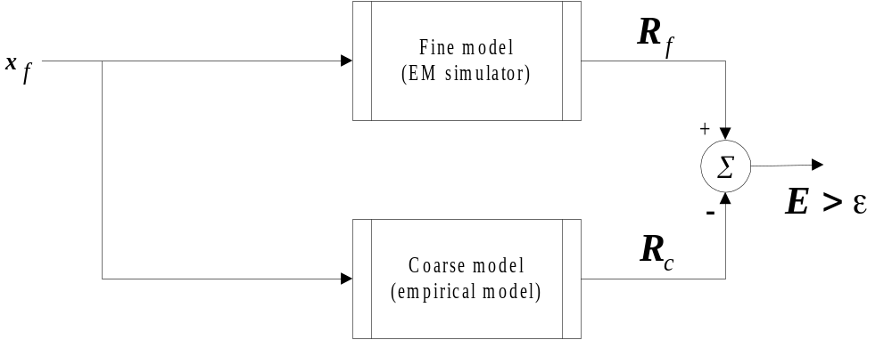

how can we improve the accuracy of empirical models?

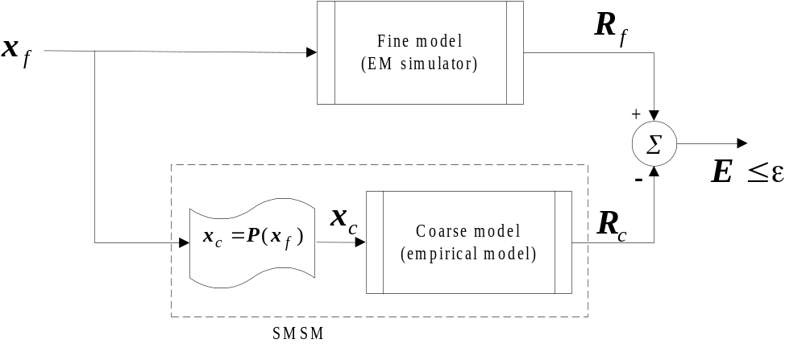

Introduction

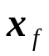: is a vector representing the fine model parameters (the physical parameters)

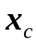: is a vector representing the coarse model parameters

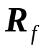: the fine model (EM simulator) response

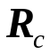: the coarse model (empirical model) response

the mapping P is established over a region of parameters in the fine model space and in a predefined frequency range
Space Mapping Super Model (SMSM)

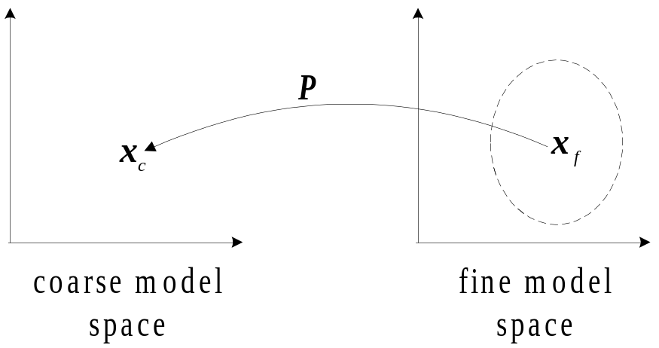

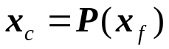

such that
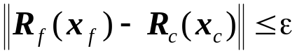

in a predefined frequency range 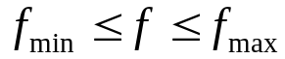

the numerical values given by the mapping P can be obtained by solving the parameter extraction problem (Bandler et al., 1994-1997)

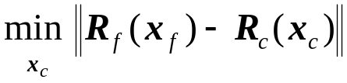

Space Mapping Super Model (SMSM)

the mapping P is assumed to be linear, that is

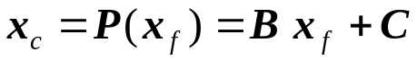
where
: a vector of dimension n₁

: a vector of dimension n₂

B : an n₂xn₁ matrix of constant coefficients

C : a constant vector of dimension n₂
SMSM Algorithm
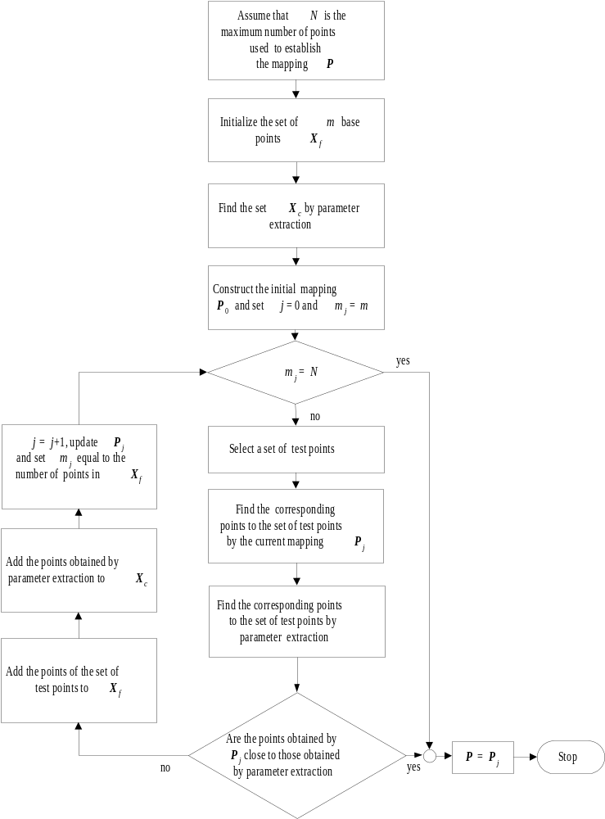

Example 1

Right Angle Bend

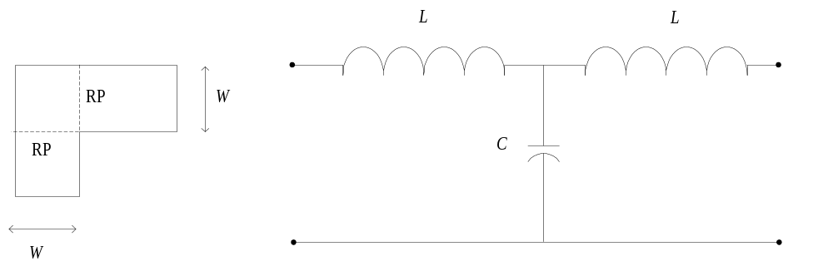
(a)
right angle bend
(W, H, ε_{r})
(b)
the equivalent circuit of the right angle bend

the capacitance C and the inductance L are computed from (Gupta et al., 1979)

the range of the parameters W, H, and ε_{r} are

Parameter | Minimum value | Maximum value
W | 20 mil | 30 mil
H | 8 mil | 16 mil
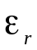 | 8 | 10

Right Angle Bend

the mapping P is defined by

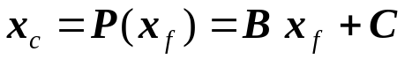

where
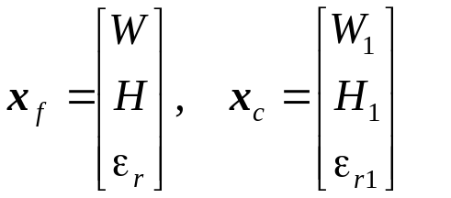

where W₁, H₁ and 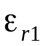 are the parameters to be used by the empirical model in order to match its response with that obtained by Sonnet em simulator

only 7 simulation sweeps at 7 points in the space were used

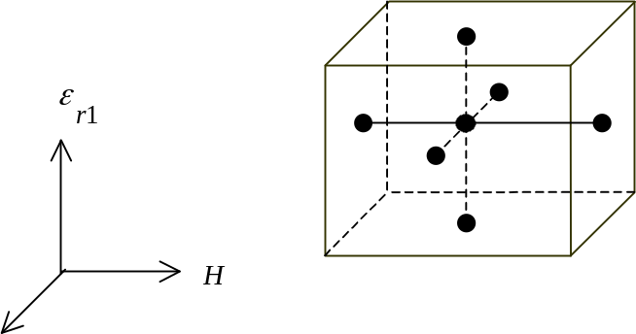
W

Right Angle Bend

The mapping parameters B and C in the frequency range from 29 GHz to 33 GHz are

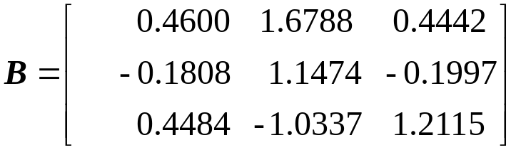, 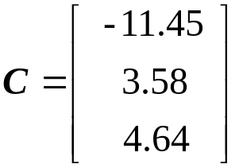

Right Angle Bend

the SMSM was tested at 50 uniformly distributed random points in the region of the fine model parameters.

the difference in 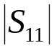 computed by Sonnet em simulator and by (Gupta et al., 1979) empirical model before and after applying SMSM
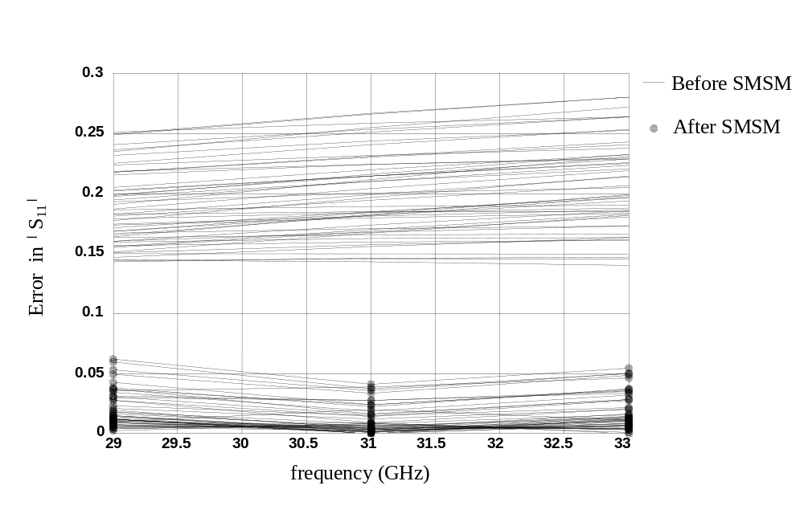
Right Angle Bend

the difference in 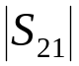 computed by Sonnet em simulator and by (Gupta et al., 1979) empirical model before and after applying SMSM

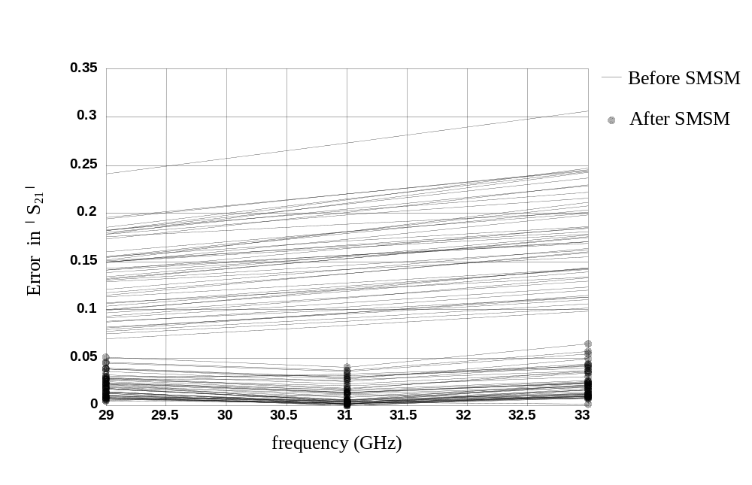

Right Angle Bend

the results of applying SMSM in the frequency range 1 GHz to 41 Ghz

the difference in 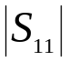 computed by Sonnet em simulator and by (Gupta et al., 1979) empirical model before and after applying SMSM
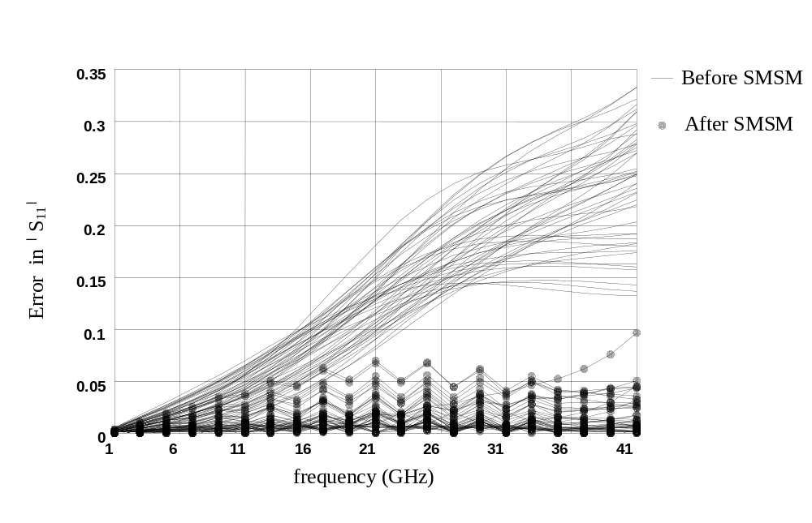
Right Angle Bend

the difference in computed by Sonnet em simulator and by (Gupta et al., 1979) empirical model before and after applying SMSM
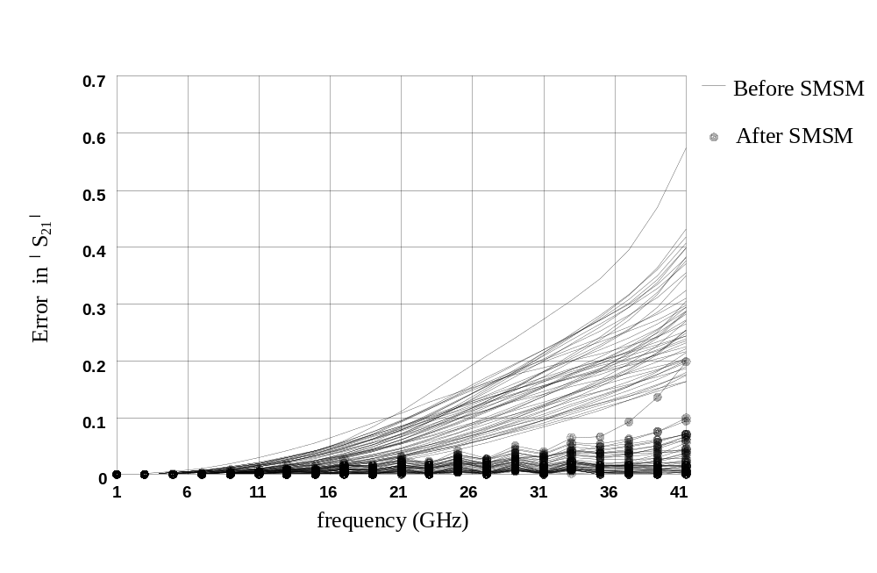
Example 2

Microstrip Line with High Dielectric Constant

the fine model is the Sonnet em simulator with parameters given by
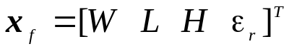

the coarse model is Jansen empirical model with parameters given by
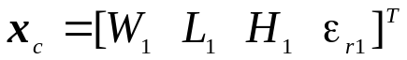

the frequency range

the region of parameters in the fine model space is defined in the following table

Parameter | Minimum value | Maximum value
W | 5 mil | 9 mil
L | 15 mil | 25 mil
H | 40 mil | 60 mil
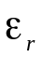 | 20 | 25

the mapping P is defined by

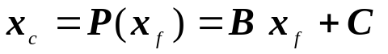
Microstrip Line with High Dielectric Constant

where
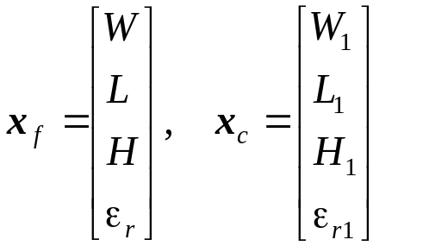

only 9 simulation sweeps at 9 points in the space were used

The matrix B and the vector C are given by

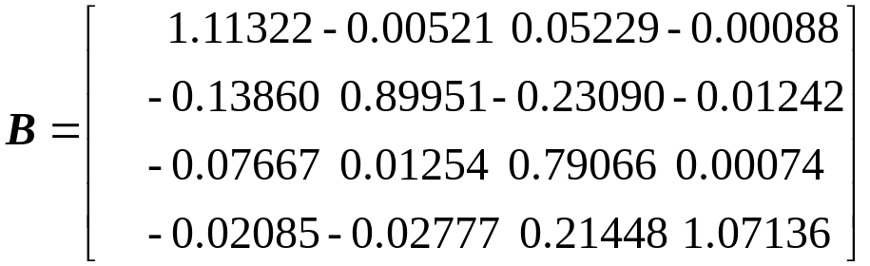, 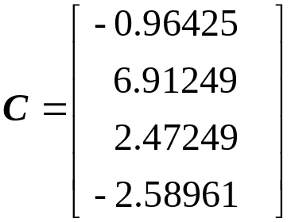

the SMSM was tested at 100 uniformly distributed random points in the region of interest
Microstrip Line with High Dielectric Constant

the difference in 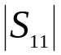 computed by Sonnet em simulator and by Jansen empirical model before applying SMSM
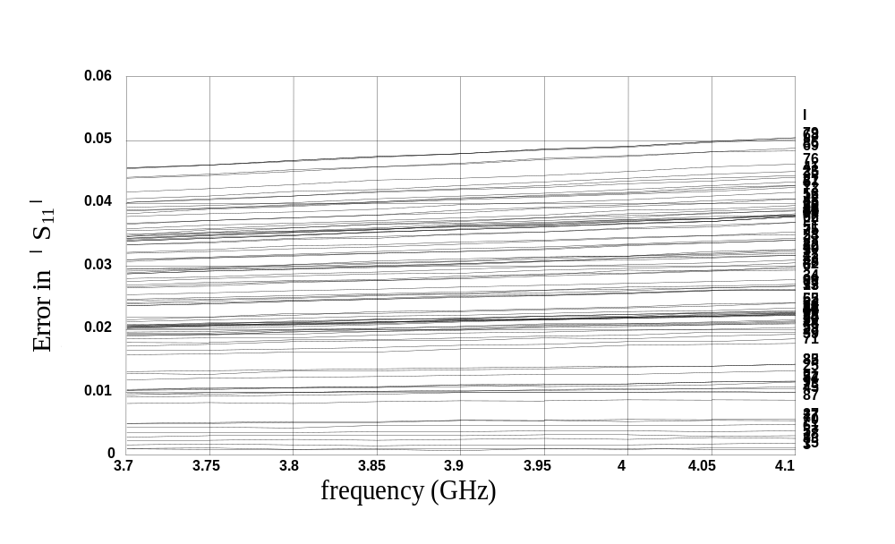
the difference in computed by Sonnet em simulator and by Jansen empirical model after applying SMSM
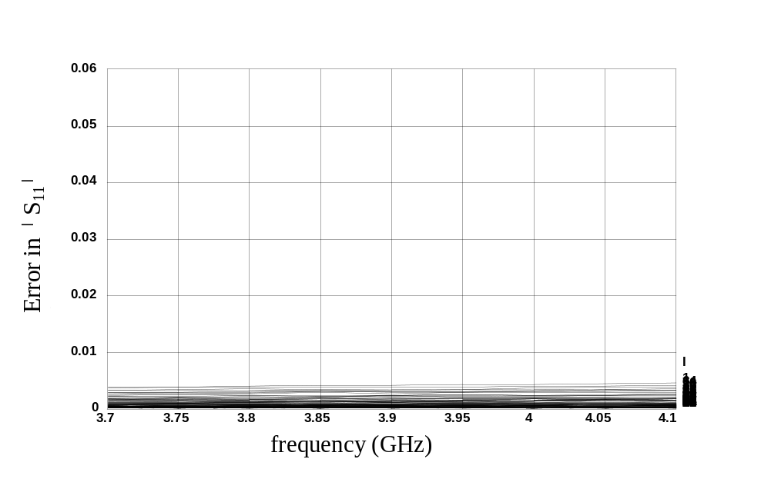
Microstrip Line with High Dielectric Constant

the difference in the phase of 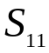 computed by Sonnet em simulator and by Jansen empirical model before applying SMSM
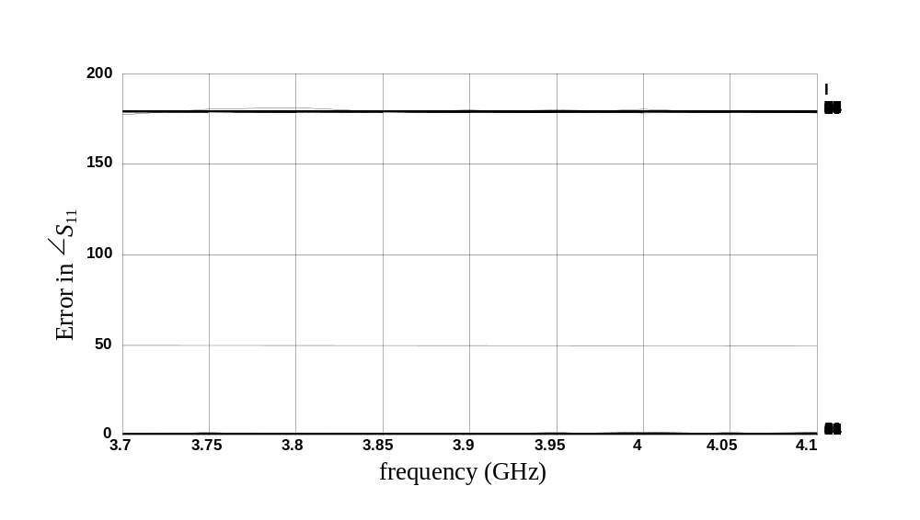
the difference in the phase of computed by Sonnet em simulator and by Jansen empirical model after applying SMSM


