A SIX-RESONATOR C-BAND H-PLANE
WAVEGUIDE FILTER

N. Georgieva

SOS-98-31-R
October 1998

© N. Georgieva 1998
No part of this document may be copied, translated, transcribed or entered in any form into any machine without written permission. Address inquiries in this regard to Dr. J.W. Bandler. Excerpts may be quoted for scholarly purposes with full acknowledgment of source. This document may not be lent or circulated without this title page and its original cover.

A Six-Resonator C-Band H-plane Waveguide Filter

Natalia Georgieva

Simulation Optimization Systems Research Laboratory
and Department of Electrical and Computer Engineering
McMaster University, Hamilton, Canada L8S 4L7

presented at

SOS Research Laboratory Meeting, Hamilton, October 15, 1998
General Structure Description

The optimization example considered here is a six-resonator H-plane waveguide C-band filter. The passband is from 5.4 GHz to 9 GHz. For this design a waveguide with a cross-section of 1.372 inches by 0.622 inches is used. The six resonators are separated by seven H-plane septa (see Fig. 1). The symmetry of the dominant-mode field distribution is used and a perfect H boundary is applied.

The filter was designed, manufactured and measured by Leo Young and M. Schiffman [1]. The measurements show that the measured VSWR is slightly larger than the predicted one. A direct optimization is performed using HP HFSS to enhance the performance of the filter.
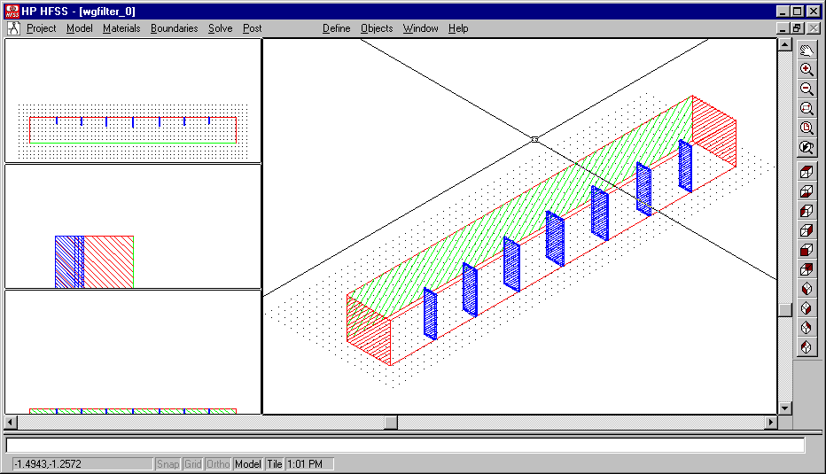

Fig. 1. The nominal geometry file.

Optimization Variables

The structure is symmetrical with respect to the central septum (the center of its length). There are seven optimization variables: the four septa’s widths and the three resonators’ lengths. The nominal project was built after the values reported in [1] and in [2]. Only half of the width of each septum corresponds to the c_{i} (i=1, .. ,4) in TABLE 1 because the symmetry of the structure was used.

TABLE 1

OPTIMIZATION VARIABLES: NOMINAL AND PERTURBED VALUES

 | nominal, inches | perturbed, inches
c1 | 0.513 | 0.514
c2 | 0.479 | 0.480
c3 | 0.449 | 0.450
c4 | 0.435 | 0.436
l1 | 0.626 | 0.630
l2 | 0.653 | 0.660
l3 | 0.674 | 0.680

The HP HFSS solution setup is shown in the following two figures, Fig. 2 and Fig. 3. The mesh seeding is the default one.
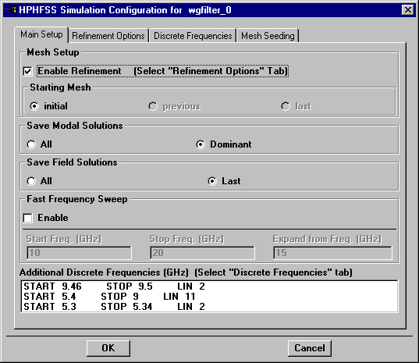

Fig. 2. Main Setup of the nominal project.

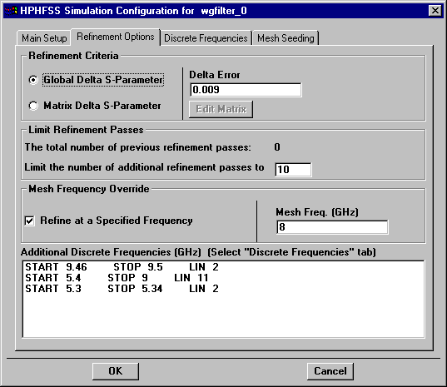
Fig. 3. Refinement Options of the nominal project.

Direct Optimization Results

The frequency sweep before optimization is shown in Fig. 4.
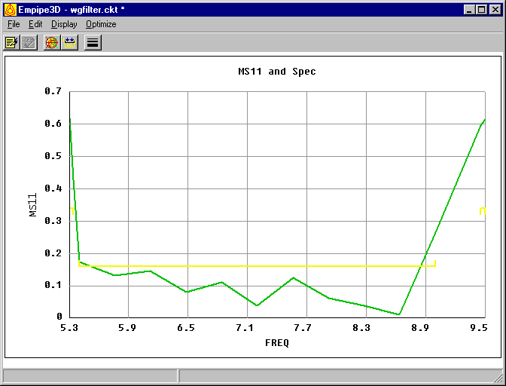

Fig. 4. |S₁₁| response before optimization.

The optimization iteration report is shown in Fig. 5. The |S21| response after optimization is in Fig 6.

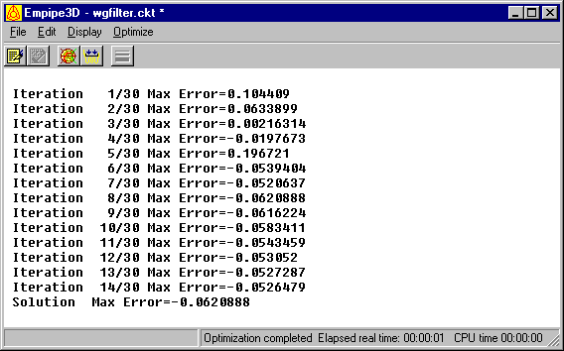
Fig. 5. Iteration report for direct optimization starting from the nominal set of values.

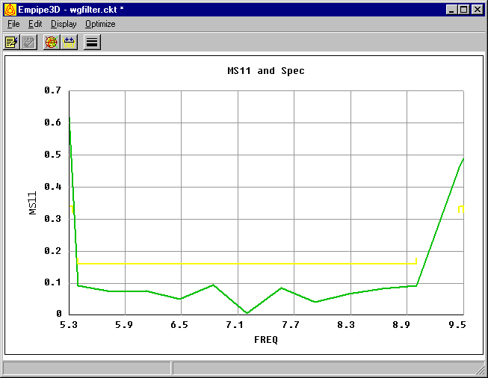
Fig. 6. |S₁₁| response after optimization, starting from the nominal set of values.

The Coarse Model

This example was developed for the verification of aggressive space mapping algorithms, which imply the existence of computationally fast coarse models. This particular structure can be relatively easily modeled in terms of an equivalent circuit consisting of lumped inductances and transmission line sections. The simulation of the obtained coarse model is computationally much more efficient in comparison with a full electromagnetic simulation, e.g. using HP HFSS. The equivalent circuit of the structure in Fig. 1 is shown in Fig. 7.

Fig. 7. Equivalent circuit of the six-resonator H-plane waveguide filter.

There are various approaches to calculate the equivalent inductive susceptance corresponding to an H-plane septum (see Fig. 8). The simplest formula is provided by Smythe [3] and is a quasi-static approximation:

$\frac{B}{Y_{0}}≈−\frac{λ_{g}}{a}\left[1+{\text{csc}}^{2}\left(\frac{π}{2}\frac{c}{a}\right)\right]{\text{cot}}^{2}\left(\frac{π}{2}\frac{c}{a}\right)$ (1)
Here λ_{g} denotes the guide wavelength.

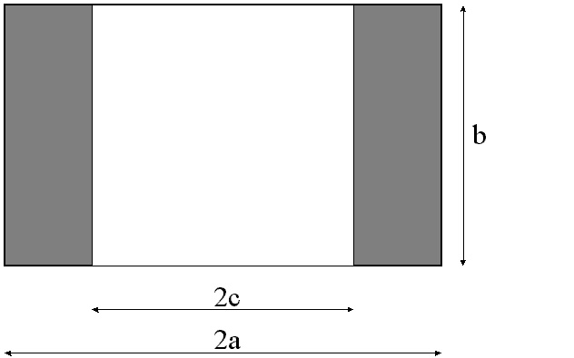

Fig. 8. Waveguide H-plane septum.

Each waveguide resonator corresponds to a piece of an ideal transmission line characterized by its characteristic impedance Y₀ and by its electrical length θ_{i} (i=1,2,3). The characteristic impedance Y₀ is equal to the guide wave impedance. The electrical length θ_{i} is proportional to the physical length of the waveguide section l_{i}:
$θ_{i}=\text{360}\frac{l_{i}}{λ_{g}}$ , deg (2)

The OSA90 netlist file of the coarse model:

! Thu Oct 15 12:37:52 1998. Minimax Optimizer. 18 Iterations. 00:00:00 CPU.
Expression
MS11_SPEC = 0.16;

INMM = 25.4;
V = 2.99792458E+11;
MU0 = 4*PI*1E-10;
EPS0 = 1/(36*PI)*1E-12;
GAMMA = SQRT(MU0/EPS0);

A = 1.372*INMM; B = 0.622*INMM;

CC1: ?0.557111?;
CC2: ?0.523275?;
CC3: ?0.510365?;
CC4: ?0.508484?;

C1 = 2*CC1*INMM; C2 = 2*CC2*INMM;
C3 = 2*CC3*INMM; C4 = 2*CC4*INMM;

LL1: ?0.633067?;
LL2: ?0.65315?;
LL3: ?0.675303?;

L1 = LL1*INMM; L2 = LL2*INMM;
L3 = LL3*INMM;
LIO = 0.7*INMM;
! wave impedance Z0 and wavelength LAMBDA
Fc=(1E-9*V)/(2*A); ! GHz
Z0=GAMMA/SQRT(1-(Fc/FREQ)^2);
Y0=1/Z0;
LAMBDA=1/SQRT((FREQ*1E+9/V)^2-(1/(2*A))^2);
! Susceptances (quasistatic, after Smythe)
C1A=C1/A;C2A=C2/A;C3A=C3/A;C4A=C4/A;

B1=-Y0*(LAMBDA/A)*(1+(1/sin(PI*C1A/2))^2)/((tan(PI*C1A/2))^2);
B2=-Y0*(LAMBDA/A)*(1+(1/sin(PI*C2A/2))^2)/((tan(PI*C2A/2))^2);
B3=-Y0*(LAMBDA/A)*(1+(1/sin(PI*C3A/2))^2)/((tan(PI*C3A/2))^2);
B4=-Y0*(LAMBDA/A)*(1+(1/sin(PI*C4A/2))^2)/((tan(PI*C4A/2))^2);
! inductances (nano-henry)
LI1=-1/(2.*PI*FREQ*B1);
LI2=-1/(2.*PI*FREQ*B2);
LI3=-1/(2.*PI*FREQ*B3);
LI4=-1/(2.*PI*FREQ*B4);
! electrical lengths of resonators/input lines (degrees)
THETA1=360.*L1/LAMBDA;
THETA2=360.*L2/LAMBDA;
THETA3=360.*L3/LAMBDA;
THETAIO=360.*LIO/LAMBDA;
end
Model
TEM 1 2 0 0 Z=Z0 E=THETAIO F=FREQ;
IND 2 0 L=LI1;
TEM 2 3 0 0 Z=Z0 E=THETA1 F=FREQ;
IND 3 0 L=LI2;
TEM 3 4 0 0 Z=Z0 E=THETA2 F=FREQ;
IND 4 0 L=LI3;
TEM 4 5 0 0 Z=Z0 E=THETA3 F=FREQ;
IND 5 0 L=LI4;
TEM 5 6 0 0 Z=Z0 E=THETA3 F=FREQ;
IND 6 0 L=LI3;
TEM 6 7 0 0 Z=Z0 E=THETA2 F=FREQ;
IND 7 0 L=LI2;
TEM 7 8 0 0 Z=Z0 E=THETA1 F=FREQ;
IND 8 0 L=LI1;
TEM 8 9 0 0 Z=Z0 E=THETAIO F=FREQ;

PORT 1 0 R=Z0;
PORT 9 0 R=Z0;
CIRCUIT;
MS_dB[2,2] = if (MS > 0) (20 * log10(MS)) else (NAN);
MS11_dB = MS_dB[1,1];
MS21_dB = MS_dB[2,1];
end
Sweep
AC: FREQ: from 5.3GHz to 5.34GHz step=0.04GHz
from 5.4GHz to 9GHz step=0.36GHz
from 9.46GHz to 9.5GHz step=0.04GHz
MS MS_dB PS MS11_dB MS21_dB
{XSWEEP X=FREQ Y=MS11
SPEC=(from 5.4 to 9, < 0.16) &
(from 5.3 to 5.34 , > 0.34) &
(from 9.46 to 9.5 , > 0.34)};

! {XSWEEP X=FREQ Y=MS11
! SPEC=(from 5.4 to 9, < 0.16) &
! (from 4.5 to 5.34, > 0.34) &
! (from 9.46 to 10, >0.34)};
end
Spec
AC: FREQ: from 5.4GHz to 9GHz step=0.36GHz
MS11 < 0.16;
AC: FREQ: from 5.3GHz to 5.34GHz step=0.04GHz
MS11 > 0.34;
AC: FREQ: from 9.46GHz to 9.5GHz step=0.04GHz
MS11 > 0.34;
end
!Report
! Ros=[
! ${$MS11$}$
! ];
!end
Report
Xos=[$CC1$
$CC2$
$CC3$
$CC4$
$LL1$
$LL2$
$LL3$];
end

Optimization of the coarse model

Before optimization (Fig. 9):

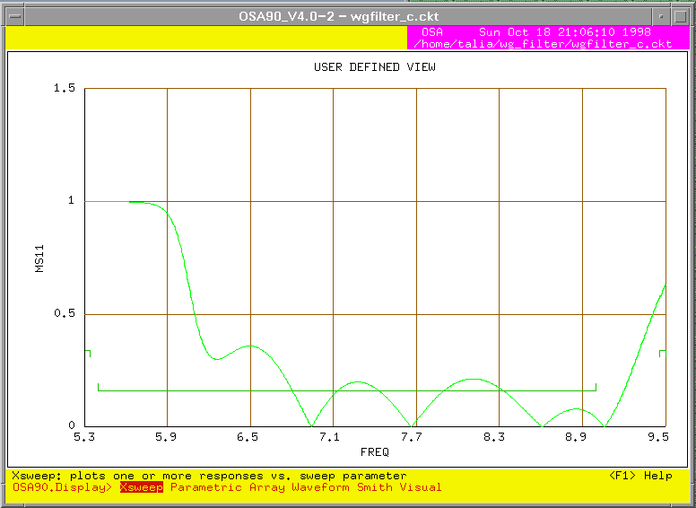

Fig. 9. |S₁₁| response of the coarse model before optimization.

After optimization (Fig. 10):

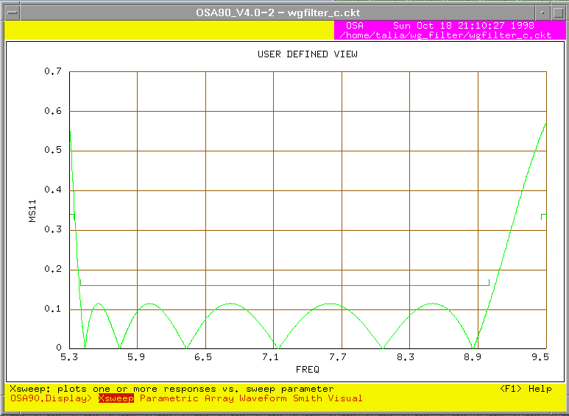

Fig. 10. |S₁₁| response of the coarse model after optimization.

Multiple Minima

It was observed that the fine model converges to another minimum when the optimal coarse model values of the optimization variables are used as a starting point. The obtained solution is worse in comparison with the one which starts with initial values set equal to the design presented in [1].

References

Leo Young and B. M. Schiffman, “A Useful High-Pass Filter Design,” The Microwave Journal, 6, No 2, February 1963, pp. 78-80

G. L. Matthaei, L. Young, E. M. T. Jones, Microwave Filters, Impedance-Matching Networks, and Coupling Structures, McGraw-Hill, New York, 1964, pp. 545-547

W. R. Smythe, Static and Dynamic Electricity, 2nd ed., McGraw-Hill, New York, 1950

