TABLE I
THE OPTIMAL COARSE MODEL DESIGN AND THE DESIGNS
OBTAINED DURING DIFFERENT PHASES OF THE HASM ALGORITHM FOR
THE THREE-SECTION WAVEGUIDE TRANSFORMER
Parameter | $$x_{\text{os}}^{}$$ | First Phase Design | Second Phase Design | $$x_{\text{em}}^{}$$
b₁ | 0.90318 | 0.90331 | 0.90114 | 0.90549
b₂ | 1.37093 | 1.36436 | 1.35687 | 1.35777
b₃ | 1.73609 | 1.73208 | 1.72470 | 1.71866
L₁ | 1.54879 | 1.46991 | 1.47203 | 1.47008
L₂ | 1.58375 | 1.56402 | 1.56521 | 1.57587
L₃ | 1.64590 | 1.79666 | 1.77744 | 1.78286
All values are in cm

TABLE II
THE OPTIMAL COARSE MODEL DESIGN, THE FINAL SPACE-MAPPED
AND THE OPTIMAL FINE MODEL DESIGNS FOR THE
SIX-SECTION H-PLANE WAVEGUIDE FILTER
Parameter | $$x_{\text{os}}^{}$$ | $${\overline{x}}_{\text{em}}^{}$$ | $$x_{\text{em}}^{}$$
W₁ | 0.48583 | 0.51326 | 0.51344
W₂ | 0.43494 | 0.47379 | 0.47396
W₃ | 0.40433 | 0.45091 | 0.45100
W₄ | 0.39796 | 0.44675 | 0.44664
L₁ | 0.65585 | 0.63701 | 0.63695
L₂ | 0.65923 | 0.63954 | 0.63977
L₃ | 0.67666 | 0.65704 | 0.65694
All values are in inches

Space Mapping
x, f, B
Direct Optimization
x, J_{em}

Fig. 1. Illustration of the connection between space mapping and direct optimization.

Phase 2
Set i=i+1
Given
,
,
and
Set
=
Evaluate
using space mapping. and set
Obtain
using the points in V
Both success
criteria satisfied?
No
Direct optimization success criterion satisfied ?
Evaluate
from
and
No
Yes
k=1?
No
Yes
Update B to get
and obtain
using
and
k=n?
No
Obtain a temporary point
and set
Obtain
using the points in V
Yes
No
Update
and
Yes
Fig. 2. A flow chart of the first phase of the HASM algorithm.
Yes

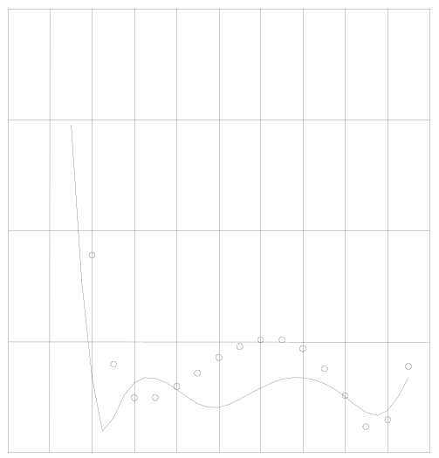
1.20
1.15
1.10
1.05
1.00
VSWR
5.3
5.5
5.7
5.9
6.1
6.3
6.5
6.7
6.9
7.1
7.3
frequency (GHz)
Fig. 3.The optimal coarse model response (⎯) and the fine model response (ο) at the optimal coarse model design for the three-section waveguide transformer.

Optimal coarse Model response and initial fine model response

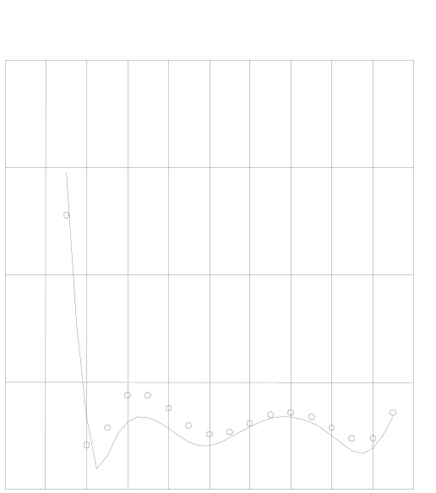
1.20
1.15
1.10
1.05
1.00
VSWR
5.3
5.5
5.7
5.9
6.1
6.3
6.5
6.7
6.9
7.1
7.3
frequency (GHz)

Fig. 4. The optimal coarse model response (⎯) and the fine model response (ο) obtained at the end of the first phase of the HASM algorithm for the three-section waveguide transformer.

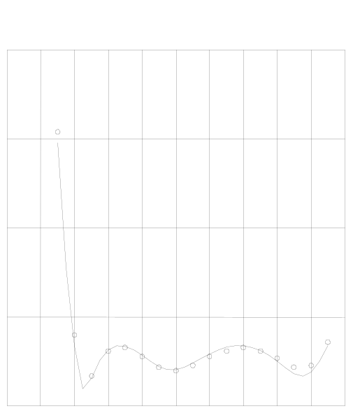
1.20
1.15
1.10
1.05
1.00
VSWR
5.3
5.5
5.7
5.9
6.1
6.3
6.5
6.7
6.9
7.1
7.3
frequency (GHz)
Fig. 5.The optimal coarse model response (⎯) and the fine model response (ο) obtained at the end of the second phase of the HASM algorithm for the three-section waveguide transformer.

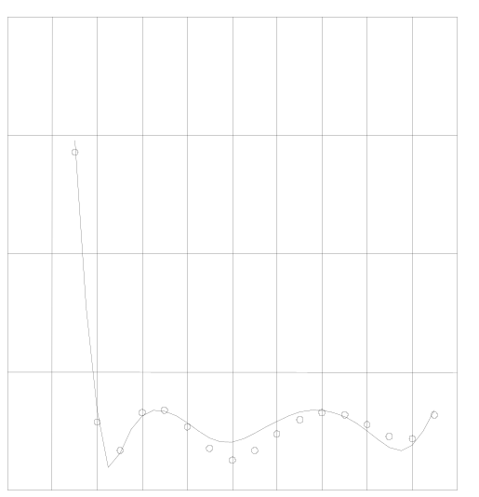
1.20
1.15
1.10
1.05
1.00
VSWR
5.3
5.5
5.7
5.9
6.1
6.3
6.5
6.7
6.9
7.1
7.3
frequency (GHz)
Fig. 6.The optimal coarse model response (⎯) and the minimax optimal fine model response (ο) for the three-section waveguide transformer.

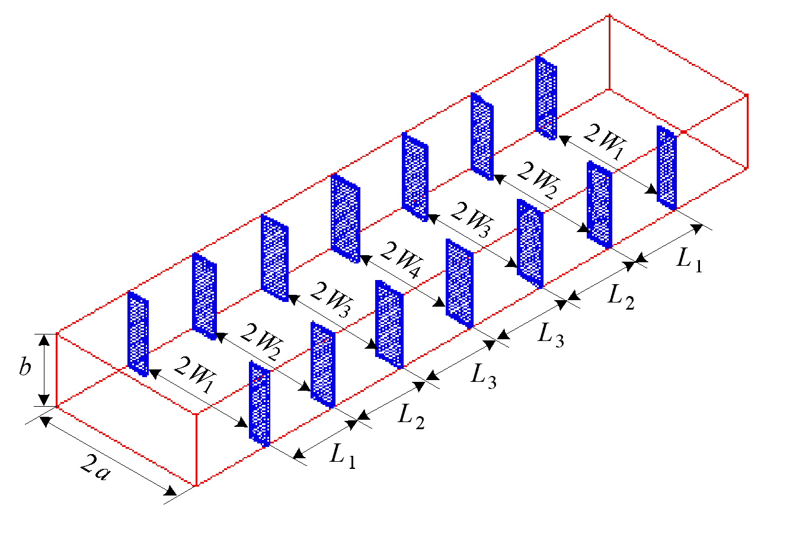
Fig. 7. The fine model of the six-section waveguide filter [12, 13].

Fig. 8. The coarse model of the six-section waveguide filter [15].
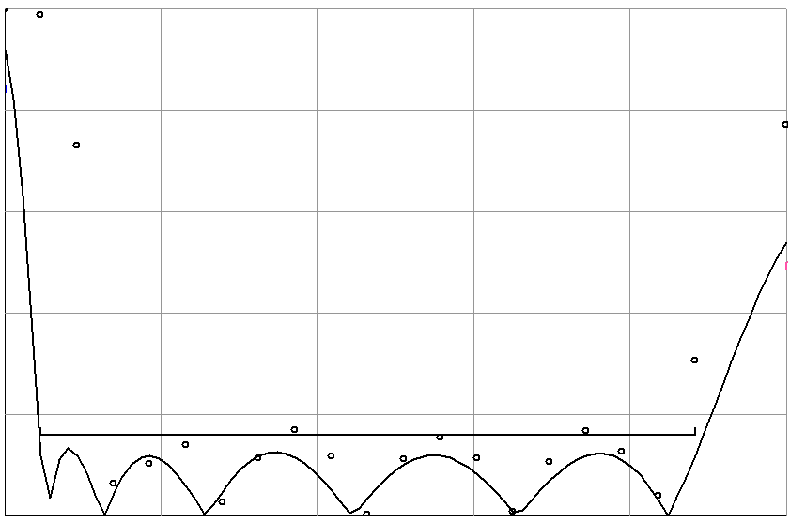
5.20
6.06
6.92
7.78
8.64
9.50
frequency (GHz)
0
0.2
0.4
0.6
0.8
1.0
⏐S_{11⏐}

Fig. 9. The optimal coarse model response (⎯) and the fine model response (ο) at the optimal coarse model design for the six-section waveguide filter.

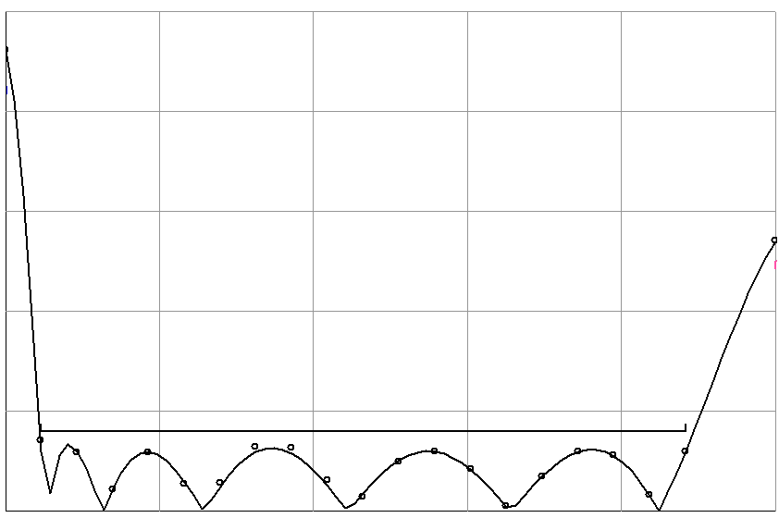
5.20
6.06
6.92
7.78
8.64
9.50
0
0.2
0.4
0.6
0.8
1.0
frequency (GHz)
⏐S_{11⏐}

Fig. 10. The optimal coarse model response (⎯) and the fine model response (ο) at the end of the second phase of the HASM algorithm for the six-section waveguide filter.

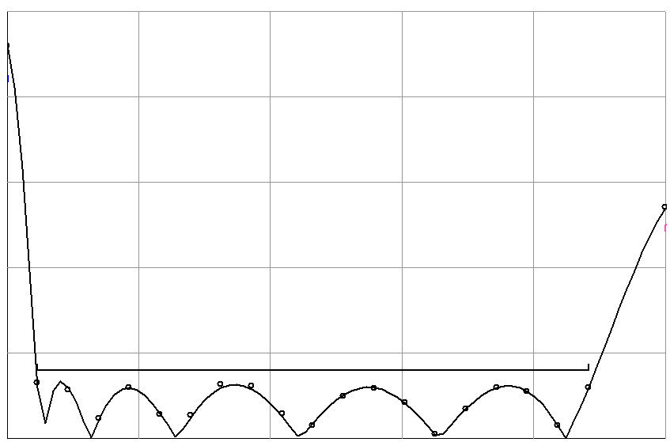
5.20
6.06
6.92
7.78
8.64
9.50
frequency (GHz)
0
0.2
0.4
0.6
0.8
1.0
⏐S_{11⏐}

Fig. 11. The optimal coarse model response (⎯) and the optimal minimax fine model response (ο) for the six-section waveguide filter.

