TABLE I
THE VARIATION IN THE EXTRACTED PARAMETERS
FOR THE 10:1 IMPEDANCE TRANSFORMER
Number of Points |  |  | $$x_{\text{os}\text{,1}}^{e}$$ |  |  | $$x_{\text{os},2}^{e}$$
1 |  | 3.62043 |  | 7.24147
2 | 3.47160 |  |  |  | 7.43214
3 |  | 3.60357 |  | 7.35052

TABLE II
MATERIAL AND PHYSICAL PARAMETERS
FOR THE COARSE AND FINE MODELS OF THE HTS FILTER
Model Parameter | Coarse Model | Fine Model
substrate dielectric constant | 23.425 | 23.425
substrate thickness (mil) | 19.9516 | 19.9516
shielding cover height (mil) | 100 | 250
conducting material thickness | 0 | 0
substrate dielectric loss tangent | 0 | 0
resistivity of metal (Ωm) | 0 | 0
magnetic loss tangent | 0 | 0
surface reactance (Ω/sq) | 0 | 0
x-grid cell size (mil) | 2.00 | 1.00
y-grid cell size (mil) | 1.75 | 1.75

TABLE III
THE OPTIMAL COARSE MODEL DESIGN
FOR THE HTS FILTER
Parameter | Value
L₁ | 181.00
L₂ | 201.59
L₃ | 180.97
S₁ | 20.12
S₂ | 67.89
S₃ | 66.85
all values are in mils

TABLE IV
THE FINE MODEL POINTS USED IN THE APE
ALGORITHM FOR THE HTS FILTER
Parameter | $$x_{f}^{(1)}$$ | $$x_{f}^{(2)}$$ | $$x_{f}^{(3)}$$ | $$x_{f}^{(4)}$$
L₁ | 181.00 | 182.55 | 181.34 | 179.86
L₂ | 201.59 | 205.64 | 205.38 | 197.74
L₃ | 180.97 | 183.36 | 184.20 | 178.08
S₁ | 20.12 | 20.05 | 20.07 | 20.46
S₂ | 67.89 | 68.40 | 68.08 | 67.35
S₃ | 66.85 | 67.25 | 66.98 | 66.46
all values are in mils

TABLE V
THE VARIATION IN THE EXTRACTED PARAMETERS
FOR THE HTS FILTER
Parameter | 1 | 2 | 3 | 4
L₁ | 188.31 | 179.99 | 176.67 | 178.50
L₂ | 197.69 | 204.52 | 208.52 | 206.78
L₃ | 189.72 | 181.230 | 178.00 | 179.09
S₁ | 19.34 | 17.13 | 17.21 | 18.99
S₂ | 52.67 | 63.44 | 56.52 | 57.99
S₃ | 52.06 | 53.18 | 53.47 | 56.77
all values are in mils

- (b)

Fig. 1. Results for single point parameter extraction for the 10:1 transformer, (a) the responses at the fine model point (ο) and the response (−) at the corresponding coarse model point, and (b) the corresponding contours of the $ℓ_{2}$ objective function.

(a) (b)

(c)

Fig. 2. Results for two-point parameter extraction for the 10:1 transformer, (a) and (b) the responses at the first and second fine model points (ο) and the responses (−) at the corresponding coarse model points, and (c) the corresponding contours of the $ℓ_{2}$ objective function.

(a) (b)

(c) (d)

Fig. 3. Results for three-point parameter extraction for the 10:1 transformer, (a), (b) and (c) the responses at the first, second and third fine model points (ο) and the responses (−) at the corresponding coarse model points, and (d) the corresponding contours of the $ℓ_{2}$ objective function.

L₀
L₁
L₂
L₃
L₂
L₁
L₀
S₁
S₂
S₃
S₂
S₁
W
x
y
First Section
Second Section
Third
Section
Fourth Section
Fifth Section

Fig. 4. The HTS filter [10].

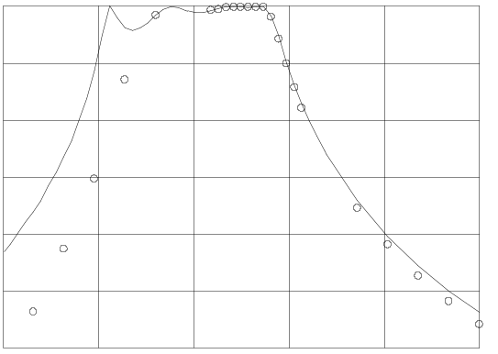
3.867
3.929
3.992
4.054
4.117
4.179
frequency (GHz)
-60
-50
-40
-30
-20
-10
0
⏐S_{21⏐} dB

(a)

Fig. 5. The fine model response (ο) and the corresponding coarse model response (−) at the point utilized for single point extraction for the HTS filter. Note that only points in the range 3.967 GHz to 4.099 GHz were actually used.

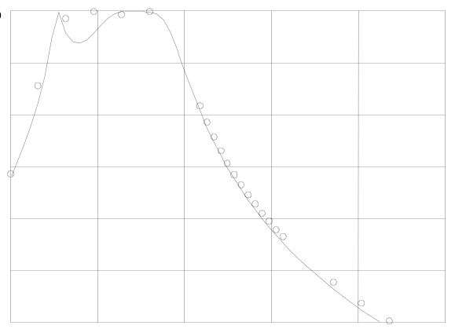
3.867
3.929
3.992
4.054
4.117
4.179
frequency (GHz)
-60
-50
-40
-30
-20
-10
0
⏐S_{21⏐} dB
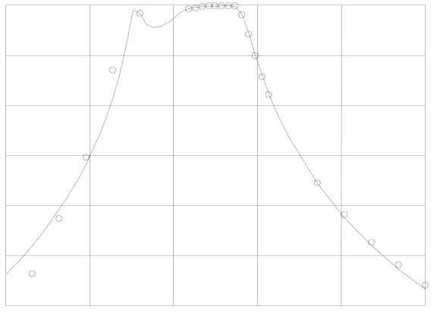
3.867
3.929
3.992
4.054
4.117
4.179
frequency (GHz)
-60
-50
-40
-30
-20
-10
0
⏐S_{21⏐} dB
(a) (b)

Fig. 6. The fine model response (ο) and the corresponding coarse model response (−), (a) at the first point, and (b) at the second point utilized in the two-point parameter extraction for the HTS filter. Note that only points in the range 3.967 GHz to 4.099 GHz were actually used.

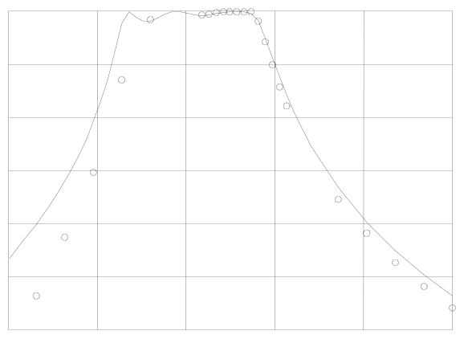
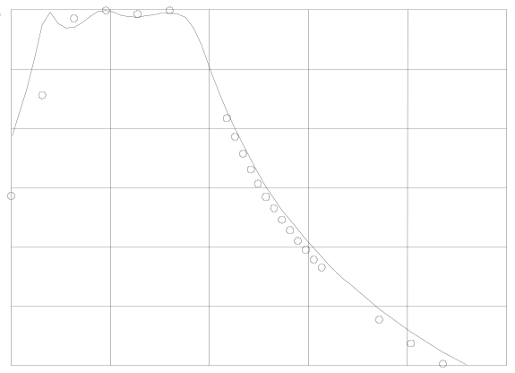
3.867
3.929
3.992
4.054
4.117
4.179
frequency (GHz)
-60
-50
-40
-30
-20
-10
0
⏐S_{21⏐} dB
3.867
3.929
3.992
4.054
4.117
4.179
frequency (GHz)
-60
-50
-40
-30
-20
-10
0
⏐S_{21⏐} dB

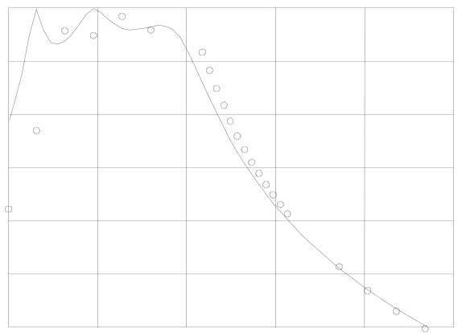
(a) (b)
3.867
3.929
3.992
4.054
4.117
4.179
frequency (GHz)
-60
-50
-40
-30
-20
-10
0
⏐S_{21⏐} dB

(c)

Fig. 7. The fine model response (ο) and the corresponding coarse model response (−), (a) at the first point, (b) at the second point, and (c) at the third point utilized in the three-point parameter extraction for the HTS filter. Note that only points in the range 3.967 GHz to 4.099 GHz were actually used.

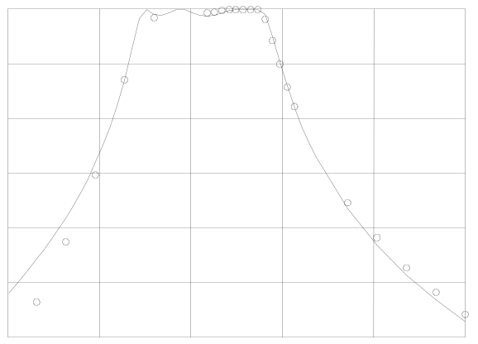
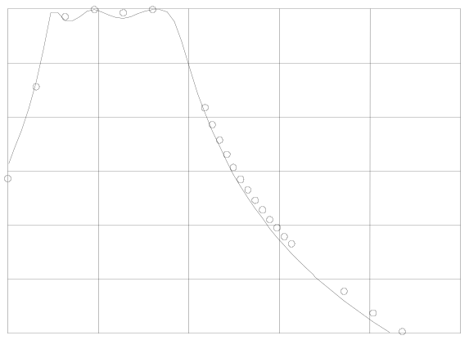
3.867
3.929
3.992
4.054
4.117
4.179
frequency (GHz)
-60
-50
-40
-30
-20
-10
0
⏐S_{21⏐} dB
3.867
3.929
3.992
4.054
4.117
4.179
frequency (GHz)
-60
-50
-40
-30
-20
-10
0
⏐S_{21⏐} dB
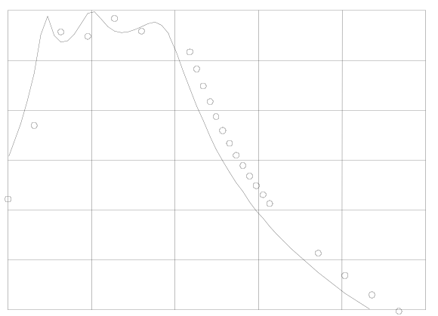
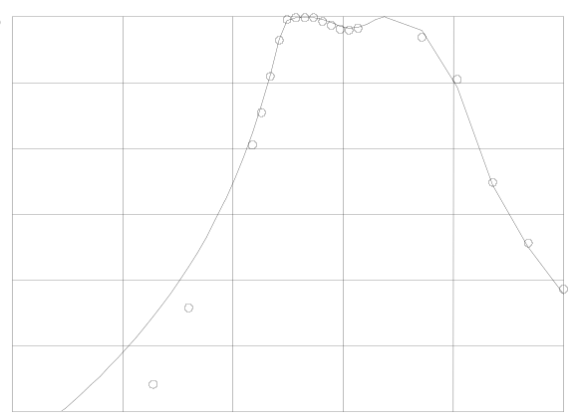
(a) (b)
3.867
3.929
3.992
4.054
4.117
4.179
frequency (GHz)
-60
-50
-40
-30
-20
-10
0
⏐S_{21⏐} dB
3.867
3.929
3.992
4.054
4.117
4.179
frequency (GHz)
-60
-50
-40
-30
-20
-10
0
⏐S_{21⏐} dB

(c) (d)

Fig. 8. The fine model response (ο) and the corresponding coarse model response (−), (a) at the first point, (b) at the second point, (c) at the third point, and (d) at the fourth point utilized in the four-point parameter extraction for the HTS filter. Note that only points in the range 3.967 GHz to 4.099 GHz were actually used.

