TABLE I
THE OPTIMAL FINE MODEL DESIGN AND THE CORRESPONDING
EXTRACTED COARSE MODEL POINT FOR THE TWO-SECTION
WAVEGUIDE TRANSFORMER
Parameter | $$x_{\text{em}}^{}$$ | $${\overline{x}}_{\text{os}}$$
b₁ | 0.71737 | 0.71468
b₂ | 1.39574 | 1.39092
L₁ | 1.55077 | 1.64691
L₂ | 1.50654 | 1.59799
all values are in cm

TABLE II
THE YIELD FOR THE TWO-SECTION WAVEGUIDE TRANSFORMER OBTAINED USING THE SDM STATISTICAL ANALYSIS COMPARED WITH FINE MODEL YIELD
Tolerance | Space-Mapped Yield | Fine Model Yield
1.0% | 59% | 53%
2.0% | 27% | 19%
4.0% | 8% | 3%

TABLE III
THE OPTIMAL FINE MODEL DESIGN AND THE CORRESPONDING
EXTRACTED COARSE MODEL POINT FOR THE THREE-SECTION
WAVEGUIDE TRANSFORMER WITH ROUNDED CORNERS
Parameter | $$x_{\text{em}}^{}$$ | $${\overline{x}}_{\text{os}}$$
L₁ | 0.32408 | 0.32507
L₂ | 0.32492 | 0.32747
L₃ | 0.33114 | 0.33223
h₁ | 0.20750 | 0.21543
h₂ | 0.26025 | 0.27415
h₃ | 0.32815 | 0.33700
All values are in inches

TABLE IV
THE OPTIMAL FINE MODEL DESIGN AND THE CORRESPONDING
EXTRACTED COARSE MODEL POINT FOR THE SIX-SECTION
WAVEGUIDE FILTER
Parameter | $$x_{\text{em}}^{}$$ | $${\overline{x}}_{\text{os}}$$
C₁ | 0.51336 | 0.49956
C₂ | 0.47293 | 0.45926
C₃ | 0.45031 | 0.43709
C₄ | 0.44575 | 0.43274
L₁ | 0.63570 | 0.65468
L₂ | 0.63910 | 0.65873
L₃ | 0.65681 | 0.67579
All values are in inches

Fig. 1. The two-section waveguide transformer.

Fig. 2. The optimal fine model response (ο) and the response (⎯) at the corresponding coarse model point for the two-section waveguide transformer.

(a) (b)
5.8
5.9
6.0
6.1
6.2
6.3
6.4
6.5
6.6
1.000
1.025
1.050
-
1.075
1.100
frequency (GHz)
VSWR
5.8
5.9
6.0
6.1
6.2
6.3
6.4
6.5
6.6
1.000
1.025
1.050
1.075
1.100
frequency (GHz)
VSWR

(a) (b)

Fig. 3. Statistical analysis for the two-section waveguide transformer assuming uniform distribution with relative tolerances of 1.0%, (a) using the SDMM, and (b) using fine model simulations.
5.8
5.9
6.0
6.1
6.2
6.3
6.4
6.5
6.6
1.00
1.05
1.10
1.15
frequency (GHz)
VSWR
5.8
5.9
6.0
6.1
6.2
6.3
6.4
6.5
6.6
frequency (GHz)
1.00
1.05
1.10
1.15
VSWR

(a) (b)
Fig. 4. Statistical analysis for the two-section waveguide transformer assuming uniform distribution with relative tolerances of 2.0%, (a) using the SDMM, and (b) using fine model simulations.
5.8
5.9
6.0
6.1
6.2
6.3
6.4
6.5
6.6
1.00
1.05
1.10
1.15
1.20
frequency (GHz)
VSWR
5.8
5.9
6.0
6.1
6.2
6.3
6.4
6.5
6.6
1.00
1.05
1.10
1.15
1.20
frequency (GHz)
VSWR

(a) (b)

Fig. 5. Statistical analysis for the two-section waveguide transformer assuming uniform distribution with relative tolerances of 4.0%, (a) using the SDMM, and (b) using fine model simulations.

Fig. 6. The simulated part of the three-section waveguide transformer with rounded corners [6].
Fig. 7. The optimal fine model response (ο) and the response (⎯) at the corresponding coarse model point for the three-section waveguide transformer with rounded corners.

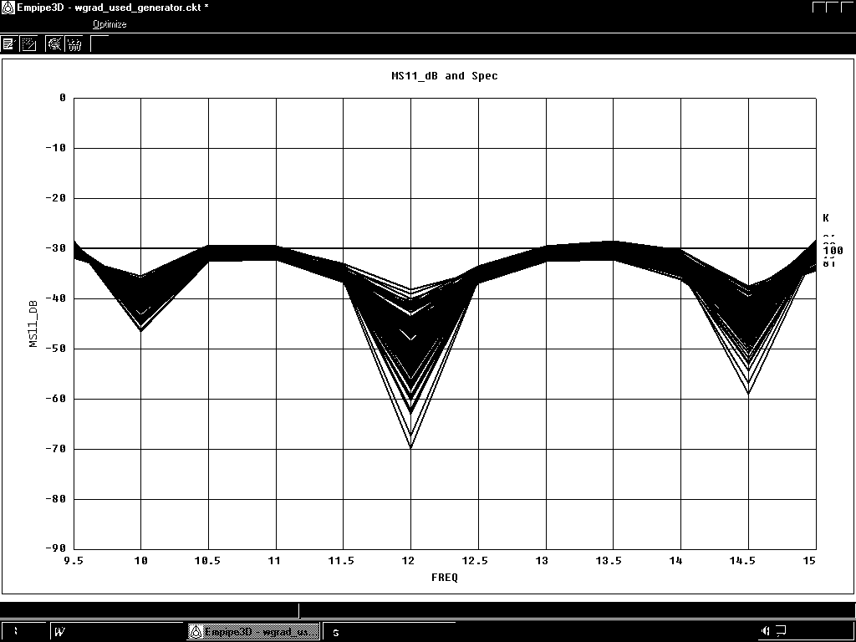
15.0
14.5
14.0
13.5
13.0
12.5
12.0
11.5
11.0
10.5
10.0
9.5
-90
-80
-70
-60
-50
-40
-30
-20
-10
0
⏐S_{11⏐}dB
frequency (GHz)
9.5
10.0
10.5
11.0
11.5
12.0
12.5
13.0
13.5
14.0
14.5
15.0
frequency (GHz)
-90
-80
-70
-60
-50
-40
-30
-20
-10
0
|S_{11|} dB
(a) (b)
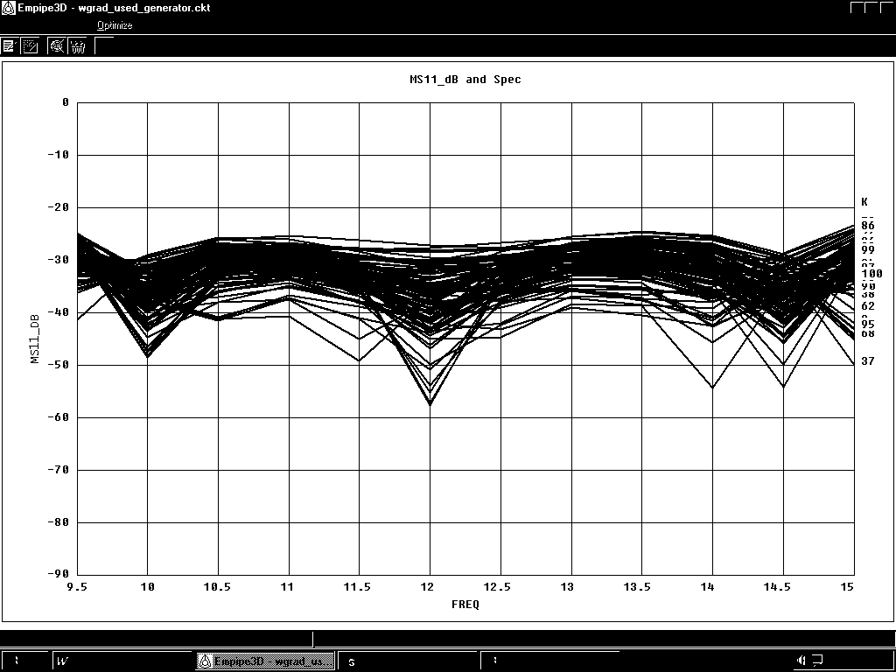
Fig. 8. Statistical analysis for the three-section waveguide transformer assuming uniform distribution with relative tolerances of 0.5%, (a) using the SDMM, and (b) using fine model simulations.
15.0
14.5
14.0
13.5
13.0
12.5
12.0
11.5
11.0
10.5
10.0
9.5
-70
-60
-50
-40
-30
-20
-10
0
frequency (GHz)
⏐S_{11⏐}dB
-80
-90
Fig. 9. Statistical analysis for the three-section waveguide transformer assuming uniform distribution with relative tolerances of 2%, (a) using the SDMM, and (b) using fine model simulations.
9.5
10.0
10.5
11.0
11.5
12.0
12.5
13.0
13.5
14.0
14.5
15.0
0
-20
-30
-40
-50
-60
-10
-70
-80
-90
frequency (GHz)
|S₁₁ | dB
(a) (b)
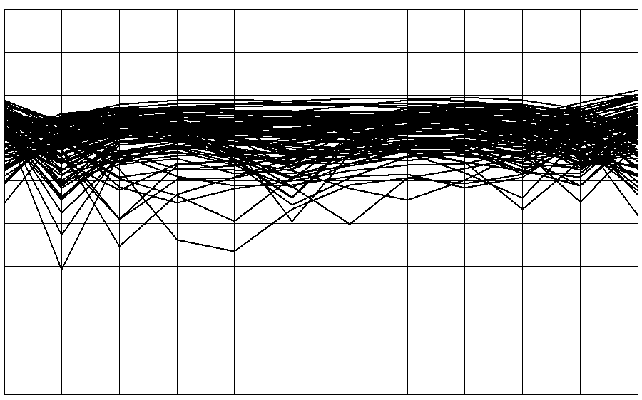
10.0
10.5
11.0
11.5
12.0
12.5
13.0
13.5
14.0
14.5
15.0
frequency (GHz)
-70
-60
-50
-40
-30
-20
-10
0
-90
-80
9.5
⏐S_{11⏐}dB
frequency (GHz)
9.5
10.0
10.5
11.0
11.5
12.0
12.5
13.0
13.5
14.0
14.5
15.0
-70
-60
-50
-40
-30
-20
-10
0
-90
-80
⏐S_{11⏐}dB
(a) (b)
Fig. 10. Statistical analysis for the three-section waveguide transformer assuming uniform distribution with relative tolerances of 4%, (a) using the SDMM, and (b) using fine model simulations.
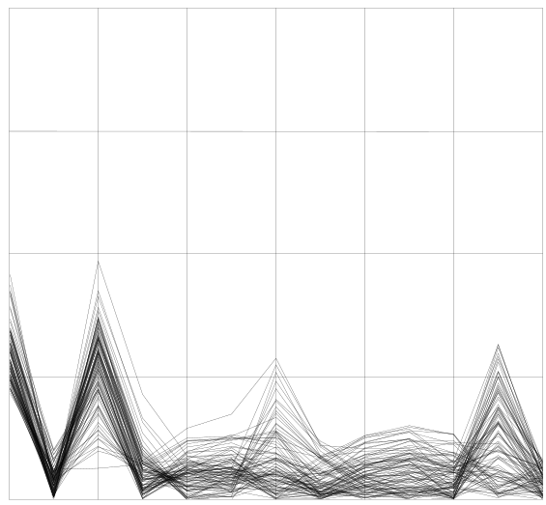
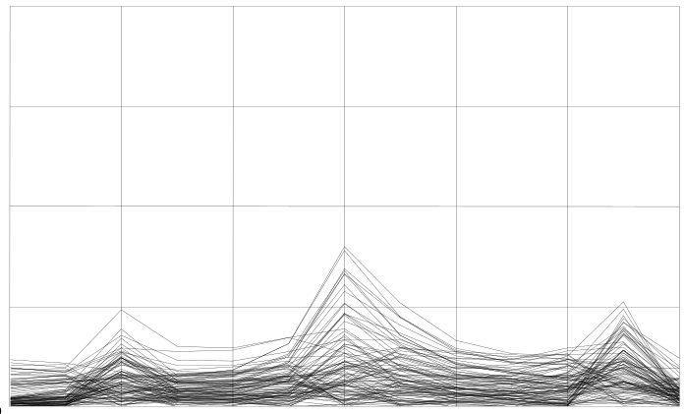
Fig. 11. Error in the statistical analysis for the three-section waveguide transformer assuming uniform distribution with relative tolerances of 0.5%, (a) using SDMM, and (b) using linear approximation.
9
10
11
12
13
14
15
0
0.01
0.02
0.03
0.04
Error
frequency (GHz)
9
10
11
12
13
14
15
0
0.01
0.02
0.03
0.04
Error
frequency (GHz)
(a)(b)
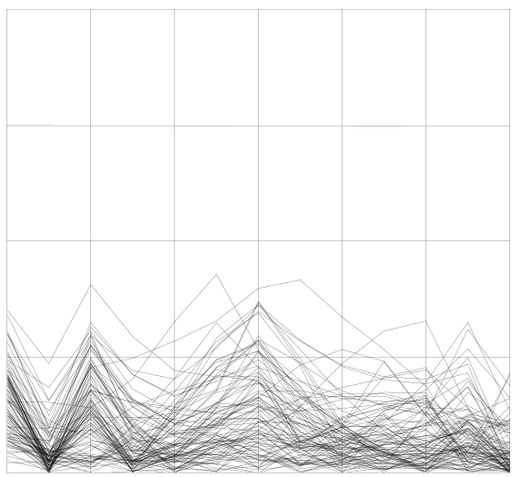
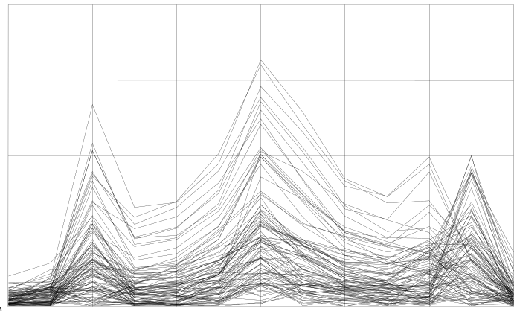
9
10
11
12
13
14
15
0
0.02
0.04
0.06
0.08
Error
frequency (GHz)
9
10
11
12
13
14
15
0.02
0.04
0.06
0.08
Error
0
frequency (GHz)
(a)(b)
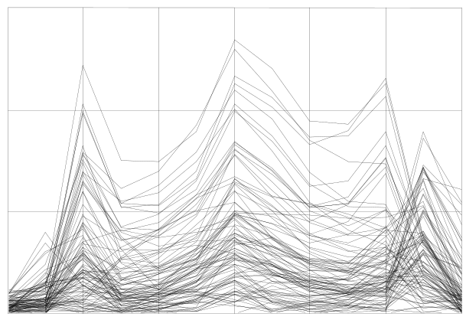
Fig. 12. Error in the statistical analysis for the three-section waveguide transformer assuming uniform distribution with relative tolerances of 2%, (a) using SDMM, and (b) using linear approximation.
9
10
11
12
13
14
15
0
0.05
0.10
0.15
Error
frequency (GHz)
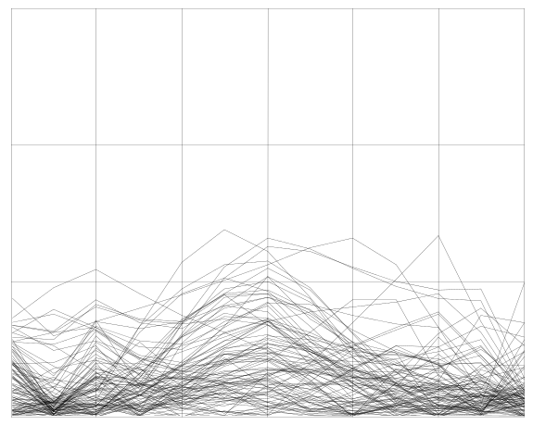
9
10
11
12
13
14
15
0
0.05
0.10
0.15
Error
frequency (GHz)

(a) (b)
Fig. 13. Error in the statistical analysis for the three-section waveguide transformer assuming uniform distribution with relative tolerances of 4%, (a) using SDMM, and (b) using linear approximation.
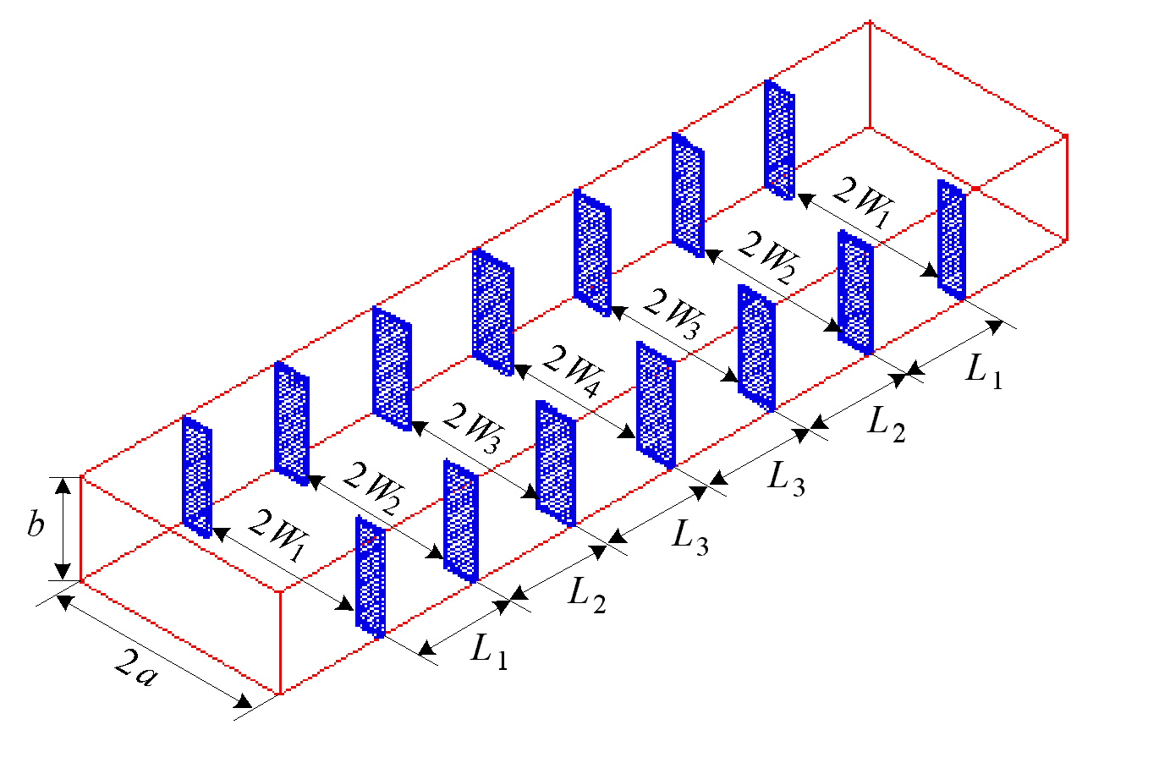
Fig. 14. The fine model of the six-section waveguide filter [11, 12].

Fig. 15. The coarse model of the six-section waveguide filter [13].

Fig. 16. The fine model response (ο) and the response (⎯) at the extracted coarse model point for the six-section waveguide filter.

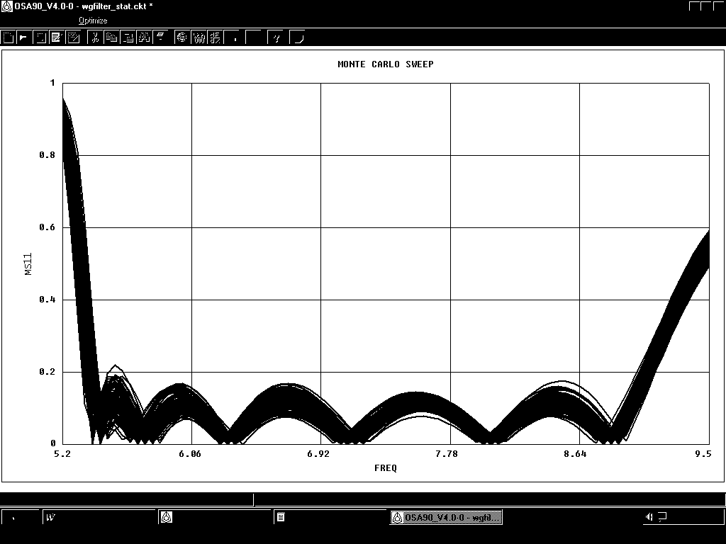
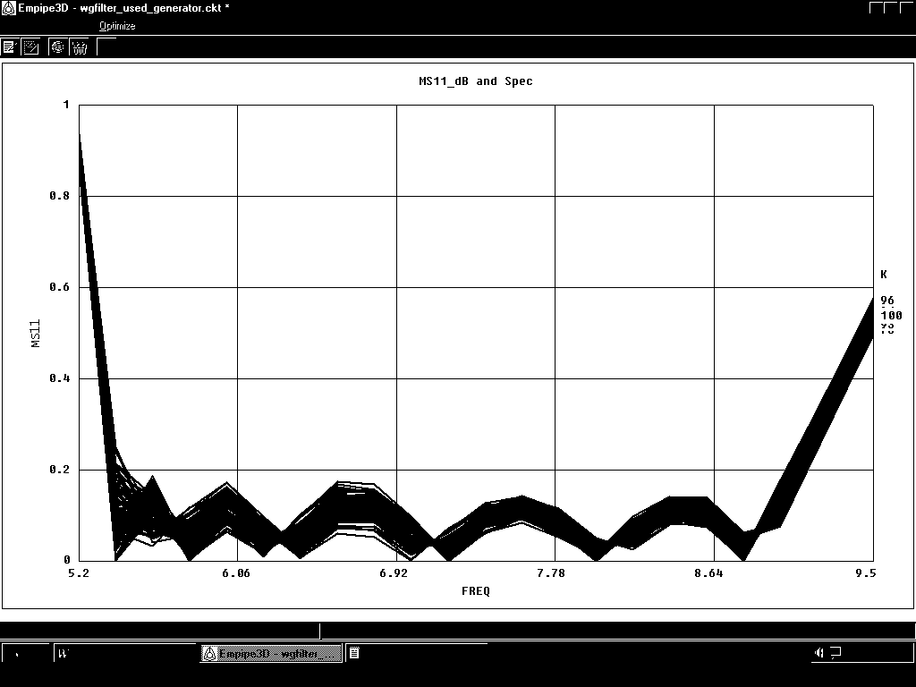
Fig. 17. Statistical analysis for the six-section waveguide filter assuming uniform distribution with relative tolerances of 1%, (a) using the SDMM, and (b) using fine model simulations.
5.20
6.06
6.92
7.78
8.64
9.50
0
0.2
0.4
0.6
0.8
1.0
frequency (GHz)
⏐S_{11⏐}
5.20
6.06
6.92
7.78
8.64
9.50
0
0.2
0.4
0.6
0.8
1.0
frequency (GHz)
⏐S_{11⏐}
(a)(b)
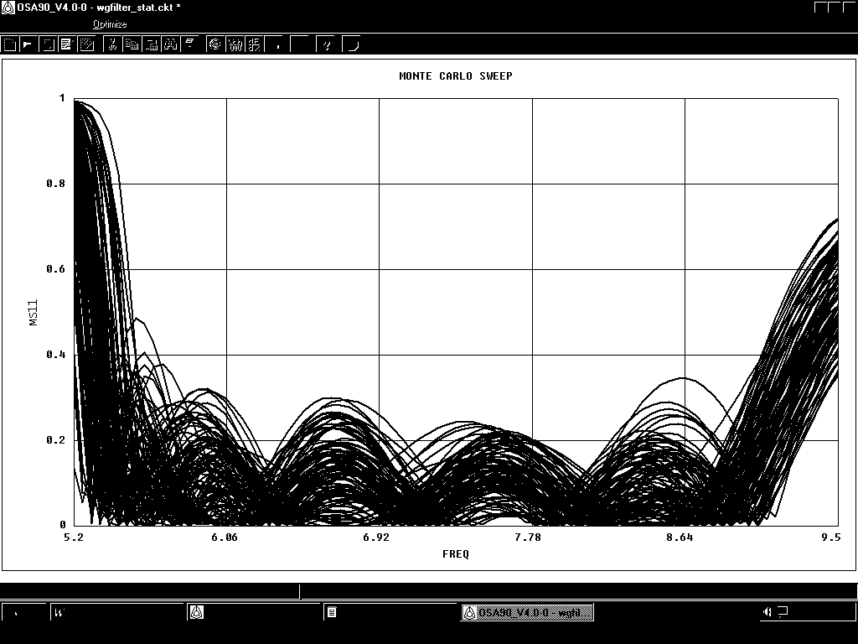
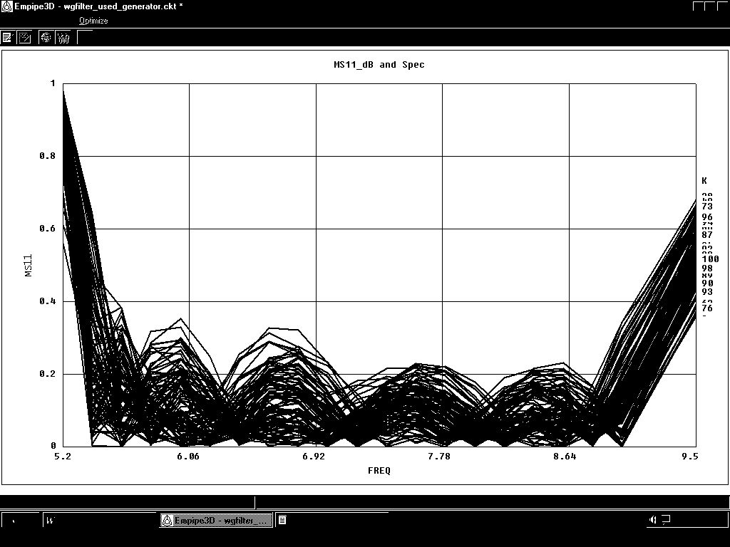
5.20
6.06
6.92
7.78
8.64
9.50
frequency (GHz)
0
0.2
0.4
0.6
0.8
1.0
⏐S_{11⏐}
5.20
6.06
6.92
7.78
8.64
9.50
0
0.2
0.4
0.6
0.8
1.0
frequency (GHz)
⏐S_{11⏐}
(a)(b)
Fig. 18. Statistical analysis for the six-section waveguide filter assuming uniform distribution with relative tolerances of 4%, (a) using the SDMM, and (b) using fine model simulations.
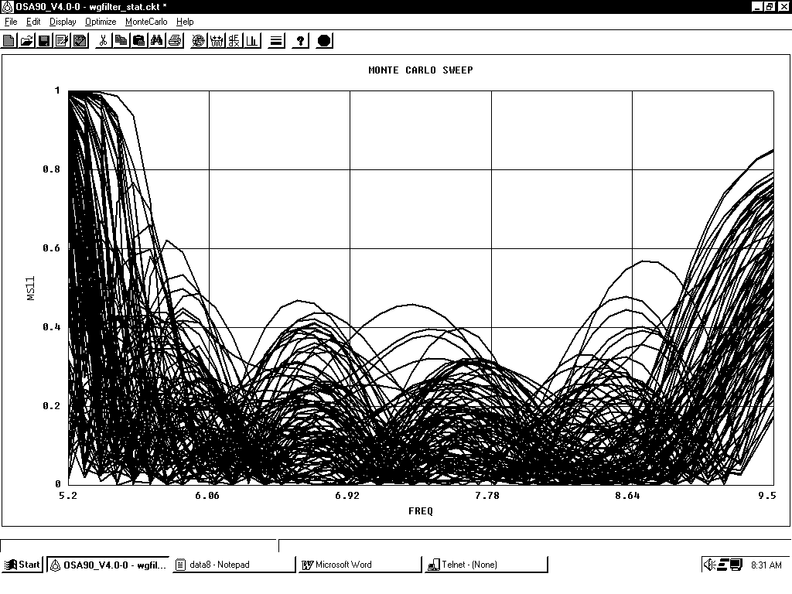
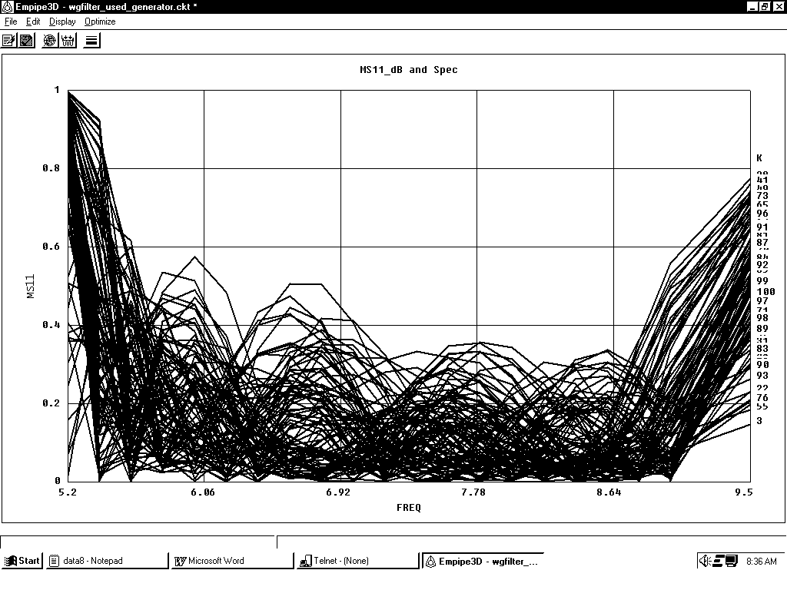
5.20
6.06
6.92
7.78
8.64
9.50
frequency (GHz)
0
0.2
0.4
0.6
0.8
1.0
⏐S_{11⏐}
5.20
6.06
6.92
7.78
8.64
9.50
frequency (GHz)
0
0.2
0.4
0.6
0.8
1.0
⏐S_{11⏐}
(a)(b)
Fig. 19.Statistical analysis for the six-section waveguide filter assuming uniform distribution with relative tolerances of 8%, (a) using the SDMM, and (b) using fine model simulations.

Fig. 20. Error in the statistical analysis for the six-section waveguide filter assuming uniform distribution with relative tolerances of 1%, (a) using SDMM, and (b) using linear approximation.
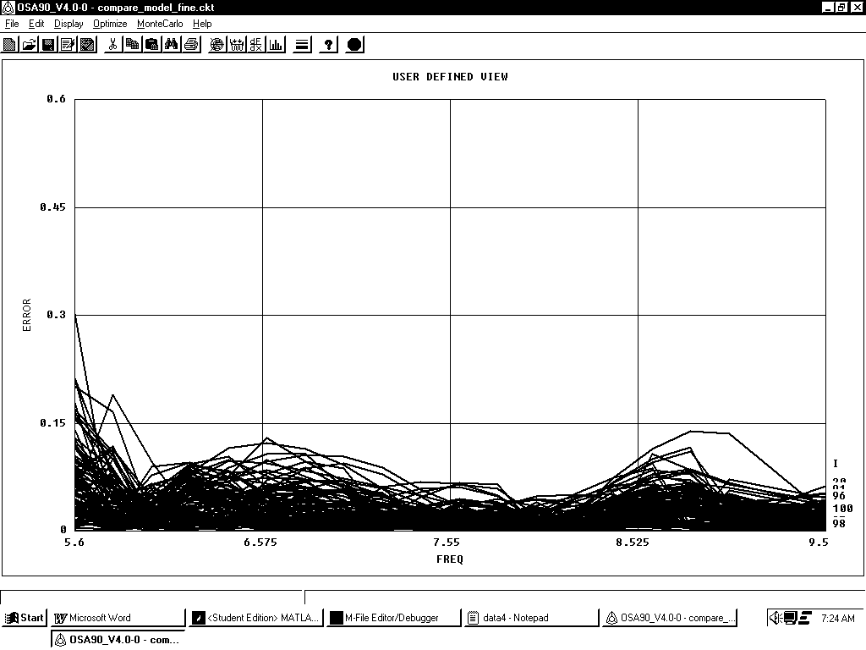
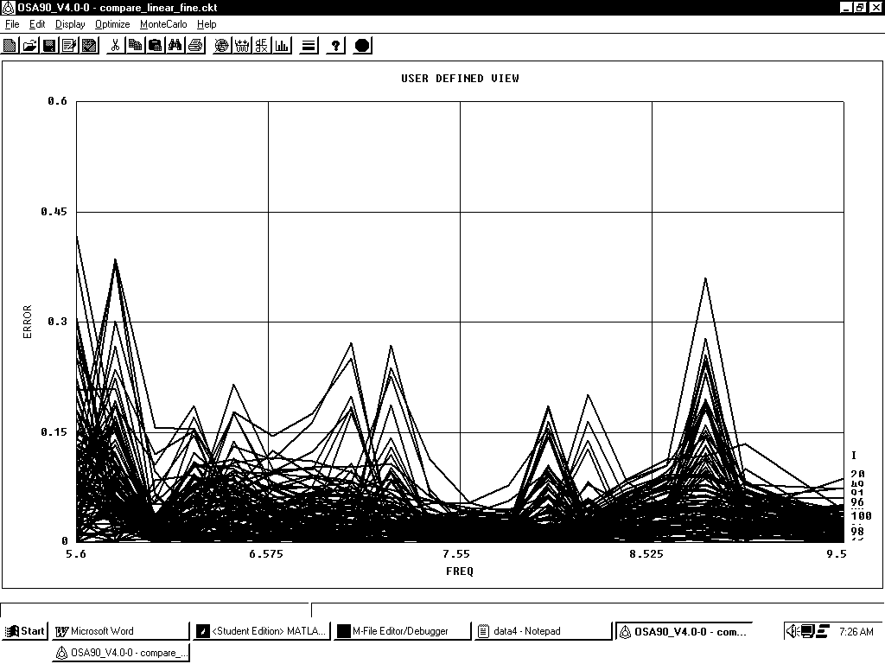
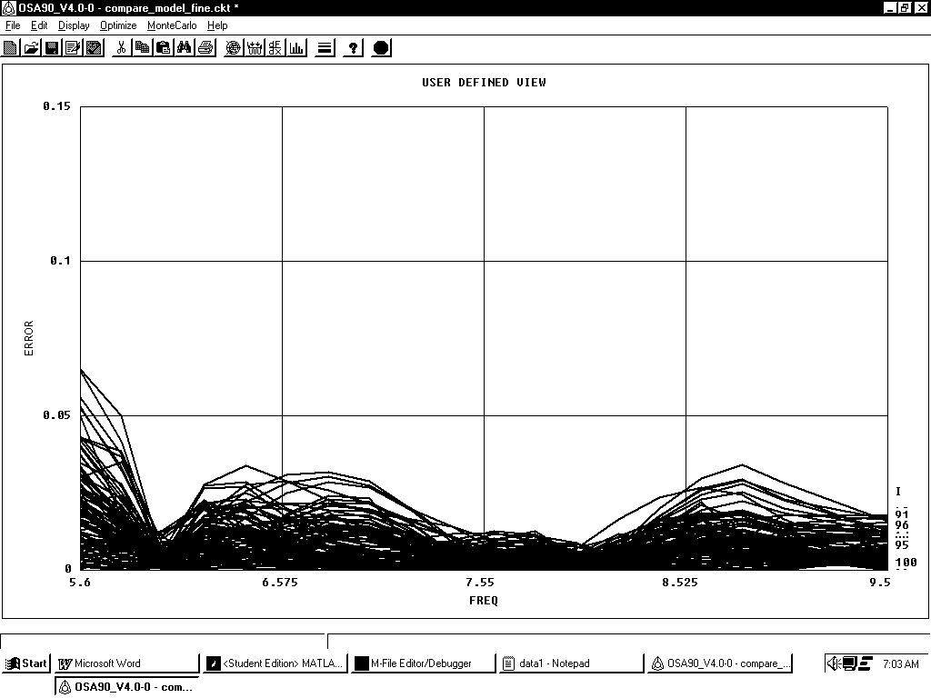
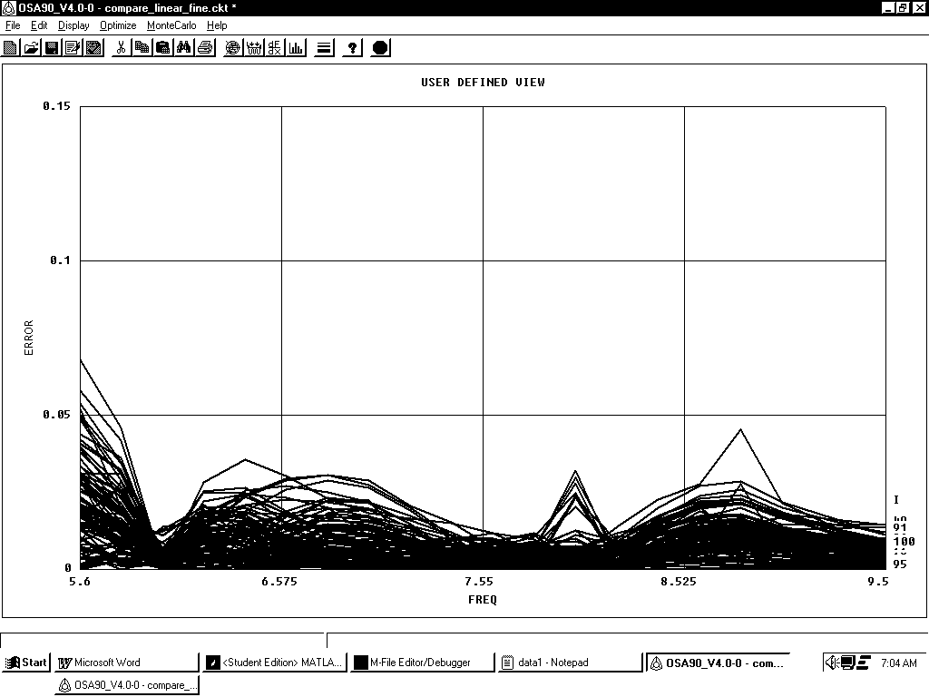
Fig. 21. Error in the statistical analysis for the six-section waveguide filter assuming uniform distribution with relative tolerances of 4%, (a) using SDMM, and (b) using linear approximation.
5.600
6.575
7.550
8.525
9.500
frequency (GHz)
0
0.15
0.30
0.45
0.60
Error
5.600
6.575
7.550
8.525
9.500
frequency (GHz)
0
0.15
0.30
0.45
0.60
Error
(a)(b)
5.600
6.575
7.550
8.525
9.500
frequency (GHz)
0.10
0
0.05
0.15
Error
5.600
6.575
7.550
8.525
9.500
frequency (GHz)
0
0.05
0.15
Error
0.10
(a)(b)
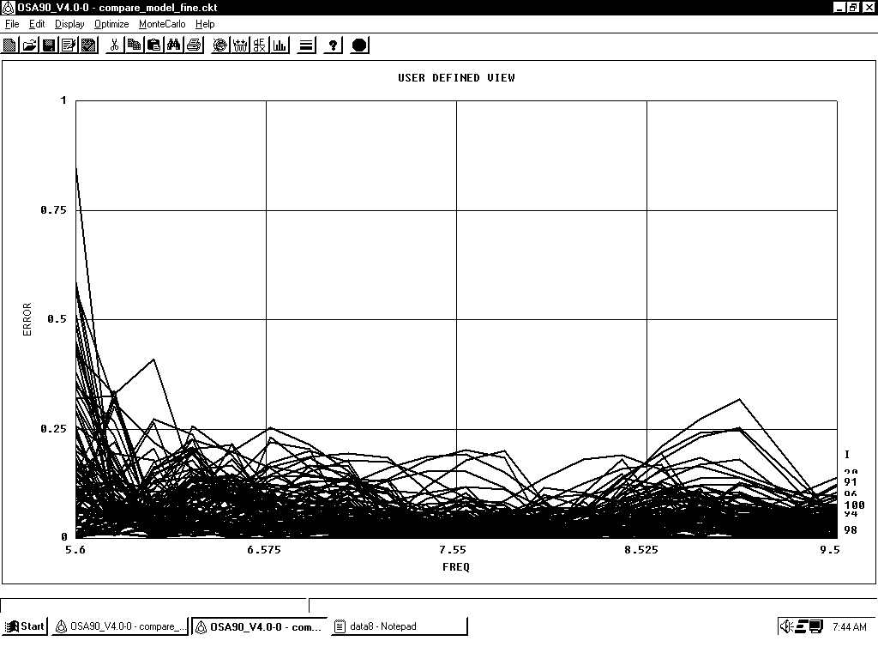
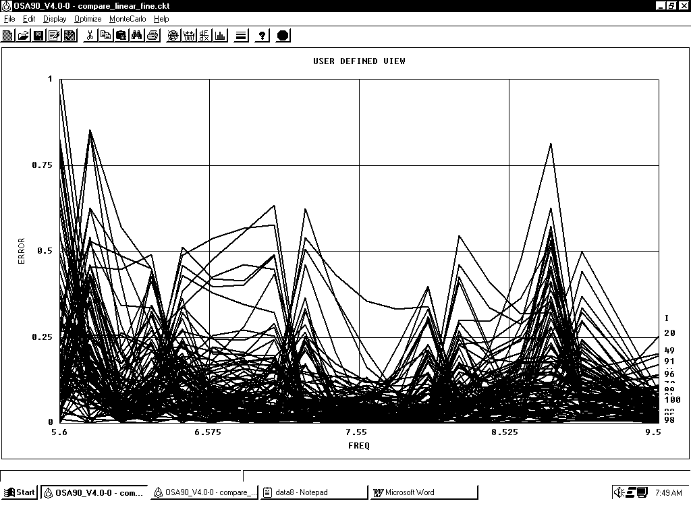
Fig. 22. Error in the statistical analysis for the six-section waveguide filter assuming uniform distribution with relative tolerances of 8%, (a) using SDMM, and (b) using linear approximation.
5.600
6.575
7.550
8.525
9.500
frequency (GHz)
0
0.25
0.50
0.75
1.00
Error
5.600
6.575
7.550
8.525
9.500
frequency (GHz)
0
0.25
0.50
0.75
1.00
Error
(a)(b)

