PROPOSED ALGORITHMS FOR THE AGGRESSIVE
SPACE MAPPING TECHNIQUE

M.H. Bakr
SOS-98-41-V
November 1998

© M.H. Bakr 1998
No part of this document may be copied, translated, transcribed or entered in any form into any machine without written permission. Address inquiries in this regard to Dr. J.W. Bandler. Excerpts may be quoted for scholarly purposes with full acknowledgment of source. This document may not be lent or circulated without this title page and its original cover.

PROPOSED ALGORITHMS FOR THE AGGRESSIVE
SPACE MAPPING TECHNIQUE

M.H. Bakr

Simulation Optimization Systems Research Laboratory
and Department of Electrical and Computer Engineering
McMaster University, Hamilton, Canada L8S 4K1

presented at

Supervisory Committee Meeting, Hamilton, November 1998
Basic Concepts

it is assumed that the circuit under consideration can be simulated using two models: a fine model and a coarse model

the fine model is accurate but is computationally intensive

$x_{\text{em}}$ is the vector of fine model parameters

the coarse model is a fast model but less accurate than the fine model

$x_{\text{os}}$ is the vector of coarse model parameters

space mapping aims at avoiding the computationally intensive direct optimization of the fine model

The Aggressive Space Mapping (ASM) Algorithm

the initial fine model design is the optimal coarse model design $x_{\text{os}}^{}$

parameter extraction is used to predict the step to be taken in the fine model space

x_{em,1}
x_{em,2}
x_{os,1}
x_{os,2}
x_{os}

in the ith iteration the new iterate is given by
$$x_{\text{em}}^{(i+1)}=x_{\text{em}}^{(i)}+h^{(i)}$$
and $h^{(i)}$ is obtained by solving
$B^{(i)}h^{(i)}=−f(x_{\text{em}}^{(i)})$
where $f=P(x_{\text{em}}^{(i)})−x_{\text{os}}^{}$

the nonuniqueness of the parameter extraction problem can lead to divergence or oscillation of the algorithm
The Trust Region Aggressive Space Mapping (TRASM) Algorithm

this algorithm integrates a trust region methodology with the aggressive space mapping technique

certain success criterion must be satisfied at each iteration so as to accept the predicted step

a recursive multi-point parameter extraction procedure was introduced in the context of this algorithm

all available fine model simulations are utilized in order to improve the uniqueness of the parameter extraction step

the available information about the mapping between the two spaces is integrated in this extraction procedure

Illustration of the TRASM Algorithm
x_{os,1}
x_{os,2}
$$P(x_{\text{em}}^{(i+1)})$$
x_{em,1}
x_{em,2}
$$x_{\text{em}}^{(i)}$$
$$x_{\text{em}}^{(i+1)}$$
$$x_{t}^{1}$$
initial parameter extraction at the suggested point
x_{os,1}
x_{os,2}
x_{em,1}
x_{em,2}
$$P(x_{\text{em}}^{(i+1)})$$
$$x_{\text{em}}^{(i)}$$
$$x_{\text{em}}^{(i+1)}$$
x_{os,1}
x_{os,2}
x_{em,1}
x_{em,2}
$$x_{\text{em}}^{(i)}$$
the current state at the ith iteration
trust region
trust region
multi-point extraction is applied

$$P(x_{\text{em}}^{(i)})$$

Parameter Extraction

single point parameter extraction aims at matching the responses of both models at a single point
x_{em,1}
x_{em,2}
x_{os,1}
x_{os,2}
R_{os}
R_{em}
x_{em}
x_{os}

it can formulated as an optimization problem;
$$\underset{x_{\text{os}}}{\text{minimize}}\left\|R_{\text{em}}(x_{\text{em}}^{})−R_{\text{os}}(x_{\text{os}}^{})\right\|$$

multi-point parameter extraction aims at matching the responses of both models at a number of points
x_{em,1}
x_{em,2}
x_{os,1}
x_{os,2}
x_{em}
V
x_{os}
B

the extracted parameters should satisfy
$$R_{\text{os}}(x_{\text{os}}+B^{}(x−x_{\text{em}}))=R_{\text{em}}(x)$$
simultaneously for a set of points $x∈V$; the set of points used for the multi-point parameter extraction where x_{em}∈V

The New Multi-Point Parameter Extraction Algorithm

we propose an algorithm that addresses the selection of the new points used for multi-point parameter extraction

the algorithm classifies the solutions of the parameter extraction problem based on the rank of the Jacobian matrix of the matched responses of the coarse model

a new point that aims at maximizing the improvement in the uniqueness of the parameter extraction step is obtained either by solving an eigenvalue problem or by solving a system of linear equations depending on the rank of the Jacobian matrix

the algorithm terminates when the extracted coarse model parameters in two consecutive iterations are close enough

the algorithm was applied successfully to a number of examples and the results obtained are encouraging
Illustrative Example: A 10:1 Impedance Transformer

the parameters of this problem are the two characteristic impedances of the two transmission lines

the coarse model is an ideal 10:1 impedance transformer

the fine model scales each of the impedances by 1.6

the responses of both models at 11 different frequencies in the band 0.5 GHz ≤ f ≤ 1.5 GHz are used to match the two models

three iterations are required to trust the extracted parameters

the set of points utilized is
$$V=\left\{\left[\begin{matrix}2\text{.}\text{26277} \\ 4\text{.}\text{52592}\end{matrix}\right],\left[\begin{matrix}1\text{.}\text{49975} \\ 4\text{.}\text{76634}\end{matrix}\right],\left[\begin{matrix}3\text{.}\text{02024} \\ 4\text{.}\text{26855}\end{matrix}\right]\right\}$$

the extracted parameters in each iteration are

$x_{\text{os}}^{e,1}=\left[\begin{matrix}3\text{.}\text{62043} \\ 7\text{.}\text{24147}\end{matrix}\right]$, $x_{\text{os}}^{e,2}=\left[\begin{matrix}3\text{.}\text{4716} \\ 7\text{.}\text{43214}\end{matrix}\right]$ and $x_{\text{os}}^{e,3}=\left[\begin{matrix}3\text{.}\text{60357} \\ 7\text{.}\text{35052}\end{matrix}\right]$

The Contours of the L₂ Objective Function for the 10:1
Transformer

single-point extraction two-point extraction

three-point extraction
Space Mapping and Direct Optimization: Crossing the Gap
x_{em,2}
x_{os,2}
J_{em}
x_{em}
x_{os}
J_{os}
B

x_{em,1}
x_{os,1}

x_{em} and x_{os} are two corresponding points in the fine and coarse model parameter spaces, respectively

J_{em} and J_{os} are the Jacobians of the fine model responses and the coarse model responses at the points x_{em} and x_{os}, respectively

the mapping B between the two spaces at the point x_{em} is related to the matrices J_{em} and J_{os} by
J_{em} = J_{os}B

it follows that the matrix B can be approximated by
$$B={\left(J_{\text{os}}^{\text{ T}}J_{\text{os}}\right)}^{\text{ - }1}J_{\text{os}}^{\text{ T}}J_{\text{em}}$$
Mapping-Based Modeling of Microwave Circuits

a fast and accurate model for a microwave circuit can be constructed using the mapping estimate

at any fine model point $x_{\text{em}}^{}$ the corresponding coarse model point x_{os} is obtained by applying single point parameter extraction

using an estimate of the Jacobian matrices J_{em} and J_{os} the corresponding mapping between the two spaces can be constructed

the mapping-based model is given by
$$R_{\text{em}}(x_{\text{em}})≈R_{\text{os}}(x_{\text{os}}+B(x_{\text{em}}−x_{\text{em}}^{}))$$

this modeling technique enables mapping-based modeling of microwave circuits without the need to carry out space mapping optimization
Example: Statistical Analysis of Six-Section H-Plane Waveguide Filter

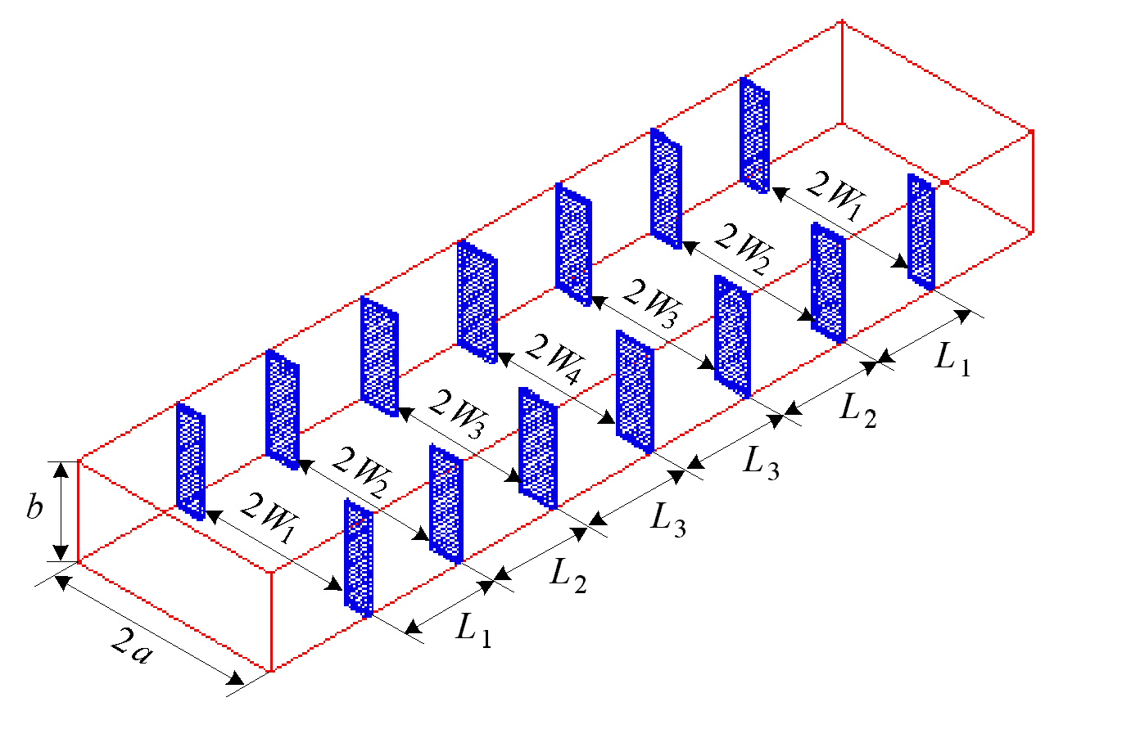
fine model

coarse model

the designable parameters are W₁, W₂, W₃, W₄, L₁, L₂ and L₃

the fine model is optimized and the mapping between the two spaces is established

the yield is estimated using the mapping-based model and using fine model simulations
The Hybrid Aggressive Space Mapping Algorithm

space mapping assumes that the coarse model is sufficiently accurate

if the coarse model is severely different from the fine model space mapping is unlikely to converge

the final solution of the problem may not be the optimal fine model design due to the differences between the two models

this suggested algorithm defaults to the computationally efficient space mapping if convergence is smooth and defaults to direct optimization otherwise

Space Mapping
x, f, B
Direct Optimization
x, J_{em}

Example: A Three-Section Waveguide Transformer

the design constraints are
vswr ≤ 1.04 for 5.7 GHz ≤ f ≤ 7.2 GHz

the designable parameters are the heights of the waveguide sections b₁, b₂ and b₃ and the lengths of waveguide sections L₁, L₂ and L₃

the fine model exploits HP HFSS through HP Empipe3D

the coarse analytical model does not take into account the junction discontinuity effects

the first phase executed two iterations which required 4 fine model simulations

the second phase carries out only one iteration which required 2 fine model simulations

minimax optimization is then applied to the original problem starting from the second phase design

Example: A Three-Section Waveguide Transformer
1.20
1.15
1.10
1.05
1.00
VSWR
5.3
5.5
5.7
5.9
6.1
6.3
6.5
6.7
6.9
7.1
7.3
frequency (GHz)

initial response of the fine model
1.20
1.15
1.10
1.05
1.00
VSWR
5.3
5.5
5.7
5.9
6.1
6.3
6.5
6.7
6.9
7.1
7.3
frequency (GHz)

the first phase design
Example: A Three-Section Waveguide Transformer
1.20
1.15
1.10
1.05
1.00
VSWR
5.3
5.5
5.7
5.9
6.1
6.3
6.5
6.7
6.9
7.1
7.3
frequency (GHz)

the second phase design

1.20
1.15
1.10
1.05
1.00
VSWR
5.3
5.5
5.7
5.9
6.1
6.3
6.5
6.7
6.9
7.1
7.3
frequency (GHz)

the optimal fine model design
Example: The Six-Section H-plane Waveguide Transformer

the fine model

the coarse model

design specifications are taken as
|S₁₁| ≤ 0.16 for 5.4 GHz ≤ f ≤ 9.0 GHz
|S₁₁| ≥ 0.85 for f ≤ 5.2 GHz and |S₁₁| ≥ 0.5 for 9.5 GHz ≤ f

optimizable parameters are the four septa widths W₁, W₂, W₃ and W₄ and the three waveguide-section lengths L₁, L₂ and L₃

Example: The Six-Section H-plane Waveguide Transformer

the coarse model consists of lumped inductances and dispersive transmission line sections

a simplified version of a formula due to Marcuvitz is utilized in evaluating the inductances

the fine model exploits HP HFSS through HP Empipe3D

the first phase executed 4 iterations requiring a total of 5 fine model simulations

the second phase did not carry out any successful iterations

the optimal fine model design is obtained using minimax optimization

the convergence of the TRASM algorithm is smooth for this problem

the fine model response at the end of the first phase is almost identical to the optimal fine model response
Example: The Six-Section H-plane Waveguide Transformer

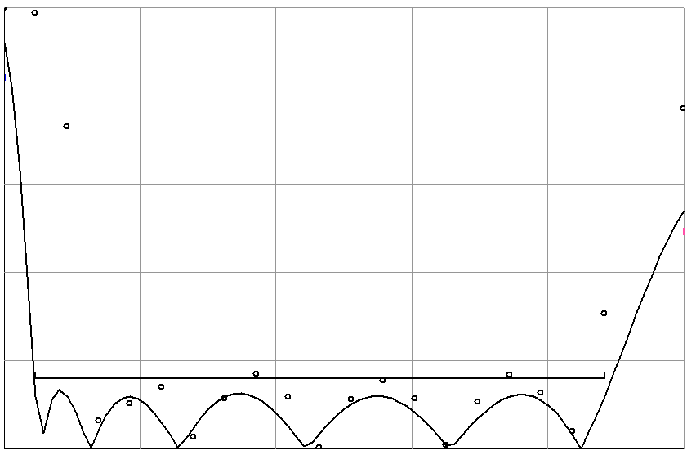
5.20
6.06
6.92
7.78
8.64
9.50
frequency (GHz)
0
0.2
0.4
0.6
0.8
1.0
⏐S_{11⏐}

the initial fine model response
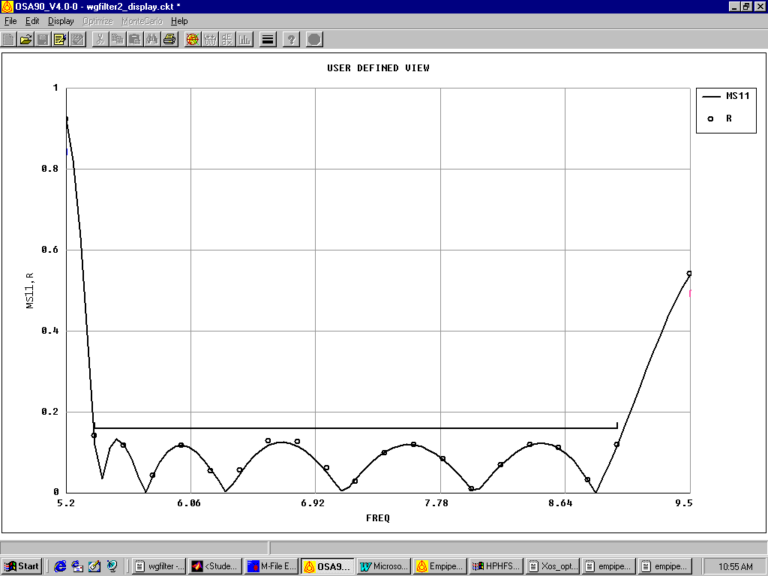
5.20
6.06
6.92
7.78
8.64
9.50
0
0.2
0.4
0.6
0.8
1.0
frequency (GHz)
⏐S_{11⏐}

the second phase design
Example: The Six-Section H-plane Waveguide Transformer

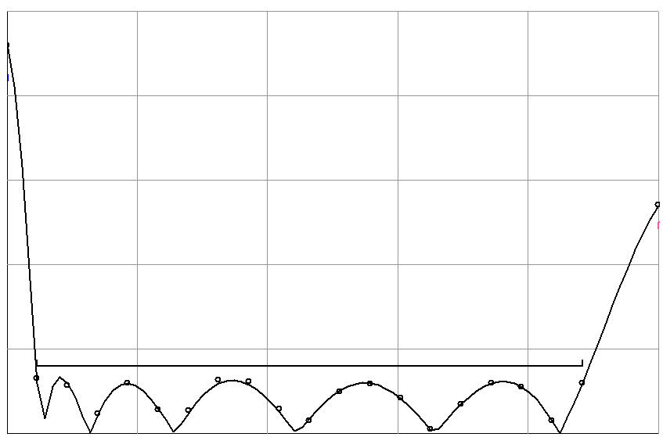
5.20
6.06
6.92
7.78
8.64
9.50
frequency (GHz)
0
0.2
0.4
0.6
0.8
1.0
⏐S_{11⏐}

the optimal fine model design

Example: The Seven-Section Waveguide Transformer
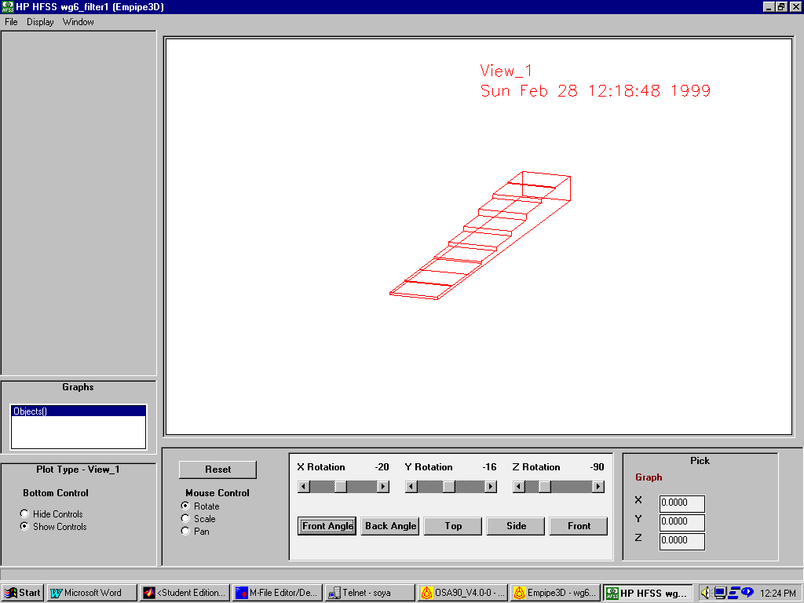
design specifications are
VSWR ≤ 1.01 for 1.08 GHz ≤ f ≤ 1.8 GHz

designable parameters for this problem are the height and length of each waveguide section

the fine model is simulated using HP HFSS through HP Empipe3D

the coarse model is an analytical model which neglects the junction discontinuity

the first executed three successful iterations that required six fine model simulations

the second phase executed four iterations

the convergence of this problem is also smooth as the fine model response obtained at the end of the first phase is similar to the optimal fine model response
Example: The Seven-Section Waveguide Transformer

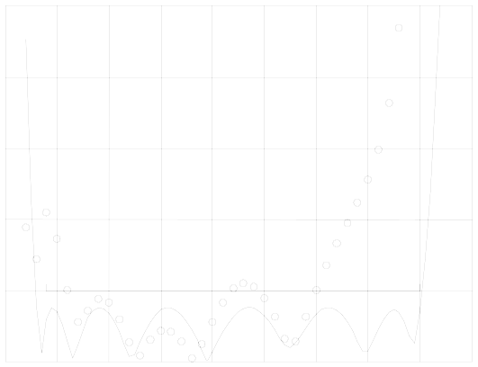
1.0
1.1
1.2
1.3
1.4
1.5
1.6
1.7
1.8
1.9
frequency (GHz)
1.00
1.01
1.02
1.03
1.04
1.05
VSWR

initial design of the fine model

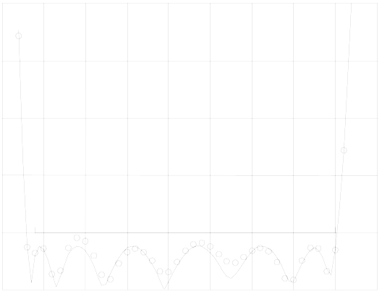
1.0
1.1
1.2
1.3
1.4
1.5
1.6
1.7
1.8
1.9
frequency (GHz)
1.00
1.01
1.02
1.03
1.04
1.05
VSWR

first phase design

Example: The Seven-Section Waveguide Transformer

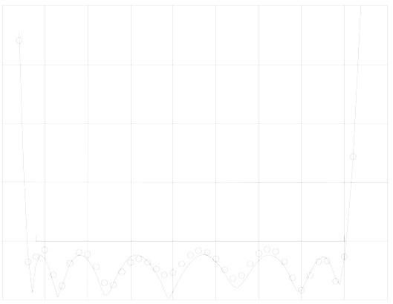
1.0
1.1
1.2
1.3
1.4
1.5
1.6
1.7
1.8
1.9
frequency (GHz)
1.00
1.01
1.02
1.03
1.04
1.05
VSWR

second phase design

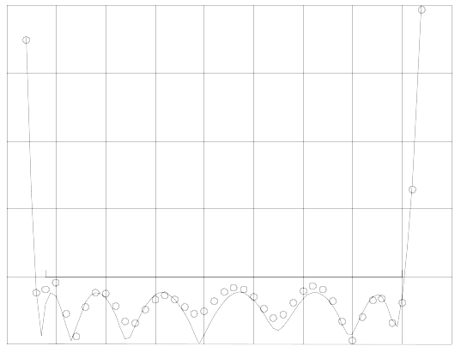
1.0
1.1
1.2
1.3
1.4
1.5
1.6
1.7
1.8
1.9
frequency (GHz)
1.00
1.01
1.02
1.03
1.04
1.05
VSWR

optimal fine model design

