DESIGN OF A BALANCED MICROSTRIP
FILTER

J.W. Bandler, M.H. Bakr, C.E. Falt and N. Georgieva

SOS-99-4-R
February 1999
(Revised June 1999)

© J.W. Bandler, M.H. Bakr, C.E. Falt and N. Georgieva 1999
No part of this document may be copied, translated, transcribed or entered in any form into any machine without written permission. Address inquiries in this regard to Dr. J.W. Bandler. Excerpts may be quoted for scholarly purposes with full acknowledgment of source. This document may not be lent or circulated without this title page and its original cover.
Design of a Balanced Microstrip Filter

J.W. Bandler, M.H. Bakr, C.E. Falt∗ and N. Georgieva

Simulation Optimization Systems Research Laboratory
Department of Electrical and Computer Engineering
McMaster University, Hamilton, Canada L8S 4K1

∗Nortel
Advanced High Speed Projects, Nortel Networks
P.O.Box 3511 Station C, Ottawa, Canada K1Y 4H7

Introduction

Conventional microstrip-line filters, consisting of parallel open-end microstrip-line sections [1], have excessive radiation losses at millimeter-wave frequencies. There are two general types of microwave transmission structures, which would provide similar filtering properties but with reduced radiation losses: the coplanar type and the balanced microstrip type. A novel structure, which can be used to construct bandpass filters at millimeter-wave frequencies, was proposed by Chris Falt in 1996 [2]. Due to the odd mode of operation, the field is concentrated in the slot between the microstrip lines of each balanced section. The length of each balanced section (resonator) should be approximately equal to a half-wavelength of the wave propagating along the balanced line. In a manner similar to conventional microstrip filters, each balanced section is coupled to its neighbors and the coupling is of crucial importance to the relative bandwidth and the shape of the filtering response. The electromagnetic coupling is realized by partially inserting the narrower balanced-line section into the broader one.

Design Specifications

Fig. 1. The balanced microstrip filter: general geometry and parameter notation.

Passband specifications are |S₂₁| 0.987 (-0.108 dB) for 27.625 GHz f 28.375 GHz.

Stopband specifications are |S₂₁| 0.25 for f 27.2 GHz and f 28.8 GHz.

Relative bandwidth is 2.68 %.

Port impedance at both differential ports is Z₀=100 Ω.

This design is developed for a substrate of height h=10 mil and a relative dielectric constant ε_{r}=2.2.

The optimized parameters are s_{c,} l_{in}, l_{s1}, l_{s2}, l_{clb} and l_{cln}.

The two parameters w and s₀ are both fixed at 5 mil.

The Nominal Structure

The nominal design corresponds to the optimization variable values given in Table I.

TABLE I
NOMINAL VALUES OF THE OPTIMIZED PARAMETERS
OF THE MICROSTRIP BALANCED FILTER

Parameter | Value (mil)
s_{c}  l_{in}  l_{s1}  l_{s2}  l_{clb}  l_{cln} | 5  50  50  7.2  100  147

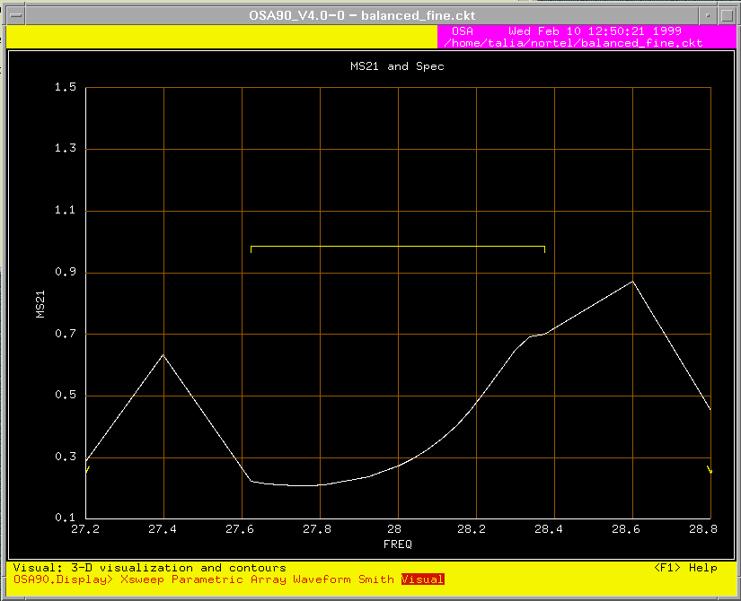
Fig. 2. The fine model |S₂₁| response for the nominal set of parameters.

The nominal values above were obtained by preliminary calculations based on the analogy between a section of two coupled microstrip lines and a section of two coupled coupled-microstrip lines. The preliminary frequency sweep of the structure (using Sonnet’s em™ [5]) showed that a direct optimization would be a very slow and troublesome approach because of the considerable CPU time requirements and because the initial filter response was very far from the optimization specifications (see Fig. 2).

Design Stages

It was established that the structure is very sensitive to small perturbations of the optimized lengths, which required further decrease of the mesh size in the longitudinal (x-axis) direction. Finally, a fine model was built for analysis with Sonnet’s em™ [5] with a discretization step along the x-axis Δx=0.5 mil, and along the y-axis Δy=1.25 mil.

Two intermediate steps were taken in order to arrive faster to a better starting point for direct optimization of the fine Sonnet’s em™ model using Empipe [6]. First, a very coarse model was built in OSA90 [7]. It is entirely based on the microwave circuit-element library. It is very fast but the results of the optimization cannot be considered accurate enough. Its optimal solution was then used as a starting point for a better model, which included full wave simulation (Sonnet’s em™) only of the four-line sections, each of which is viewed as an eight-port network. The rest of the filter uses the built-in microstrip coupled line model. This model is reasonably fast but its results might still be somewhat inaccurate, because of possible unaccounted coupling along the x-axis, and, because of possible inaccuracy of the OSA90 built-in coupled-line model at frequencies above 10 GHz. Finally, a fine model was built for optimization with Empipe [6].

The Coarse Model

Fig. 3. The equivalent circuit used as a very coarse approximation of the odd mode of a section of two coupled coupled-microstrip lines.

The coarse model is an equivalent circuit, which uses the built-in coupled microstrip line model of OSA90 and Walker’s formulas [3] to represent the four-line sections of the filter. The netlist file is given in the Appendix. To understand the model better, the following guidelines can be given. The filter includes four four-line sections, which are two by two identical. The two four-line sections are defined as subcircuits in the netlist file: c_lines_1 and c_lines_2. The difference between them is only in their length. The subcircuits correspond to the circuit topology shown in Fig. 3.

It is important to mention that the equivalent circuit is relevant in the odd-mode case, where push-pull feed is applied at ports 1-4, 2-3, 5-8 and at 6-7. Thus, the equivalent circuit of Fig. 3 represents two coupled coupled-line sections operating in an odd mode.

The inductances L_{m} [H] and the capacitances C_{m} [F] are calculated by making use of the inductance per unit length L_{m1} [H/m] and the capacitance per unit length C_{m1} [F/m] of Walker’s formulas [3], [4].

The Initial Response of the Microstrip Balanced Filter Coarse Model

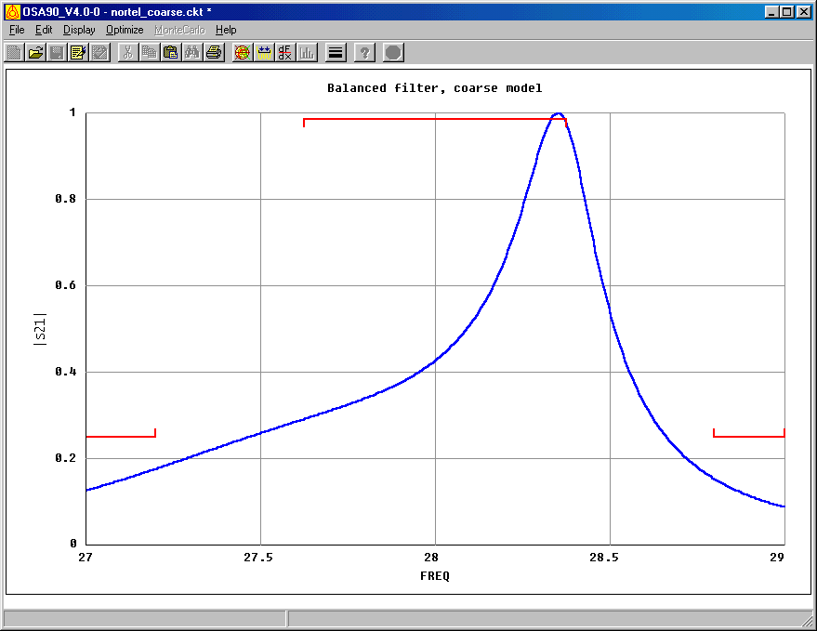The coarse model response at the starting point (corresponding to the nominal values in Table I) is shown in Fig. 4.

Fig. 4. The coarse model |S₂₁| response at the starting point (the nominal values).

The Coarse Model Optimized Response

The response after the minimax optimization (see Fig. 5) satisfies the optimization goals with a maximum error of –0.0050606. The solution is not unique and it was established that at least two local minima represent good designs (exceeding the design specifications). The optimized parameter values corresponding to the response in Fig. 5 are given in Table II.

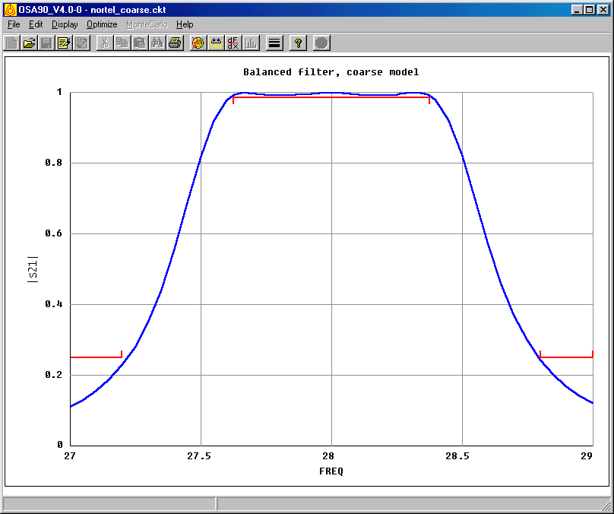
Fig. 5. |S₂₁| response of the coarse model after the minimax optimization.

TABLE II
PARAMETER VALUES OF THE COARSE MODEL

Parameter | Before optimization (mil) | After optimization (mil)
s_{c} | 5 | 4.9788
l_{in} | 50 | 75.2859
l_{s1} | 50 | 40.7028
l_{s2} | 7.2 | 8.76555
l_{clb} | 100 | 105.769
l_{cln} | 147 | 146.721

Refining the Coarse Model

The optimized coarse model solution was used as a starting point in the optimization of a refined coarse model, where the four-line sections are simulated by Sonnet’s em™. The corresponding Empipe nominal project is shown in Fig. 6.



Fig. 6. A four-line structure used in the refined coarse model to replace the equivalent circuit shown in Fig. 3.

Optimization of the Refined Coarse Model

The response after a minimax optimization (max error is –0.00146344) still slightly exceeds the specifications (see Fig. 7).

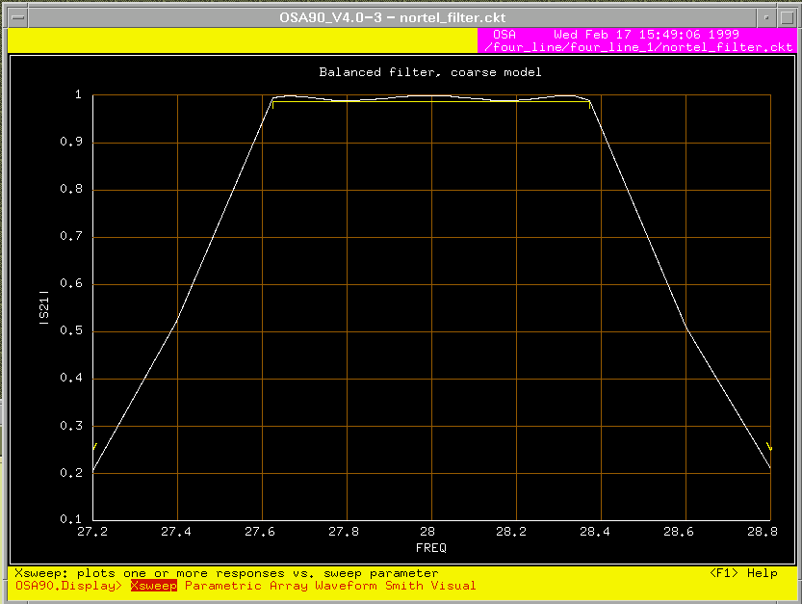

Fig. 7. |S₂₁| response of the refined coarse model after optimization.

The optimization parameter values, before and after the minimax optimization, are given in Table III.

TABLE III
PARAMETER VALUES OF THE REFINED COARSE MODEL

Parameter | Before optimization (mil) | After optimization (mil)
s_{c}  l_{in}  l_{s1}  l_{s2}  l_{clb}  l_{cln} | 4.9788  75.2859  40.7028  8.76555  105.769  146.721 | 4.9997  44.9983  47.9997  5.72307  98.1461  147.622

The Fine Model

The Empipe project for direct full electromagnetic optimization of the whole filter is the final stage of this design. The nominal Empipe project is shown in Fig. 8.

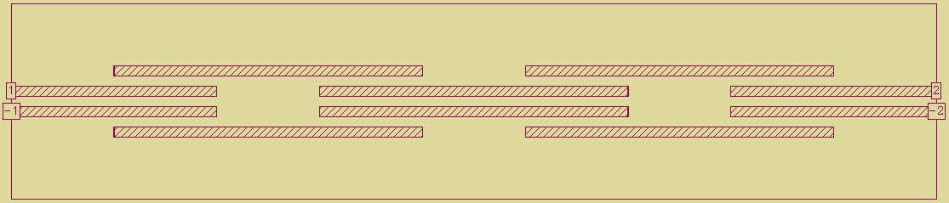

Fig. 8. Nominal project for geometry capture of the microstrip balanced filter structure with Empipe.

The respective perturbed projects are seen in Fig. 9. The optimized parameters correspond to the notation in Fig. 1.

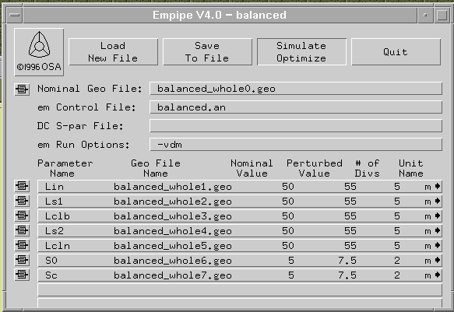

Fig. 9. Geometry capture editor in Empipe and optimization setup of the balanced filter project.

The parameters obtained from the optimized refined course model are used as a starting point for the fine model. The response of the filter at this starting point is given in Fig. 10. The response after optimization is given in Fig. 11. Fig. 12 shows the reflection loss and the insertion loss in dB after optimization.

The minimax error, after the optimization is completed, is 0.00065.
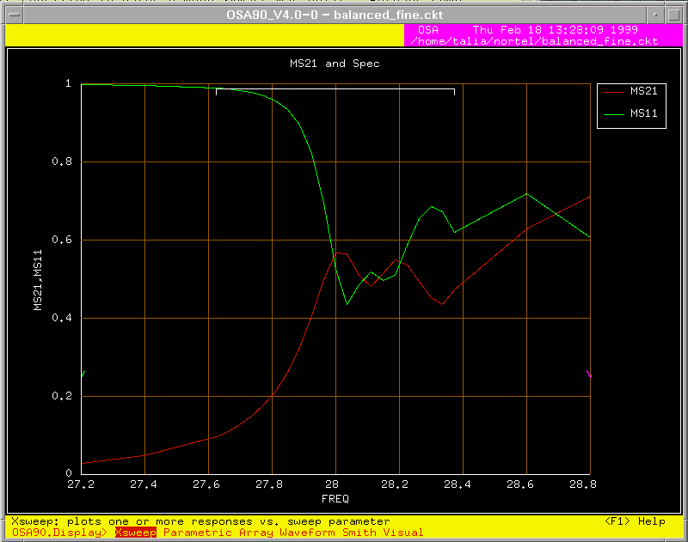

Fig. 10. |S₂₁| and |S₁₁| responses of the fine model of the balanced filter at the starting point of optimization.

The optimization parameter values, before and after the minimax optimization of the fine model, are given in Table IV.

TABLE IV

PARAMETER VALUES OF THE FINE MODEL

Parameter | Before optimization (mil) | After optimization (mil)
s_{c}  l_{in}  l_{s1}  l_{s2}  l_{clb}  l_{cln} | 4.99970  44.9983  47.9997  5.72307  98.1461  147.622 | 5.00000  43.5776  48.9889  5.99988  101.996  149.618

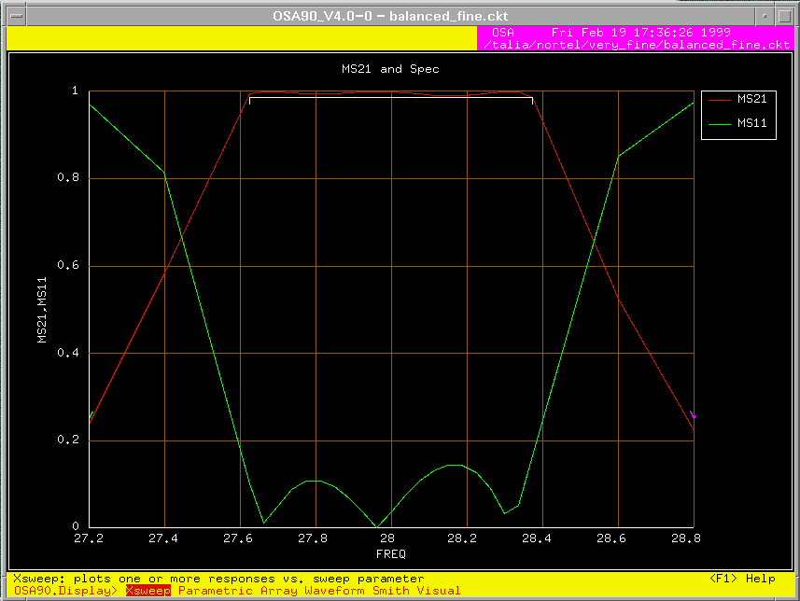

Fig. 11. |S₂₁| and |S₁₁| responses of the fine model of the balanced filter after the optimization is completed.

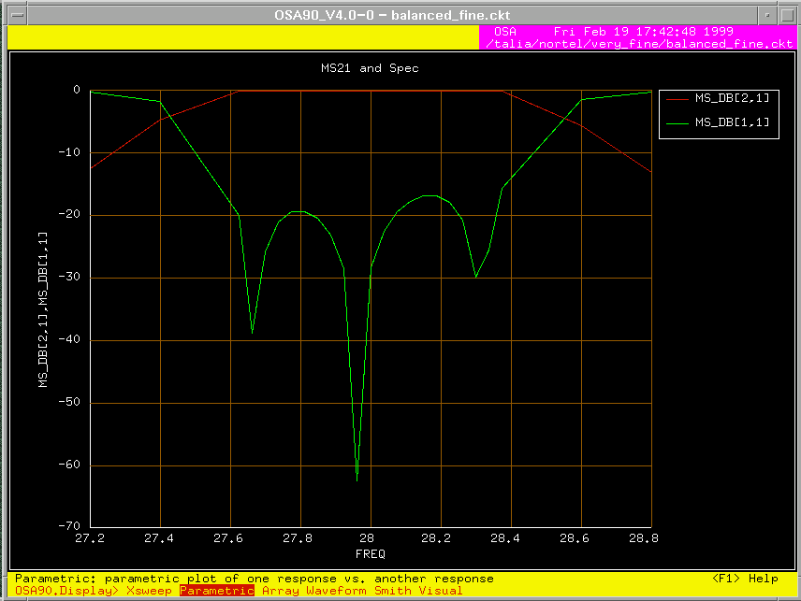

Fig. 12. |S₂₁| and |S₁₁| responses in dB of the fine model of the balanced filter after the optimization is completed.

The numerical values corresponding to the optimal solution in Fig. 11 and in Fig. 12 are presented below.

Lin= 43.57760
Ls1= 48.98890
Lclb= 101.99600
Ls2= 5.99988
Lcln= 149.61800
Sc= 5.00000

FREQ MS21 MS11 MS21,dB MS11,dB

27.20000 0.23728 0.97144 -12.49461 -0.25168
27.40000 0.57960 0.81491 -4.73745 -1.77783
27.62500 0.99487 0.10120 -0.04470 -19.89652
27.66250 0.99994 0.01155 -0.00055 -38.74694
27.70000 0.99868 0.05124 -0.01145 -25.80727
27.73750 0.99597 0.08972 -0.03508 -20.94254
27.77500 0.99420 0.10754 -0.05051 -19.36869
27.81250 0.99415 0.10817 -0.05100 -19.31792
27.85000 0.99551 0.09475 -0.03908 -20.46853
27.88750 0.99751 0.07019 -0.02163 -23.07415
27.92500 0.99927 0.03788 -0.00630 -28.43144
27.96250 0.99999 0.00075 -0.00007 -62.44584
28.00000 0.99927 0.03796 -0.00638 -28.41458
28.03750 0.99721 0.07486 -0.02429 -22.51517
28.07500 0.99427 0.10693 -0.04989 -19.41773
28.11250 0.99137 0.13103 -0.07525 -17.65285
28.15000 0.98951 0.14446 -0.09159 -16.80526
28.18750 0.98952 0.14437 -0.09149 -16.81017
28.22500 0.99170 0.12801 -0.07238 -17.85510
28.26250 0.99582 0.09163 -0.03639 -20.75902
28.30000 0.99942 0.03238 -0.00501 -29.79314
28.33750 0.99846 0.05279 -0.01342 -25.54861
28.37500 0.98635 0.16537 -0.11934 -15.63065
28.60000 0.52544 0.85075 -5.58956 -1.40393
28.80000 0.22339 0.97473 -13.01889 -0.22232

Conclusion

The design of a balanced microstrip filter through the consecutive implementation of three types of models is described in this report. The following conclusions can be made with regard to those models:

the empirical formulas [3], [4], used to build the equivalent-circuit coarse model, are inaccurate at the frequency band of operation (27 GHz f 29 GHz);

the structure is very sensitive to changes of all optimized lengths (l_{in}, l_{s1}, l_{s2}, l_{clb} and l_{cln});

very fine mesh size (0.5 mil) along the x-axis (longitudinal axis) is recommended for the fine model (Empipe), for the simulation results to be trusted within an error of 10%.
References

[1] S. B. Cohn, “Parallel-coupled transmission-line-resonator filters,” IRE Trans. Microwave Theory Tech., vol. MTT-6, pp. 223-231, 1958.

[2] C. E. Falt, Low Radiation Balanced Microstrip Bandpass Filter, United States Patent, Patent Number 5825263.

[3] C. S. Walker, Capacitance, Inductance and Crosstalk Analysis. Norwood, MA: Artech House, 1990.

[4] J. W. Bandler and J. E. Rayas-Sánchez, “Interconnect crosstalk minimization: an alternative route,” Simulation Optimization Systems Research Laboratory, McMaster University, Hamilton, Canada, Report SOS-98-8-R, April 1998, Appendix A.

[5] em™, Version 4.0b, Sonnet Software, Inc., 1020 Seventh North Street, Suite 210, Liverpool, NY 13088, 1997.

[6] Empipe™ Version 4.0, formerly Optimization Systems Associates Inc., P.O. Box 8083, Dundas, Ontario, Canada L9H 5E7, 1997, now HP EEsof Division, Hewlett-Packard Company, 1400 Fountaingrove Parkway, Santa Rosa, CA 95403-1799.

[7] OSA90/hope™ Version 4.0, formerly Optimization Systems Associates Inc., P.O. Box 8083, Dundas, Ontario, Canada L9H 5E7, now HP EEsof Division, Hewlett-Packard Company, 1400 Fountaingrove, Parkway, Santa Rosa, CA 95403-1799.

Appendix

! Example nortel_filter.ckt
! Sun Feb 7 14:03:23 1999. Minimax Optimizer. 47 Iterations. 00:01:56 CPU.

Expression
MILMM=0.0254; ! mil -> mm
VL=2.99792458; ! velocity of light,*1e+11 mm/s
MU0=4*PI*1e-10; ! H/mm
EPS0=1/(4*PI*(VL^2)); ! pF/mm

fmin=(27*1GHz);fmax=(29*1GHz);fstep=(0.005*1GHz);

ER=2.2;
WW=5;HSUB=10; ! mils

S0=5; ! mil
SC=? 1.5 5.05628 20?;
SCL=S0+2*(SC+WW);
D=S0+WW;

Lin: ?74.9411? ;
LS1: ?41.2024?;
LS2: ?8.8507?;
LCLB: ?104.238?;
LCLN: ?145.86?;

WS=(WW*1mil);HS=(HSUB*1mil);
QLS1=(0.25*LS1*1mil);
QLS2=(0.25*LS2*1mil);
HLS1=(0.5*LS1*1mil);
HLS2=(0.5*LS2*1mil);
! effective dielectric constant, infinitesimally thin strip, non-dispersive
WOH=WW/HSUB;
A=1+LOG((WOH^4+(WOH/52)^2)/(WOH^4+0.432))/49+LOG(1+(WOH/18.1)^3)/18.7;
B=0.564*((ER-0.9)/(ER+3))^0.053;
EREF=0.5*(ER+1)+0.5*(ER-1)*((1+10/WOH)^(-A*B));
! mutual capacitance/unit lenght
Z0: if (WOH <= 1) (60*LOG(8/WOH+WOH/4))
else (120*PI/(WOH+2.42-0.44/WOH+(1-1/WOH)^6));
KL=120*PI/(Z0*WOH);
KC=KL*(EREF/ER);

CM0=(EPS0*ER/(4*PI))*KC*KL*(WOH^2)*LOG(1+(2*HSUB/S0)^2); ! pF/mm
CMC=(EPS0*ER/(4*PI))*KC*KL*(WOH^2)*LOG(1+(2*HSUB/SC)^2); ! pF/mm

C0S1=CM0*(HLS1*MILMM)*1e-3; ! nF -> HLS1
C0S2=CM0*(HLS2*MILMM)*1e-3; ! nF -> HLS2
CCS1=CMC*(HLS1*MILMM)*1e-3; ! nF -> HLS1
CCS2=CMC*(HLS2*MILMM)*1e-3; ! nF -> HLS2
! mutual inductance/unit length
LM0=0.1*LOG(1+(2*HSUB/D)^2); ! nH/mm
LM1=LM0*(HLS1*MILMM); ! nH -> HLS1
LM2=LM0*(HLS2*MILMM); ! nH => HLS2
End

Model
SUBCIRCUIT c_clines_1 1 2 3 4 5 6 7 8 0 {
MSUB EPSR=ER H=HS;
IND 2 21 L=(-LM1*1nH);
MSCL 1 21 10 9 W=WS L=QLS1 S=(SC*1mil);
MSCL 9 10 14 13 W=WS L=QLS1 S=(SC*1mil);
MSCL 13 14 18 17 W=WS L=QLS1 S=(SC*1mil);
MSCL 17 18 23 8 W=WS L=QLS1 S=(SC*1mil);
IND 7 23 L=(-LM1*1nH);

IND 3 22 L=(-LM1*1nH);
MSCL 22 4 12 11 W=WS L=QLS1 S=(SC*1mil);
MSCL 11 12 16 15 W=WS L=QLS1 S=(SC*1mil);
MSCL 15 16 20 19 W=WS L=QLS1 S=(SC*1mil);
MSCL 19 20 5 24 W=WS L=QLS1 S=(SC*1mil);
IND 6 24 L=(-LM1*1nH);

CAP 10 11 C=(C0S1*1nF);
CAP 10 0 C=(-C0S1*1nF);
CAP 11 0 C=(-C0S1*1nF);
CAP 18 19 C=(C0S1*1nF);
CAP 18 0 C=(-C0S1*1nF);
CAP 19 0 C=(-C0S1*1nF);
};
SUBCIRCUIT c_clines_2 1 2 3 4 5 6 7 8 0 {
MSUB EPSR=ER H=HS;
IND 2 21 L=(-LM2*1nH);
MSCL 1 21 10 9 W=WS L=QLS2 S=(SC*1mil);
MSCL 9 10 14 13 W=WS L=QLS2 S=(SC*1mil);
MSCL 13 14 18 17 W=WS L=QLS2 S=(SC*1mil);
MSCL 17 18 23 8 W=WS L=QLS2 S=(SC*1mil);
IND 7 23 L=(-LM2*1nH);

IND 3 22 L=(-LM2*1nH);
MSCL 22 4 12 11 W=WS L=QLS2 S=(SC*1mil);
MSCL 11 12 16 15 W=WS L=QLS2 S=(SC*1mil);
MSCL 15 16 20 19 W=WS L=QLS2 S=(SC*1mil);
MSCL 19 20 5 24 W=WS L=QLS2 S=(SC*1mil);
IND 6 24 L=(-LM2*1nH);

CAP 10 11 C=(C0S2*1nF);
CAP 10 0 C=(-C0S2*1nF);
CAP 11 0 C=(-C0S2*1nF);
CAP 18 19 C=(C0S2*1nF);
CAP 18 0 C=(-C0S2*1nF);
CAP 19 0 C=(-C0S2*1nF);
};

MSUB EPSR=ER H=HS;
MSCL 1 2 5 4 W=WS L=(Lin*1mil) S=(S0*1mil);
MOPEN 3 W=WS L=0.5mil;
MOPEN 6 W=WS l=0.5mil;
c_clines_1 3 4 5 6 7 8 9 10;
MOPEN 8 W=WS L=0.5mil;
MOPEN 9 W=WS L=0.5mil;
MSCL 10 7 14 11 W=WS L=(LCLB*1mil) S=(SCL*1mil);
MOPEN 12 W=WS L=0.5mil;
MOPEN 13 W=WS L=0.5mil;
c_clines_2 11 12 13 14 15 16 17 18;
MOPEN 15 W=WS L=0.5mil;
MOPEN 18 W=WS L=0.5mil;
MSCL 17 16 21 20 W=WS L=(LCLN*1mil) S=(S0*1mil);
MOPEN 19 W=WS L=0.5mil;
MOPEN 22 W=WS L=0.5mil;
c_clines_2 19 20 21 22 23 24 25 26;
MOPEN 24 W=WS L=0.5mil;
MOPEN 25 W=WS L=0.5mil;
MSCL 26 23 30 27 W=WS L=(LCLB*1mil) S=(SCL*1mil);
MOPEN 28 W=WS L=0.5mil;
MOPEN 29 W=WS L=0.5mil;
c_clines_1 27 28 29 30 31 32 33 34;
MOPEN 31 W=WS L=0.5mil;
MOPEN 34 W=WS L=0.5mil;
MSCL 33 32 36 35 W=WS L=(Lin*1mil) S=(S0*1mil);

PORT 1 2 R=100 X=0;
PORT 35 36 R=100 X=0;

CIRCUIT;

MS21_DB: 20 * LOG10(MS21);
MS11_DB: 20 * LOG10(MS11);
end

Sweep
AC: FREQ: from 27GHz to 27.6GHz STEP=0.05GHz
from 27.625GHz to 28.375GHz step=0.03GHz
from 28.38GHz to 29GHz step=0.05GHz
MS21 MS MS21_dB MS11_dB
{Xsweep Title="Balanced filter, coarse model"
Y=MS21.white Y_title="|S21|" Xmin=27 Ymax=1 ! NXticks=15
SPEC=(from 27 to 27.2, < 0.25).yellow &
(from 27.625 to 28.375, > 0.987).yellow &
(from 28.8 to 29, < 0.25).yellow};
end

Spec
AC: FREQ: from 27.625GHz to 28.375GHz step=0.03GHz MS21 > 0.987;
AC: FREQ: from 27GHz to 27.2GHz step=0.05GHz MS21 < 0.25;
AC: FREQ: from 28.8GHz to 29GHz step=0.05GHz MS21 < 0.25;

! AC: FREQ: 27.675GHz 28GHz 28.325GHz MS11=0 W=0.5;
! AC: FREQ: from 27.625GHz to 28.375GHz step=FSTEP MS11 < 0.16
end

Control
Allow_Neg_Parameters
end

Report
R=[ ${ $FREQ$ $MS21_DB$ }$ ];
End

