ACCELERATED OPTIMIZATION OF
MIXED EM/CIRCUIT STRUCTURES

J.W. Bandler, M.H. Bakr and J.E. Rayas-Sánchez

SOS-99-8-V

March 1999

© J.W. Bandler, M.H. Bakr and J.E. Rayas-Sánchez 1999

No part of this document may be copied, translated, transcribed or entered in any form into any machine without written permission. Address enquiries in this regard to Dr. J.W. Bandler. Excerpts may be quoted for scholarly purposes with full acknowledgement of source. This document may not be lent or circulated without this title page and its original cover.
ACCELERATED OPTIMIZATION OF MIXED EM/CIRCUIT STRUCTURES

J.W. Bandler, M.H. Bakr and J.E. Rayas-Sánchez

Simulation Optimization Systems Research Laboratory
and Department of Electrical and Computer Engineering
McMaster University, Hamilton, Canada L8S 4K1

bandler@mcmaster.ca
www.sos.mcmaster.ca

presented at

WORKSHOP ON ADVANCES IN MIXED ELECTROMAGNETIC FIELD AND CIRCUIT SIMULATION

1999 IEEE MTT-S Int. Microwave Symposium, Anaheim, CA, June 18, 1999
ACCELERATED OPTIMIZATION OF MIXED EM/CIRCUIT STRUCTURES

J.W. Bandler, M.H. Bakr and J.E. Rayas-Sánchez

Simulation Optimization Systems Research Laboratory
and Department of Electrical and Computer Engineering
McMaster University, Hamilton, Canada L8S 4K1

bandler@mcmaster.ca
www.sos.mcmaster.ca

Abstract

We review recent developments in Space Mapping (SM) optimization. The Aggressive Space Mapping (ASM) technique is illustrated through a step-by-step numerical example based on the Rosenbrock function. The Trust Region Aggressive Space Mapping (TRASM) algorithm is described. TRASM integrates a trust region methodology with the ASM technique. It improves the uniqueness of the extraction phase by utilizing a recursive multi-point parameter extraction process. The algorithm is illustrated by the design of an HTS filter using Sonnet’s em. The new Hybrid Aggressive Space Mapping (HASM) algorithm is briefly reviewed. It is based on a novel lemma that enables smooth switching from SM optimization to direct optimization if SM is not converging. It is illustrated by the design of a six-section H-plane waveguide filter.
Basic Concepts of Space Mapping
(Bandler et al., 1993, 1994)

it is assumed that the circuit to be designed can be simulated using two models: a “fine” model and a “coarse” model

the fine model is accurate but computationally intensive

$x_{f}$ is the vector of fine model design parameters

the coarse model is fast but less accurate

$x_{c}$ is the vector of coarse model design parameters

Space Mapping aims at avoiding the computationally intensive direct optimization of the fine model by iteratively developing a mapping between$x_{f}$and $x_{c}$

we present illustrations and progress to date on this exciting concept applied to accelerated optimization of mixed EM/circuit structures

Aggressive Space Mapping (ASM) Concept

An Aggressive Space Mapping (ASM) Algorithm
(Bandler et al., 1995)

the initial fine model design is taken as $x_{c}^{}$

x_{f,1}
x_{f,2}
x_{c,1}
x_{c,2}
$$x_{c}^{}$$
x_{c}⁽¹⁾
$$x_{f}^{(1)}$$
$$x_{f}^{(2)}$$

at the jth iteration

$$x_{f}^{(j+1)}=x_{f}^{(j)}+h^{(j)}$$

$h^{(j)}$ is obtained by solving

$$B^{(j)}h^{(j)}=−f(x_{f}^{(j)})$$
where
$$f=x_{c}^{(j)}−x_{c}^{}$$

and $x_{c}^{(j)}$ is obtained through parameter extraction
ASM Algorithm

Step 0. Initialize $x_{f}^{(1)} = x_{c}^{}$, $B^{(1)} = 1$, $j = 1$.
Step 1. Evaluate $R_{f}(x_{f}^{(1)})$.
Step 2. Extract $x_{c}^{(1)}$ such that $R_{c}(x_{c}^{(1)}) ≈ R_{f}(x_{f}^{(1)})$.
Step 3. Evaluate $f^{(1)} = x_{c}^{(1)} − x_{c}^{}$. Stop if $\left\|f^{(1)}\right\| ≤ η$.
Step 4. Solve $B^{(j)} h^{(j)} = −f^{(j)}$ for $h^{(j)}$.
Step 5. Set $x_{f}^{(j+1)} = x_{f}^{(j)} +h^{(j)}$.
Step 6. Evaluate $R_{f}(x_{f}^{(j+1)})$.
Step 7. Extract $x_{c}^{(j+1)}$ such that $R_{c}(x_{c}^{(j+1)}) ≈ R_{f}(x_{f}^{(j+1)})$.
Step 8. Evaluate $f^{(j+1)} = x_{c}^{(j+1)} − x_{c}^{}$. Stop if $\left\|f^{(j+1)}\right\| ≤ η$.
Step 9. Update $B^{(j+1)} = B^{(j)}+\frac{f^{(j+1)}h^{{(j)}^{T}}}{h^{{(j)}^{T}}h^{(j)}}$.
Step 10. Set $j = j+1$; go to Step 4.
Parameter Extraction

single point parameter extraction aims at matching the responses of both models at a single point
x_{f,1}
x_{f,2}
x_{c,1}
x_{c,2}
R_{c}
R_{f}
x_{f}
x_{c}

it can be formulated as

$$\underset{x_{c}}{\text{minimize}}\left\|R_{f}(x_{f}^{})−R_{c}(x_{c}^{})\right\|$$

multi-point parameter extraction aims at simultaneously matching the responses at a number of corresponding points
x_{f,1}
x_{f,2}
x_{c,1}
x_{c,2}
x_{f}
V
x_{c}
B

the extracted parameters should satisfy

$$R_{c}(x_{c}+B^{}(x−x_{f}))=R_{f}(x)$$

simultaneously for a set of points $x∈V$
Coarse Model Example: Rosenbrock Function
$R_{c} (x) = \text{100} (x_{2} − x_{1}^{2})^{2} + (1−x_{1})^{2}$ , where $x = \left[\begin{matrix}x_{1} \\ x_{2}\end{matrix}\right]$
$$x_{c}^{} = \left[\begin{matrix}1 \\ 1\end{matrix}\right]$$

$$R_{c}^{} = R_{c} (x_{c}^{}) = 0$$
Fine Model : Shifted Rosenbrock Function
$R_{f} (x) = \text{100} (u_{2} − u_{1}^{2})^{2} + (1−u_{1})^{2}$ where $u = \left[\begin{matrix}u_{1} \\ u_{2}\end{matrix}\right] = x + \left[\begin{matrix}−0\text{.}2 \\ +0\text{.}2\end{matrix}\right]$

Multi-Point Parameter Extraction

we minimize a parameter extraction objective function ${\left\|E\right\|}_{p}$
considering five matching points, with error functions

$$E_{i}=R_{c} (x+B^{(j)}{Δx}_{i}) − R_{f} (x_{c}^{}+{Δx}_{i})$$
where

${Δx}_{1} = \left[\begin{matrix}0 \\ 0\end{matrix}\right]$, ${Δx}_{2} = \left[\begin{matrix}0 \\ 0\text{.}5\end{matrix}\right]$, ${Δx}_{3} = \left[\begin{matrix}0\text{.}5 \\ 0\end{matrix}\right]$, ${Δx}_{4} = \left[\begin{matrix}0\text{.}5 \\ −0\text{.}5\end{matrix}\right]$, ${Δx}_{5} = \left[\begin{matrix}−0\text{.}5 \\ −0\text{.}5\end{matrix}\right]$

since the matrix $B^{(j)} = 1$ for the first parameter extraction optimization, the corresponding five error functions are taken as

$$E_{i} =R_{c} (x+{Δx}_{i}) − R_{f} (x_{c}^{}+{Δx}_{i})$$

considering only $l_{1}$and $l_{2}$ norms, the corresponding objective functions can be taken as

$${\text{ABS}}_{n} = \left|E_{1}\right| + \left|E_{2}\right| + … +\left|E_{n}\right|$$
$${\text{SQR}}_{n} = (E_{1})^{2} + (E_{2})^{2} + … +(E_{n})^{2}$$
l₁ Objective Function for the Parameter Extraction Problem
single point parameter extraction
$$x_{c}^{(1)} = \left[\begin{matrix}0\text{.}8 \\ 1\text{.}2\end{matrix}\right]$$
multi-point parameter extraction (with 4 additional points)
l₂ Objective Function for the Parameter Extraction Problem
single point parameter extraction
$$x_{c}^{(1)} = \left[\begin{matrix}0\text{.}8 \\ 1\text{.}2\end{matrix}\right]$$
multi-point parameter extraction (with 4 additional points)
Space Mapping Solution Process

Step 0. $x_{f}^{(1)} = \left[\begin{matrix}1 \\ 1\end{matrix}\right]$, $B^{(1)} = 1$, $j = 1$
Step 1. $R_{f}(x_{f}^{(1)}) = \text{31}\text{.}4$
Step 2. When $x_{c}^{(1)} = \left[\begin{matrix}0\text{.}8 \\ 1\text{.}2\end{matrix}\right]$, $R_{c}(x_{c}^{(1)}) = R_{f}(x_{f}^{(1)})$
Step 3. $f^{(1)} = \left[\begin{matrix}0\text{.}8 \\ 1\text{.}2\end{matrix}\right] − \left[\begin{matrix}1 \\ 1\end{matrix}\right] = \left[\begin{matrix}−0\text{.}2 \\ 0\text{.}2\end{matrix}\right]$
Step 4. Since $B^{(1)} = 1$, $h^{(1)} = \left[\begin{matrix}0\text{.}2 \\ −0\text{.}2\end{matrix}\right]$
Step 5. Set $x_{f}^{(2)} = \left[\begin{matrix}1 \\ 1\end{matrix}\right] + \left[\begin{matrix}0\text{.}2 \\ −0\text{.}2\end{matrix}\right] = \left[\begin{matrix}1\text{.}2 \\ 0\text{.}8\end{matrix}\right]$
Step 6. $R_{f}(x_{f}^{(2)}) = 0$
Step 7. $x_{c}^{(2)} = \left[\begin{matrix}1 \\ 1\end{matrix}\right]$, because we know$R_{c}(x_{c}^{(2)}) = 0$
Step 8. Since $f^{(2)} = x_{c}^{(2)} − x_{c}^{} = \left[\begin{matrix}0 \\ 0\end{matrix}\right]$, then ${\bar{x}}_{f} = x_{f}^{(2)} = \left[\begin{matrix}1\text{.}2 \\ 0\text{.}8\end{matrix}\right]$
Fine Model Example: Transformed Rosenbrock Function
$R_{f} (x) = \text{100} (u_{2} − u_{1}^{2})^{2} + (1−u_{1})^{2}$ where $u = \left[\begin{matrix}u_{1} \\ u_{2}\end{matrix}\right] = \left[\begin{matrix}1\text{.}1 & −0\text{.}2 \\ 0\text{.}2 & 0\text{.}9\end{matrix}\right]x + \left[\begin{matrix}−0\text{.}3 \\ 0\text{.}3\end{matrix}\right]$
$$R_{f}(x_{c}^{}) = \text{108}\text{.}\text{32}$$

First l₁ Parameter Extraction
single point parameter extraction
$$x_{c}^{(1)} = \left[\begin{matrix}0\text{.}6 \\ 1\text{.}4\end{matrix}\right]$$
multi-point parameter extraction (with 2 additional points)
First l₂ Parameter Extraction
single point parameter extraction
$$x_{c}^{(1)} = \left[\begin{matrix}0\text{.}6 \\ 1\text{.}4\end{matrix}\right]$$

multiple point parameter extraction (with 2 additional points)

Space Mapping Solution Process

Step 0. $x_{f}^{(1)} = \left[\begin{matrix}1 \\ 1\end{matrix}\right]$, $B^{(1)} = 1$, $j = 1$
Step 1. $R_{f}(x_{f}^{(1)}) = \text{108}\text{.}\text{32}$
Step 2. When $x_{c}^{(1)} = \left[\begin{matrix}0\text{.}6 \\ 1\text{.}4\end{matrix}\right]$, $R_{c}(x_{c}^{(1)}) = R_{f}(x_{f}^{(1)})$
Step 3. $f^{(1)} = \left[\begin{matrix}0\text{.}6 \\ 1\text{.}4\end{matrix}\right] − \left[\begin{matrix}1 \\ 1\end{matrix}\right] = \left[\begin{matrix}−0\text{.}4 \\ 0\text{.}4\end{matrix}\right]$
Step 4. Since $B^{(1)} = 1$, $h^{(1)} = \left[\begin{matrix}0\text{.}4 \\ −0\text{.}4\end{matrix}\right]$
Step 5. Set $x_{f}^{(2)} = \left[\begin{matrix}1 \\ 1\end{matrix}\right] + \left[\begin{matrix}0\text{.}4 \\ −0\text{.}4\end{matrix}\right] = \left[\begin{matrix}1\text{.}4 \\ 0\text{.}6\end{matrix}\right]$
Step 6. $R_{f}(x_{f}^{(2)}) = 1\text{.}\text{8207}$
Step 7. When $x_{c}^{(2)} = \left[\begin{matrix}1\text{.}\text{12} \\ 1\text{.}\text{12}\end{matrix}\right]$, $R_{c}(x_{c}^{(2)}) = R_{f}(x_{f}^{(2)})$

Space Mapping Solution Process (continued)
Step 8. $f^{(2)} = \left[\begin{matrix}1\text{.}\text{12} \\ 1\text{.}\text{12}\end{matrix}\right] − \left[\begin{matrix}1 \\ 1\end{matrix}\right] = \left[\begin{matrix}0\text{.}\text{12} \\ 0\text{.}\text{12}\end{matrix}\right]$
Step 9. $B^{(2)} = B^{(1)}+\frac{f^{(2)}h^{{(1)}^{T}}}{h^{{(1)}^{T}}h^{(1)}} = \left[\begin{matrix}1\text{.}\text{15} & −0\text{.}\text{15} \\ 0\text{.}\text{15} & 0\text{.}\text{85}\end{matrix}\right]$
Step 4b. $h^{(2)} = − B^{{(2)}^{−1}}f^{(2)} =\left[\begin{matrix}−0\text{.}\text{12} \\ −0\text{.}\text{12}\end{matrix}\right]$
Step 5b. Set $x_{f}^{(3)} = \left[\begin{matrix}1\text{.}4 \\ 0\text{.}6\end{matrix}\right] + \left[\begin{matrix}−0\text{.}\text{12} \\ −0\text{.}\text{12}\end{matrix}\right] = \left[\begin{matrix}1\text{.}\text{28} \\ 0\text{.}\text{48}\end{matrix}\right]$
Step 6b. $R_{f}(x_{f}^{(3)}) = 0\text{.}\text{1308}$
Step 7b. When $x_{c}^{(3)} = \left[\begin{matrix}1\text{.}\text{012} \\ 0\text{.}\text{988}\end{matrix}\right]$, $R_{c}(x_{c}^{(3)}) = R_{f}(x_{f}^{(3)})$
Step 8b. $f^{(3)} = \left[\begin{matrix}1\text{.}\text{012} \\ 0\text{.}\text{988}\end{matrix}\right] − \left[\begin{matrix}1 \\ 1\end{matrix}\right] = \left[\begin{matrix}0\text{.}\text{012} \\ −0\text{.}\text{012}\end{matrix}\right]$
Space Mapping Solution Process (continued)
Step 9b. $B^{(3)} = B^{(2)}+\frac{f^{(3)}h^{{(2)}^{T}}}{h^{{(2)}^{T}}h^{(2)}} = \left[\begin{matrix}1\text{.}1 & −0\text{.}2 \\ 0\text{.}2 & 0\text{.}9\end{matrix}\right]$
Step 4c. $h^{(3)} = − B^{{(3)}^{−1}} f^{(3)} =\left[\begin{matrix}−0\text{.}\text{0082} \\ 0\text{.}\text{0151}\end{matrix}\right]$
Step 5c. Set $x_{f}^{(4)} = \left[\begin{matrix}1\text{.}\text{28} \\ 0\text{.}\text{48}\end{matrix}\right] + \left[\begin{matrix}−0\text{.}\text{0082} \\ 0\text{.}\text{0151}\end{matrix}\right] = \left[\begin{matrix}1\text{.}\text{2718} \\ 0\text{.}\text{4951}\end{matrix}\right]$
Step 6c. $R_{f}(x_{f}^{(4)}) = 9\text{.}2×{\text{10}}^{−8}$ , then ${\bar{x}}_{f} = x_{f}^{(4)}$ and we can end the algorithm
Second l₁ Parameter Extraction
single point parameter extraction
$$x_{c}^{(2)} = \left[\begin{matrix}1\text{.}\text{12} \\ 1\text{.}\text{12}\end{matrix}\right]$$
multi-point parameter extraction (4 additional points)
Second l₂ Parameter Extraction
single point parameter extraction
$$x_{c}^{(2)} = \left[\begin{matrix}1\text{.}\text{12} \\ 1\text{.}\text{12}\end{matrix}\right]$$
multi-point parameter extraction (with 4 additional points)
Third Parameter Extraction

$$x_{c}^{(3)} = \left[\begin{matrix}1\text{.}\text{012} \\ 0\text{.}\text{988}\end{matrix}\right]$$
single point l₁ parameter extraction
$$x_{c}^{(3)} = \left[\begin{matrix}1\text{.}\text{012} \\ 0\text{.}\text{988}\end{matrix}\right]$$
single point l₂ parameter extraction

The Trust Region Aggressive Space Mapping (TRASM) Algorithm (Bakr et al., 1998)

TRASM integrates a trust region methodology with ASM

a certain success criterion must be satisfied in each iteration to accept the predicted step

a recursive multi-point parameter extraction procedure is introduced

all available fine model simulations are utilized to improve parameter extraction uniqueness

available mapping information is integrated into this extraction procedure
Illustration of the TRASM Algorithm
x_{c,1}
x_{c,2}
x_{f,1}
x_{f,2}
the current state at the ith iteration
trust region

initial parameter extraction at the suggested point
x_{c,1}
x_{c,2}
x_{f,1}
x_{f,2}
trust region

x_{c,1}
x_{c,2}
x_{f,1}
x_{f,2}
multi-point extraction is applied

TRASM Algorithm
(Bakr et al., 1998)

using $f^{(i)}=P(x_{f}^{(i)})−x_{c}^{}$
solve ${(B^{(i)T}B}^{(i)}+λI)h^{(i)}\text{=-}B^{(i)T}f^{(i)}$ for $h^{(i)}$

this corresponds to minimizing ${\left\|f^{(i)}+B^{(i)}h^{(i)}\right\|}_{2}^{2}$ subject to
${\left\|h^{(i)}\right\|}_{2}^{}≤d$ where $d$ is the size of the trust region

$λ$, which correlates to δ, can be determined (Moré et al., 1983)

single point parameter extraction is performed at the new point $x_{f}^{(i+1)}=x_{f}^{(i)}+h^{(i)}$ to get $f^{(i+1)}$

if $f^{(i+1)}$ satisfies a certain success criterion for the reduction in the l₂ norm of the vector f, the point $x_{f}^{(i+1)}$is accepted and the matrix $B^{(i)}$ is updated using Broyden’s update

otherwise a temporary point is generated using $x_{f}^{(i+1)}$and$f^{(i+1)}$ and is added to the set of points to be used for multi-point parameter extraction

a new $f^{(i+1)}$is obtained through multi-point parameter extraction
TRASM Algorithm (continued)

the last three steps are repeated until a success criterion is satisfied or the step is declared a failure

step failure has two forms

(1) f may approach a limiting value without satisfying the success criterion or
(2) the number of fine model points simulated since the last successful step reaches n+1

Case (1): the parameter extraction is trusted but the linearization used is suspect; the size of the trust region is decreased and a new point $x_{f}^{(i+1)}$ is obtained

Case (2): sufficient information is available for an approximation to the Jacobian of the fine model responses w.r.t. the fine model parameters used to predict the new point $x_{f}^{(i+1)}$

the mapping between the two spaces is exploited in the parameter extraction step by solving

$$\underset{x_{c}}{\text{minimize}}\left\|R_{c}(x_{c}+B^{(i)}(x−x_{f}^{(i+1)}))−R_{f}(x))\right\|$$

simultaneously for a set of points x
The Current Implementation

the algorithm is currently implemented in MATLAB

OSA90 is used as a platform for the multi-point parameter extraction and for the fine model simulations

TRASM

Algorithm
(MATLAB)
Parameters

Responses

OSA90
Responses

Extracted
Parameters

Parameter
Extraction

Fine Model Simulation

HP HFSS

Sonnet’s em

Empirical Models

TRASM: Trust Region Aggressive Space Mapping
High-Temperature Superconducting Filter
(Westinghouse, 1993)
L₀
L₁
L₂
L₃
L₂
L₁
L₀
S₁
S₂
S₃
S₂
S₁
W
x
y

20 mil thick substrate

the dielectric constant is 23.4

passband specifications:⏐S₂₁⏐≥ 0.95 for f ≤ 3.967 GHz and 4.099 GHz ≤ f

stopband specifications:⏐S₂₁⏐≤ 0.05 for 4.008 GHz ≤ f ≤4.058 GHz

designable parameters L₁, L₂, L₃, S₁, S₂ and S₃; L₀ and W are kept fixed

coarse model exploits the empirical models of microstrip lines, coupled lines and open stubs available in OSA90/hope

High-Temperature Superconducting Filter Fine Model

the fine model employs a fine-grid Sonnet em simulation

the x and y grid sizes for em are 1.0 and 1.75 mil

100 elapsed minutes are needed for em analysis at single frequency on a Sun SPARCstation 10

final design is obtained in 5 TRASM iterations, requiring 8 em simulations

15 frequency points are used per em simulation

High-Temperature Superconducting Filter Responses

the optimal coarse model (⎯) response and the fine model
response (ο) at the initial and final designs

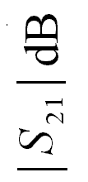

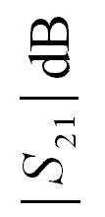

Passband Details for the High-Temperature
Superconducting Filter

Motivation for a Hybrid Algorithm

the TRASM algorithm is efficient

the number of fine model simulations needed is of the order of the problem dimension

any SM algorithm assumes the existence of a coarse model which is fast and has sufficient accuracy

if the coarse model is severely misaligned from the fine model SM optimization may not converge

the solution obtained using TRASM for most problems is a near an optimal solution

however, optimality can not be guaranteed as the optimal coarse model may significantly deviate from the optimal fine model

Illustrative Example: A Rosenbrock Function

consider a coarse model as
$$R_{c}=\text{100}{(x_{2}−x_{1}^{2})}^{2}+{(1−x_{1})}^{2}$$

and a fine model as
$$R_{f}=\text{100}{((x_{2}+α_{2})−{(x_{1}+α_{1})}^{2})}^{2}+{(1−(x_{1}+α_{1}))}^{2}$$

where $α_{1}$ and $α_{2}$ are constant shifts

suppose the target of the direct optimization problem is to minimize R_{f}

the optimal coarse model design is $x_{c}^{}$=[1.0 1.0]^{T}

the optimal fine model design is $x_{f}^{}$=[(1−$α_{1}$) (1−$α_{2}$)]^{T}

the misalignment between the two models is thus given by the two shifts $α_{1}$ and $α_{2}$
Illustrative Example: A Rosenbrock Function

consider the case $α_{1}$=$α_{2}$=−0.1
x₁
-1.0
-0.5
0
0.5
1.0
1.5
2.0
2.5
3.0
0
0.5
1.0
1.5
2.0
2.5
3.0
x₂

ideal contour plot of ${\left\|P(x_{f})−x_{c}^{}\right\|}_{2}^{2}$

x₁

actual contour plot of ${\left\|P(x_{f})−x_{c}^{}\right\|}_{2}^{2}$

the TRASM algorithm is likely to converge
Illustrative Example: A Rosenbrock Function

consider the case $α_{1}$=$α_{2}$=−1.5

x₁
-1.0
-0.5
0
0.5
1.0
1.5
2.0
2.5
3.0
0
0.5
1.0
1.5
2.0
2.5
3.0
x₂

ideal contour plot of ${\left\|P(x_{f})−x_{c}^{}\right\|}_{2}^{2}$

x₁
actual contour plot of ${\left\|P(x_{f})−x_{c}^{}\right\|}_{2}^{2}$

the TRASM algorithm is unlikely to converge
The Hybrid Aggressive Space Mapping (HASM) Algorithm
(Bakr et al., 1999)

the HASM algorithm is designed to handle severely misaligned cases

it utilizes two different phases

the first phase utilizes the TRASM algorithm

if the TRASM algorithm is not converging smoothly a switch takes place to the second phase

this switch utilizes mapping information to supply a Jacobian estimate for the fine model response to the second phase

the second phase applies direct optimization to match the fine model response to the optimal coarse model response

a switch back to the first phase can take place if SM convergence is potentially smooth

the Jacobian of the fine model response and parameter extraction are then utilized to recover the mapping matrix B

several switches can take place between the two phases
The Hybrid Aggressive Space Mapping (HASM) Algorithm

Space Mapping
x, f, B
Direct
Optimization
x, J_{f}

to ensure optimality of the final design, minimax optimization is applied from the final solution reached by the second phase
Six-Section H-plane Waveguide Filter
(Matthaei et al., 1964, Bakr et al., 1999)

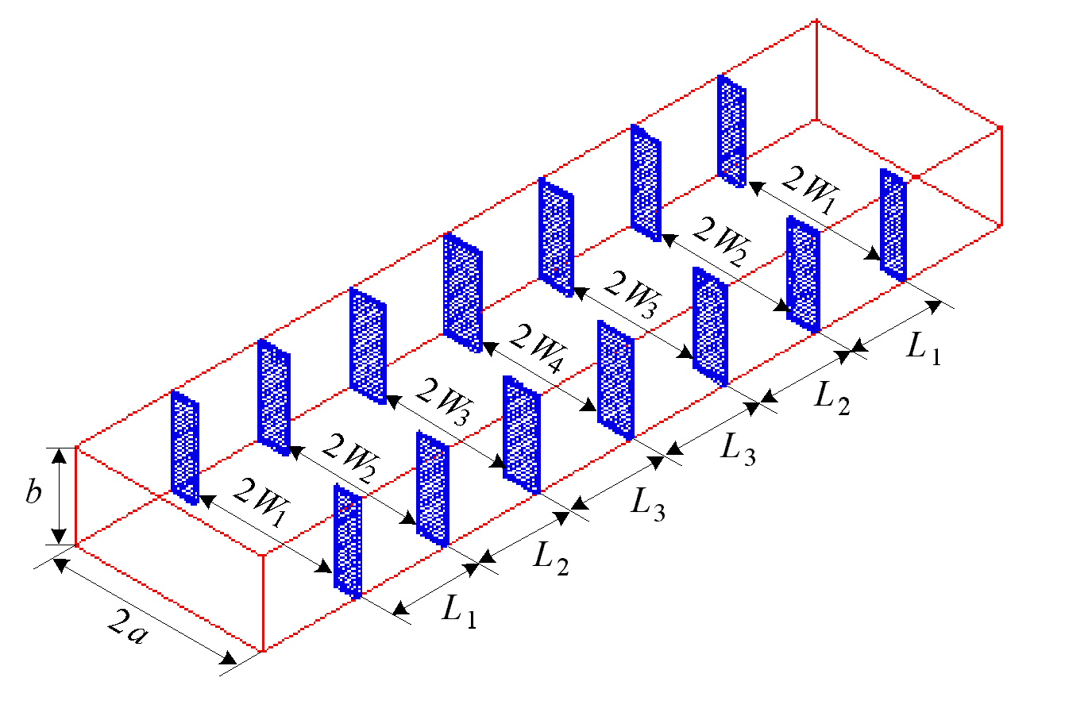
the fine model

the coarse model

design specifications are taken as
|S₁₁| ≤ 0.16 for 5.4 GHz ≤ f ≤ 9.0 GHz
|S₁₁| ≥ 0.85 for f ≤ 5.2 GHz and |S₁₁| ≥ 0.5 for 9.5 GHz ≤ f

optimizable parameters are the four septa widths W₁, W₂, W₃ and W₄ and the three waveguide-section lengths L₁, L₂ and L₃
Six-Section H-plane Waveguide Filter

the coarse model consists of lumped inductances and dispersive transmission line sections

a simplified version of a formula (Marcuvitz, 1951) is utilized in evaluating the inductances

the fine model exploits HP HFSS through HP Empipe3D

the first phase executed 4 iterations requiring a total of 5 fine model simulations

the second phase did not produce successful iterations

the optimal fine model design is obtained using minimax optimization

the convergence of TRASM is smooth: the fine model response at the end of the first phase is almost identical to the optimal fine model response
Six-Section H-plane Waveguide Filter

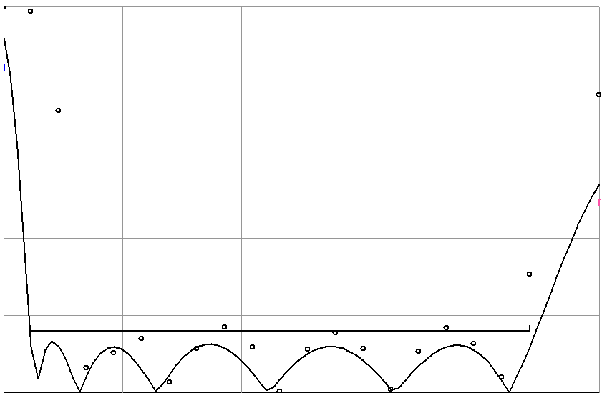
5.20
6.06
6.92
7.78
8.64
9.50
frequency (GHz)
0
0.2
0.4
0.6
0.8
1.0
⏐S_{11⏐}

the initial fine model design
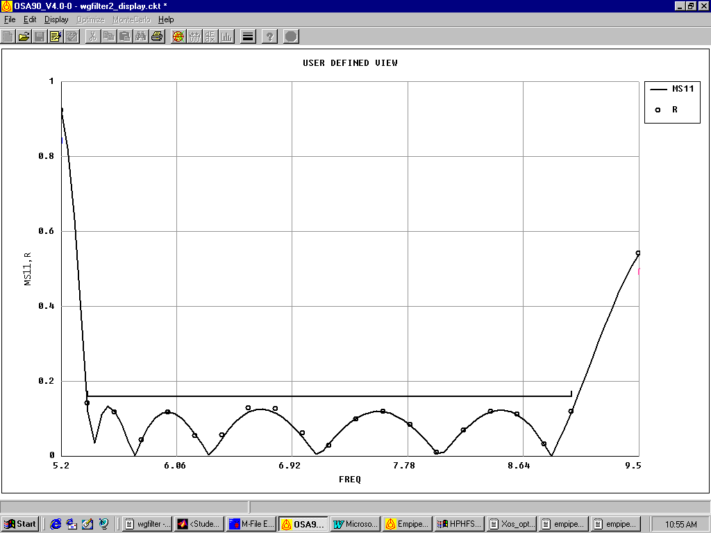
5.20
6.06
6.92
7.78
8.64
9.50
0
0.2
0.4
0.6
0.8
1.0
frequency (GHz)
⏐S_{11⏐}

the second phase design
Six-Section H-plane Waveguide Filter

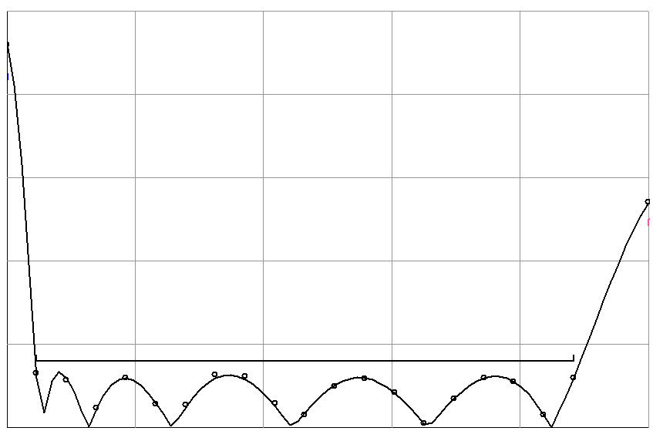
5.20
6.06
6.92
7.78
8.64
9.50
frequency (GHz)
0
0.2
0.4
0.6
0.8
1.0
⏐S_{11⏐}

the optimal fine model design
References

J.W. Bandler, R.M. Biernacki, S.H. Chen, P.A. Grobelny and R.H. Hemmers, “Space mapping technique for electromagnetic optimization,” IEEE Trans. Microwave Theory Tech., vol. 42, 1994, pp. 2536-2544.

J.W. Bandler, R.M. Biernacki, S.H. Chen, R.H. Hemmers and K. Madsen, “Electromagnetic optimization exploiting aggressive space mapping,” IEEE Trans. Microwave Theory Tech., vol. 43, 1995, pp. 2874-2882.

J.W. Bandler, R.M. Biernacki and S.H. Chen, “Fully automated space mapping optimization of 3D structures,” IEEE MTT-S Int. Microwave Symp. Dig. (San Francisco, CA), 1996, pp. 753-756.

M.H. Bakr, J.W. Bandler, R.M. Biernacki, S.H. Chen and K. Madsen, “A trust region aggressive space mapping algorithm for EM optimization,” IEEE Trans. Microwave Theory Tech., vol. 46, 1998, pp. 2412-2425.

J.J. Moré and D.C. Sorenson, “Computing a trust region step,” SIAM J. Sci. Stat. Comp., vol. 4, 1983, pp. 553-572.

C.G. Broyden, “A class of methods for solving nonlinear simultaneous equations,” Math. Comp., vol. 19, 1965, pp. 577-593.

J.W. Bandler, R.M. Biernacki, S.H. Chen, W.J. Gestinger, P.A. Grobelny, C. Moskowitz and S.H. Talisa, “Electromagnetic design of high-temperature superconducting filters,” Int. J. Microwave and Millimeter-Wave CAE, vol. 5, 1995, pp. 331-343.

em™, Sonnet Software, Inc., 1020 Seventh North Street, Suite 210, Liverpool, NY 13088, 1997.

M.H. Bakr, J.W. Bandler, N. Georgieva and K. Madsen, “A hybrid aggressive space mapping algorithm for EM optimization,” IEEE MTT-S Int. Microwave Symp. (Anaheim, CA), June 1999.

G.L. Matthaei, L. Young and E.M. T. Jones, Microwave Filters, Impedance-Matching Network and Coupling Structures. New York: McGraw-Hill, First Edition, 1964.

N. Marcuvitz, Waveguide Handbook. New York: McGraw-Hill, First Edition, 1951, p. 221.

HP HFSS™ Version 5.2, HP EEsof Division, 1400 Fountaingrove Parkway, Santa Rosa, CA 95403-1799, 1998.

HP Empipe3D™ Version 5.2, HP EEsof Division, 1400 Fountaingrove Parkway, Santa Rosa, CA 95403-1799, 1998.

