A COARSE MODEL FOR A
WAVEGUIDE H-PLANE FILTER

J.W. Bandler, M.H. Bakr and N. Georgieva

SOS-99-14-R
June 1999

© J.W. Bandler, M.H. Bakr and N. Georgieva 1999
No part of this document may be copied, translated, transcribed or entered in any form into any machine without written permission. Address inquiries in this regard to Dr. J.W. Bandler. Excerpts may be quoted for scholarly purposes with full acknowledgment of source. This document may not be lent or circulated without this title page and its original cover.

A COARSE MODEL FOR A WAVEGUIDE H-PLANE FILTER

J.W. Bandler, M.H. Bakr and N. Georgieva

Abstract
An equivalent circuit for a waveguide H-plane filter is developed in this work. This equivalent circuit can be applied as a coarse model in the highly efficient Hybrid Aggressive Space Mapping (HASM) optimization algorithm, whenever a design of a rectangular waveguide structure containing H-plane septa is carried out. This coarse model is based on empirical formulas suggested by Marcuvitz, which give very good approximation of a variety of classical waveguide discontinuities. It is fast, simple and can be easily implemented in any commercial circuit simulator. The optimization of the coarse model is discussed and its optimal design is compared with the simulation results provided by HP HFSS.
I. INTRODUCTION
Waveguide technology has long traditions in building a variety of passive devices, such as filters, impedance transformers, power dividers, couplers, etc. Many of these structures involve classical discontinuities, which have been well studied, such as H-plane and E-plane septa, waveguide junctions, T-junctions, bends, apertures, etc. An excellent source of models and empirical formulas regarding waveguide passive structures is [1].
A test example has been developed based on a waveguide filter, which was designed, manufactured and measured by Young and Schiffman [2]. The design was entirely done using empirical formulas. The measurements reported in [2] show that the measured VSWR is slightly larger than the predicted one, but, generally, the design is in very good agreement with the expectations of the designers. The nominal project was built after the values reported in [2] and in [3]. We verified this design with a HP HFSS [4] simulation. The HP HFSS simulation also shows that the nominal structure slightly violates the specifications.
We have built an equivalent circuit, which models the waveguide filter with acceptable accuracy and can be used as a coarse model in the Hybrid Aggressive Space Mapping (HASM) [5] algorithm.

II. STRUCTURE DESCRIPTION AND DESIGN SPECIFICATIONS

A waveguide with a cross-section of 1.372 inches by 0.622 inches is used for this design. The six resonators are separated by seven H-plane septa. This filter is designed to provide a very wide passband in the C-band frequency range. The design specifications are as follows:
|S₁₁| ≤ 0.16, for 5.4 GHz ≤ f ≤ 9GHz  |S₁₁| ≥ 0.32, for f ≤ 5.34GHz  |S₁₁| ≥ 0.32, for f ≥ 9.46GHz | (1)  (2)  (3)

The nominal project of the HP HFSS model is shown in Fig. 1. Note that the symmetry of the dominant-mode field distribution is used and a perfect H boundary (magnetic wall) is applied. Thus, only half of the structure is discretized, which reduces the CPU-time required for a fine-model frequency sweep almost in half.
The structure is symmetrical with respect to the central septum (the center of its length). There are seven optimization variables: the four septa’s widths and the three resonators’ lengths. The geometrical dimensions correspond to the notations in Fig. 2. Nominal values of the optimization parameters are given in Table I together with the perturbed values used for the geometry capture of the fine model.

III. THE COARSE MODEL
This particular structure is relatively easy to model in terms of an equivalent circuit consisting of lumped inductances and dispersive transmission-line sections. The simulation of the coarse model is computationally much more efficient in comparison with a full-wave electromagnetic simulation, e.g., HP HFSS simulation. The equivalent circuit of the structure in Fig. 2 is shown in Fig. 3. The lumped inductances represent the H-plane septa, while the transmission-line sections represent the waveguide sections between any two septa. The characteristic impedance of these lines is taken equal to the wave impedance of the rectangular waveguide, which depends on the frequency. The equivalent circuit of Fig. 3 was implemented and optimized in OSA90/hope [6].
There are various approaches to calculate the equivalent inductive susceptance corresponding to a H-plane septum (see Fig. 2). The simplest formula is provided by Smythe [7]. It is a quasi-static approximation:
$\frac{B_{i}}{Y_{0}}≈−\frac{λ_{g}}{W_{i}}\left[1+{\text{csc}}^{2}\left(\frac{π}{2}\frac{W_{i}}{a}\right)\right]{\text{cot}}^{2}\left(\frac{π}{2}\frac{W_{i}}{a}\right)$, B_{i}=1/(jωL_{i}) | (4)

Here λ_{g} denotes the guide wavelength. For the dominant mode
$λ_{g}=\frac{1}{\sqrt{{\left(\frac{f}{c}\right)}^{2}−{\left(\frac{1}{4a}\right)}^{2}}}$ , | (5)
where c denotes the speed of light in free space and f is the frequency. Y₀ denotes the wave admittance of the rectangular waveguide, Y₀=1/Z₀.
A more accurate model is provided in [1], Paragraph 5-2. The following approximate relations were implemented:
$\frac{X_{i}}{Z_{0}}≈\frac{2a}{λ_{g}}{\text{tan}}^{2}\left(\frac{π}{2}\frac{W_{i}}{a}\right)\left[1+\frac{2}{3}{\left(π\frac{W_{i}}{λ}\right)}^{2}\right]$, for | $$\frac{W_{i}}{a}\text{<<}1$$ | (6)
$\frac{X_{i}}{Z_{0}}≈\frac{2a}{λ_{g}}{\text{cot}}^{2}\left(\frac{π}{2}\frac{W_{i}^{'}}{a}\right)\left[1+\frac{2}{3}{\left(π\frac{W_{i}^{'}}{λ}\right)}^{2}\right]$, for | $\frac{W_{i}^{'}}{a}\text{<<}1$, where  $$W_{i}^{'}=a−W_{i}$$ | (7)
As explained in [1], the above approximations have their validity limits. These limits have to be taken into account when the range of perturbations of the septa widths is expected to be wide. Here, only one major limitation will be stated. The model is valid for a wavelength range specified by
(2/3)a < λ < 2a | (8)
Each waveguide resonator corresponds to a portion of an ideal transmission line characterized by its characteristic admittance Y₀ and by its electrical length θ_{i} (i=1,2,3). The characteristic impedance, Z₀=1/Y₀, is equal to the waveguide impedance. The electrical length θ_{i} is proportional to the physical length of the waveguide section l_{i} as
$θ_{i}=\text{360}\frac{l_{i}}{λ_{g}}$, deg | (9)
Since λ_{g} is frequency dependent, the electrical length θ_{i} also depends on the frequency.

IV. OPTIMIZATION OF THE COARSE MODEL
The starting values for the optimization of the coarse model are taken equal to the values suggested in [2, 3]. These values are given in the first column of Table II. The |S₁₁| response of the coarse model at the starting point is shown in Fig. 4.
The iteration report for the minimax optimization shows that the design is successfully optimized with an error of approximately –0.05 (see Fig. 5). The optimal parameter values are given in the second column of Table II. The |S₁₁| response of the optimal coarse model design is shown in Fig. 6.

V. ADDITIONAL NOTES
Direct optimization using HP HFSS HP and Empipe3D was carried out starting from the nominal values given in Table I, which correspond to the design presented in [2]. It was observed that the fine model converges to another minimum when the optimal coarse model values of the optimization variables are used as a starting point. The obtained solution is worse in comparison with the one which starts with initial values set equal to the design presented in [1]. This means that the problem has multiple minima.
The optimal solution to the coarse model problem depends slightly on the number of frequency points used in the discrete sweep. Generally, the more the frequency points in the sweep, the more reliable the design should be.

REFERENCES

[1] N. Marcuvitz, Waveguide Handbook. New York, NY: McGraw-Hill, 1951.

[2] L. Young and B. M. Schiffman, “A useful high-pass filter design,” Microwave Journal, vol. 6, 1963, pp. 78-80.

[3] G. L. Matthaei, L. Young, E. M. T. Jones, Microwave Filters, Impedance-Matching Networks, and Coupling Structures. New York, NY: McGraw-Hill, 1964, pp. 545-547.

[4] HP HFSS™ Version 5.2, HP EEsof Division, 1400 Fountaingrove Parkway, Santa Rosa, CA 95403-1799, 1998.

[5] M.H. Bakr, J.W. Bandler, N. Georgieva and K. Madsen, “A hybrid aggressive space mapping algorithm for EM optimization,” IEEE MTT-S Int. Microwave Symp. Dig. (Anaheim, CA), 1999.

[6] OSA90/hope™ Version 4.0, formerly Optimization Systems Associates Inc., P.O. Box 8083, Dundas, Ontario, Canada L9H 5E7, 1997, now HP EEsof Division, Hewlett-Packard Company, 1400 Fountaingrove Parkway, Santa Rosa, CA 95403-1799.

[7] W. R. Smythe, Static and Dynamic Electricity, 2nd ed. New York, NY: McGraw-Hill, 1950.

TABLE I

NOMINAL AND PERTURBED VALUES

OF THE DESIGNABLE PARAMTERS

OF THE FINE MODEL

Parameter | Nominal Value | Perturbed Value
W₁ | 0.513 | 0.514
W₂ | 0.479 | 0.480
W₃ | 0.449 | 0.450
W₄ | 0.435 | 0.436
L₁ | 0.626 | 0.630
L₂ | 0.653 | 0.660
L₃ | 0.674 | 0.680
All values are in inches

TABLE II

NOMINAL AND OPTIMIZED VALUES

OF THE DESIGNABLE PARAMETERS

OF THE COARSE MODEL

Parameter | Nominal Value | Optimized Value
W₁ | 0.513 | 0.556455
W₂ | 0.479 | 0.527037
W₃ | 0.449 | 0.510853
W₄ | 0.435 | 0.506619
L₁ | 0.626 | 0.648785
L₂ | 0.653 | 0.658020
L₃ | 0.674 | 0.674779
All values are in inches

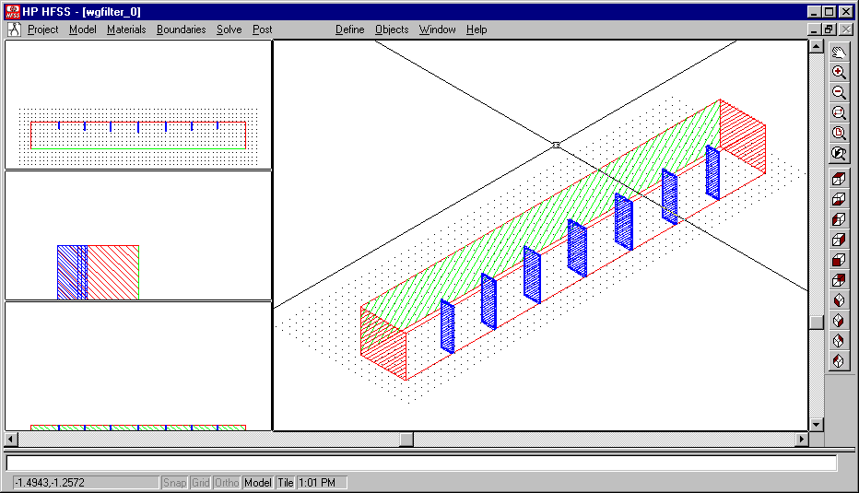
Fig. 1. The nominal geometry file of the fine model (HP HFSS simulation).

2a = 1.372, inches
b = 0.622, inches

Fig. 2. General geometry of the H-plane six-section waveguide filter.

Fig. 3. Equivalent circuit of the six-resonator H-plane waveguide filter.

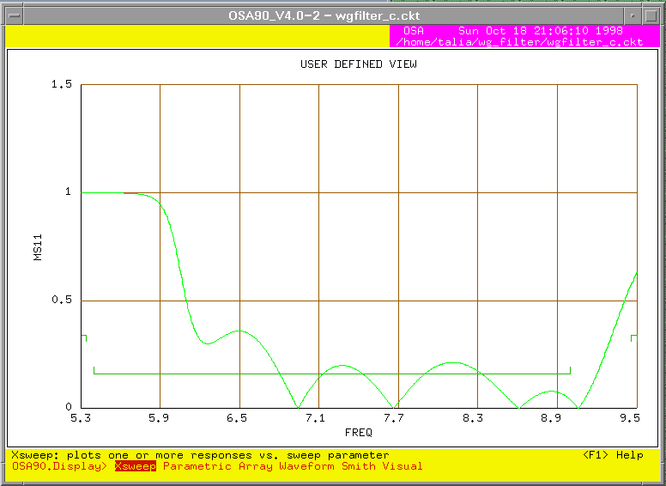

Fig. 4. The coarse model response before optimization.

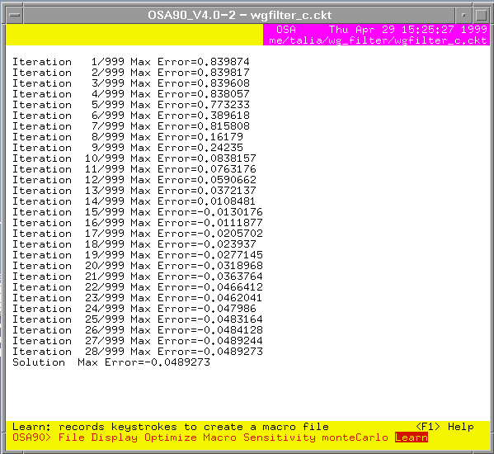

Fig. 5. The iteration report for the optimization of the coarse model of the H-plane waveguide filter.

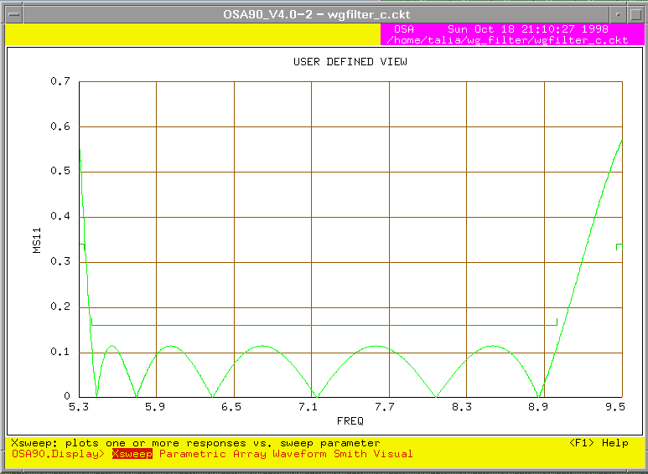

Fig. 6. The optimal coarse model response.

APPENDIX

The Coarse Model of the Waveguide Filter: OSA90 Netlist File

! Thu Oct 15 12:37:52 1998. Minimax Optimizer. 18 Iterations. 00:00:00 CPU.
Expression
MS11_SPEC = 0.16;

INMM = 25.4;
V = 2.99792458E+11;
MU0 = 4*PI*1E-10;
EPS0 = 1/(36*PI)*1E-12;
GAMMA = SQRT(MU0/EPS0);

A = 1.372*INMM; B = 0.622*INMM;
! Septa half-widths in inches
CC1: ?0.557111?;
CC2: ?0.523275?;
CC3: ?0.510365?;
CC4: ?0.508484?;

C1 = 2*CC1*INMM; C2 = 2*CC2*INMM;
C3 = 2*CC3*INMM; C4 = 2*CC4*INMM;

LL1: ?0.633067?;
LL2: ?0.65315?;
LL3: ?0.675303?;

L1 = LL1*INMM; L2 = LL2*INMM;
L3 = LL3*INMM;
LIO = 0.7*INMM;
! wave impedance Z0 and wavelength LAMBDA
Fc=(1E-9*V)/(2*A); ! GHz
Z0=GAMMA/SQRT(1-(Fc/FREQ)^2);
Y0=1/Z0;
LAMBDA=1/SQRT((FREQ*1E+9/V)^2-(1/(2*A))^2);
! Susceptances (quasistatic, after Smythe)
C1A=C1/A;C2A=C2/A;C3A=C3/A;C4A=C4/A;

B1=-Y0*(LAMBDA/A)*(1+(1/sin(PI*C1A/2))^2)/((tan(PI*C1A/2))^2);
B2=-Y0*(LAMBDA/A)*(1+(1/sin(PI*C2A/2))^2)/((tan(PI*C2A/2))^2);
B3=-Y0*(LAMBDA/A)*(1+(1/sin(PI*C3A/2))^2)/((tan(PI*C3A/2))^2);
B4=-Y0*(LAMBDA/A)*(1+(1/sin(PI*C4A/2))^2)/((tan(PI*C4A/2))^2);
! inductances (nano-henry)
LI1=-1/(2.*PI*FREQ*B1);
LI2=-1/(2.*PI*FREQ*B2);
LI3=-1/(2.*PI*FREQ*B3);
LI4=-1/(2.*PI*FREQ*B4);
! electrical lengths of resonators/input lines (degrees)
THETA1=360.*L1/LAMBDA;
THETA2=360.*L2/LAMBDA;
THETA3=360.*L3/LAMBDA;
THETAIO=360.*LIO/LAMBDA;
end
Model
TEM 1 2 0 0 Z=Z0 E=THETAIO F=FREQ;
IND 2 0 L=LI1;
TEM 2 3 0 0 Z=Z0 E=THETA1 F=FREQ;
IND 3 0 L=LI2;
TEM 3 4 0 0 Z=Z0 E=THETA2 F=FREQ;
IND 4 0 L=LI3;
TEM 4 5 0 0 Z=Z0 E=THETA3 F=FREQ;
IND 5 0 L=LI4;
TEM 5 6 0 0 Z=Z0 E=THETA3 F=FREQ;
IND 6 0 L=LI3;
TEM 6 7 0 0 Z=Z0 E=THETA2 F=FREQ;
IND 7 0 L=LI2;
TEM 7 8 0 0 Z=Z0 E=THETA1 F=FREQ;
IND 8 0 L=LI1;
TEM 8 9 0 0 Z=Z0 E=THETAIO F=FREQ;

PORT 1 0 R=Z0;
PORT 9 0 R=Z0;
CIRCUIT;
MS_dB[2,2] = if (MS > 0) (20 * log10(MS)) else (NAN);
MS11_dB = MS_dB[1,1];
MS21_dB = MS_dB[2,1];
end
Sweep
AC: FREQ: from 5.3GHz to 5.34GHz step=0.04GHz
from 5.4GHz to 9GHz step=0.36GHz
from 9.46GHz to 9.5GHz step=0.04GHz
MS MS_dB PS MS11_dB MS21_dB
{XSWEEP X=FREQ Y=MS11
SPEC=(from 5.4 to 9, < 0.16) &
(from 5.3 to 5.34 , > 0.34) &
(from 9.46 to 9.5 , > 0.34)};
end
Spec
AC: FREQ: from 5.4GHz to 9GHz step=0.36GHz
MS11 < 0.16;
AC: FREQ: from 5.3GHz to 5.34GHz step=0.04GHz
MS11 > 0.34;
AC: FREQ: from 9.46GHz to 9.5GHz step=0.04GHz
MS11 > 0.34;
end
Report
Xos=[$CC1$
$CC2$
$CC3$
$CC4$
$LL1$
$LL2$
$LL3$];
end

 This work was supported in part by the Natural Sciences and Engineering Research Council of Canada under Grants OGP0007239, STP0201832, Com Dev, Nanowave Technologies, and through the Micronet Network of Centres of Excellence. N. Georgieva is supported by an NSERC Postdoctorate Fellowship and M.H. Bakr by an Ontario Graduate Scholarship. M.H. Bakr, J.W. Bandler and N. Georgieva are with the Simulation Optimization Systems Research Laboratory and the Department of Electrical and Computer Engineering, McMaster University, Hamilton, Ontario, Canada, L8S 4K1. J.W. Bandler is also with Bandler Corporation, P.O. Box 8083, Dundas, Ontario, Canada L9H 5E7.

