A COARSE MODEL FOR A MICROSTRIP
DOUBLE FOLDED STUB FILTER

J.W. Bandler, M.H. Bakr and N. Georgieva

SOS-99-15-R
June 1999

© J.W. Bandler, M.H. Bakr and N. Georgieva 1999
No part of this document may be copied, translated, transcribed or entered in any form into any machine without written permission. Address inquiries in this regard to Dr. J.W. Bandler. Excerpts may be quoted for scholarly purposes with full acknowledgment of source. This document may not be lent or circulated without this title page and its original cover.
A COARSE MODEL FOR A Microstrip Double Folded Stub Filter

J.W. Bandler, M.H. Bakr and N. Georgieva

Simulation Optimization Systems Research Laboratory
Department of Electrical and Computer Engineering
McMaster University, Hamilton, Canada L8S 4K1

Abstract
A fast coarse model of a stop-band double folded stub (DFS) filter is suggested in this work. The general structure of the filter is discussed and the equivalent circuit of the coarse model is explained. This coarse model makes use of the empirical models of different microwave elements available in OSA90/hope. It also makes use of Walker’s formulas for modeling the coupling between the folded stubs and the microstrip line. The main purpose of developing this model is to utilize it as a fast coarse model in the design of the DFS filter by the efficient Hybrid Aggressive Space Mapping (HASM) optimization algorithm. Finally, we compare the accuracy of this coarse model with that of the filter simulated using HP HFSS.
i. INTRODUCTION
A microstrip stopband filter is considered in this work. This filter is based on a well-known structure, which includes quarter-wavelength stubs connected by quarter-wavelength microstrip-line sections. This specific example is a double folded-stub (DFS) stop-band filter. The structure has been used as a test example for optimization algorithms [1, 2, 3] on several occasions. The Hybrid Aggressive Space Mapping (HASM) algorithm [4] requires a coarse model, which has to be fast although not necessarily accurate. It also requires a fine model, which must be accurate. In microwave simulation and design, a fine model with reliable accuracy can be provided by full wave analysis tools, which are often extremely time-intensive. In a previous work, the coarse model of the DFS filter was a coarse-grid Sonnet’s em™ [5] simulation with cell size 4.8 mils by 4.8 mils. The fine model was also a Sonnet em™ simulation but with a finer mesh size: 1.6 mils by 1.6 mils. Here we consider another type of coarse model: an equivalent circuit, which is much faster than the coarse-grid em model. The fine model utilized in ASM optimization can be either a Sonnet em™ model through Empipe [6], or HP HFSS [7] through HP Empipe3D [8].

II. STRUCTURE DESCRIPTION AND DESIGN SPECIFICATIONS
This design consists of two open-end folded stubs of equal lengths connected by a microstrip-line section whose length is approximately quarter-wavelength (see Fig. 1). The substrate is of dielectric constant ε_{r}=9.9 and of height h=5 mils (0.127 mm). All microstrip elements are constructed using lines of the same width w=4.8 mils (0.12192 mm).
The optimization specifications are
|S₂₁| ≤ −30 dB for 12 GHz ≤ f ≤ 14 GHz (1)
and
|S₂₁| ≥ −3 dB for f ≤ 9.5 GHz or f ≥ 16.5 GHz (2)
The fine model utilizes HP HFSS through HP Empipe3D. The nominal geometry is shown in Fig. 2. The nominal and the perturbed values of the optimizable parameters of the fine model are given in Table I.

III. THE COARSE MODEL OF THE DOUBLE FOLDED STUB (DFS) FILTER
The coupling between each of the stubs and the connecting microstrip-line section is strong and is crucial to the performance of the filter. The coupling between the two stubs is negligible. The coarse model is built on the above assumptions. The coupling between two microstrip lines can be described in terms of the mutual capacitance per unit length C_{m1} and the mutual inductance per unit length L_{m1}. Suitable formulas for the calculation of C_{m1} and L_{m1} are provided by Walker [9, 10]. Fig. 3 shows the general geometry and notation of a pair of symmetrical coupled microstrip lines. The equivalent circuit suggested by Walker is shown in Fig. 4. The parameters corresponding to the equivalent circuit in Fig. 4 are given by [9, 10]
$$L_{s1}=\frac{μ_{r}μ_{0}}{K_{L1}}\left(\frac{h}{w}\right)−\frac{μ_{r}μ_{0}}{4π}\text{ln}\left[1+{\left(\frac{2h}{d}\right)}^{2}\right]$$  $$L_{m1}=\frac{μ_{r}μ_{0}}{4π}\text{ln}\left[1+{\left(\frac{2h}{d}\right)}^{2}\right]$$  $$C_{s1}=ε_{r}ε_{0}K_{C1}\left(\frac{w}{h}\right)$$  $$C_{m1}=\frac{ε_{r}ε_{0}}{4π}K_{C1}K_{L1}{\left(\frac{w}{h}\right)}^{2}\text{ln}\left[1+{\left(\frac{2h}{d}\right)}^{2}\right]$$ | (3)  (4)  (5)  (6)
Here, the fringing factors are  $$K_{L1}=\frac{\text{120}π}{Z_{0(ε_{r}=1)}}\left(\frac{h}{w}\right)$$  $K_{C1}={\left[\frac{\text{120}π}{Z_{0(ε_{r}=1)}}\left(\frac{h}{w}\right)\sqrt{\frac{ε_{r_{\text{eff}}}}{K_{L1}ε_{r}}}\right]}^{2}$, | (7)  (8)
where $ε_{r_{\text{eff}}}$ is the effective dielectric constant of a single microstrip line, and
$Z_{0(ε_{r}=1)}=\text{60}\text{ln}\left(\frac{8h}{w}+\frac{w}{4h}\right)\begin{matrix} & Ω\end{matrix}$, for $\frac{w}{h}≤1$  $Z_{0(ε_{r}=1)}=\frac{\text{120}π}{\frac{w}{h}+2\text{.}\text{42}−0\text{.}\text{44}\left(\frac{h}{w}\right)+{\left(1−\frac{h}{w}\right)}^{6}}\begin{matrix} & Ω\end{matrix}$, for $\frac{w}{h}≥1$ | (9)  (10)
The coarse model of the DFS filter is a microwave circuit model simulated and optimized using OSA90/hope [11] (see Fig. 5). The coupling between each stub and the connecting microstrip-line section is represented by lumped capacitors, whose capacitance corresponding to a coupled-line section of length 2Δl is calculated as
C_{m}= 2Δl C_{m1} . | (11)
The self-capacitance C_{s} and the self-inductance L_{s} of each microstrip-line section are already included in the built-in microstrip-line model of OSA90/hope, therefore, they are not included in the equivalent circuit in the form of lumped elements. The effects of mutual inductance L_{m} are not modeled mainly because of the difficulties in representing mutual inductance in the environment of OSA90/hope. This factor would contribute to the lack of accuracy of the coarse model.
The overall equivalent circuit utilizes also a number of built-in microwave elements (microstrip line sections, open-end stubs, T-junctions, right-angle bends, etc.) as shown in Fig. 5. All physical lengths of the microstrip-line sections are calculated along the mean geometrical lines of the structure. Thus, Δl=l₂/4 and 2Δl′=l₁−2Δl.
It should be emphasized that the coarse model is not expected to yield accurate results. It is expected to be fast and to provide responses, which depend on the optimized parameters and the frequency in a manner similar to that of the fine model.
IV. OPTIMIZATION OF THE COARSE MODEL
The starting values of the optimized parameters for the optimization of the coarse model were taken equal to those used as nominal values in the optimization example available in Empipe [6]. They are given in the first column of Table II. Minimax optimization is invoked. The iteration report is shown in Fig. 6. It shows that the coarse model successfully generated a design, which satisfies the specifications with an error of approximately –0.008. The optimized parameter values are given in the second column of Table II.
The response of the coarse model in terms of |S₂₁| at the starting point is shown in Fig. 7. The |S₂₁| response of the optimal design of the coarse model is given in Fig. 8.
The response of the DFS filter simulated using HP HFSS through HP Empipe3D at the optimal coarse model design is shown in Fig. 9. The significant misalignment between the two models illustrates the low accuracy of the coarse model.

V. CONCLUSIONS
In this work we discuss the construction of a fast coarse model for the Double-Folded Stub (DFS) filter. This model makes use of the empirical models of the transmission line, coupled microstrip lines, microstrip bend and T-junctions available in OSA90/hope. The coupling between the folded stubs and the microstrip line is modeled using Walker’s formulas. The coarse model is optimized using the minimax optimizer in OSA90/hope for the given design specifications. The accuracy of this model is compared to that of an EM simulation. We showed that there is a significant shift.

REFERENCES

[1] J.W. Bandler, R.M. Biernacki, S.H. Chen, D.G. Swanson, Jr. and S. Ye, “Microstrip filter design using direct EM field simulation,” IEEE Trans. Microwave Theory Tech., vol. 42, 1994, pp. 1353-1359.

[2] J.W. Bandler, R.M. Biernacki, S.H. Chen, P.A. Grobelny and R.H. Hemmers, “Space mapping technique for electromagnetic optimization,” IEEE Trans. Microwave Theory Tech., vol. 42., 1994, pp. 2536-2544.

[3] M.H. Bakr, J.W. Bandler, R.M. Biernacki, S.H. Chen and Kaj Madsen, “A trust region aggressive space mapping algorithm for EM optimization,” IEEE Trans. Microwave Theory Tech., vol. 46, 1998, pp. 2412-2425.

[4] M.H. Bakr, J.W. Bandler, N. Georgieva and K. Madsen, “A hybrid aggressive space mapping algorithm for EM optimization,” IEEE MTT-S Int. Microwave Symp. Dig. (Anaheim, CA), 1999.

[5] em™, Version 4.0b, Sonnet Software, Inc., 1020 Seventh North Street, Suite 210, Liverpool, NY 13088, 1997.

[6] Empipe™ Version 4.0, formerly Optimization Systems Associates Inc., P.O. Box 8083, Dundas, Ontario, Canada L9H 5E7, 1997, now HP EEsof Division, Hewlett-Packard Company, 1400 Fountaingrove Parkway, Santa Rosa, CA 95403-1799.

[7] HP HFSS™ Version 5.2, HP EEsof Division, 1400 Foutaingrove Parkway, Santa Rosa, CA 95403-1799, 1998.

[8] HP Empipe3D™ Version 5.2, HP EEsof Division, 1400 Foutaingrove Parkway, Santa Rosa, CA 95403-1799, 1998.

[9] C.S. Walker, Capacitance, Inductance and Crosstalk Analysis. Norwood, MA: Artech House, 1990.

[10] J.W. Bandler and J.E. Rayas-Sánchez, “Interconnect crosstalk minimization: an alternative route,” Simulation Optimization Systems Research Laboratory, McMaster University, Hamilton, Canada, Report SOS-98-8-R, April 1998, Appendix A.

[11] OSA90/hope™ Version 4.0, formerly Optimization Systems Associates Inc., P.O. Box 8083, Dundas, Ontario, Canada L9H 5E7, 1997, now HP EEsof Division, Hewlett-Packard Company, 1400 Fountaingrove Parkway, Santa Rosa, CA 95403-1799.

TABLE I

NOMINAL AND PERTURBED VALUES OF
THE DESIGNABLE PARAMETERS OF THE FINE MODEL
Variable | Nominal Value | Perturbed Value | # Div
L₁ | 80 | 85 | 5
L₂ | 64 | 70 | 6
S | 6.4 | 10 | 4
All values are in mils

TABLE II
INITIAL AND OPTIMIZED VALUES
OF THE COARSE MODEL PARAMETERS
Parameter | Initial value | Optimal value
L₁  L₂  S | 86.4  81.6  4.8 | 81.8876  77.9058  4.55518
All values are in mils

Fig. 1. Microstrip double folded stub filter: top view.

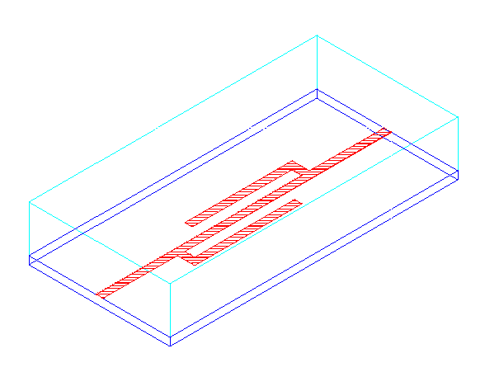

Fig. 2. Nominal geometry file of the fine model in HP HFSS.

Fig. 3. General structure and notation of the symmetrical coupled microstrip lines.

Fig. 4. Equivalent circuit suggested by Walker [9] representing a coupled microstrip-line section of length $Δl$.

Fig. 5. Schematic of the coarse model of the DFS filter built in OSA90/hope.

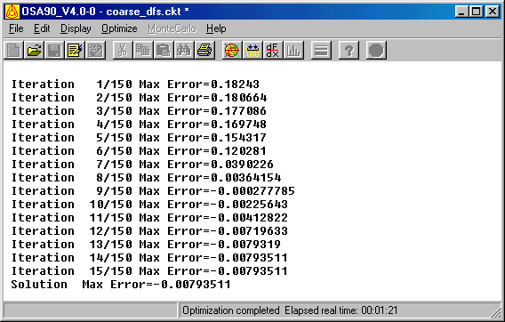
Fig. 6. The iteration report of the minimax optimization of the coarse model of the DFS filter.

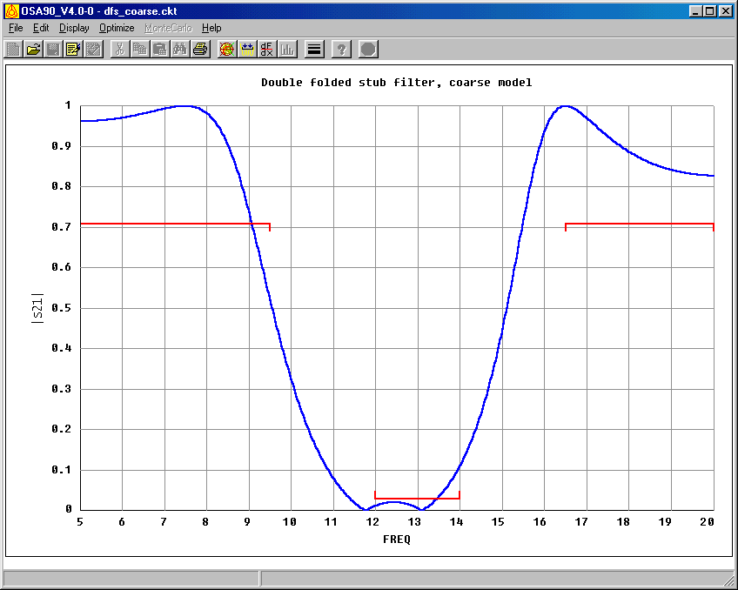
Fig. 7. The coarse model response of the DFS filter before optimization.

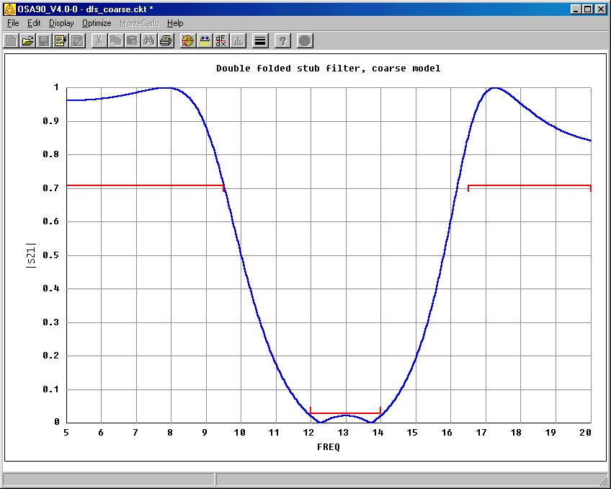
Fig. 8. The coarse model response of the DFS filter after optimization.

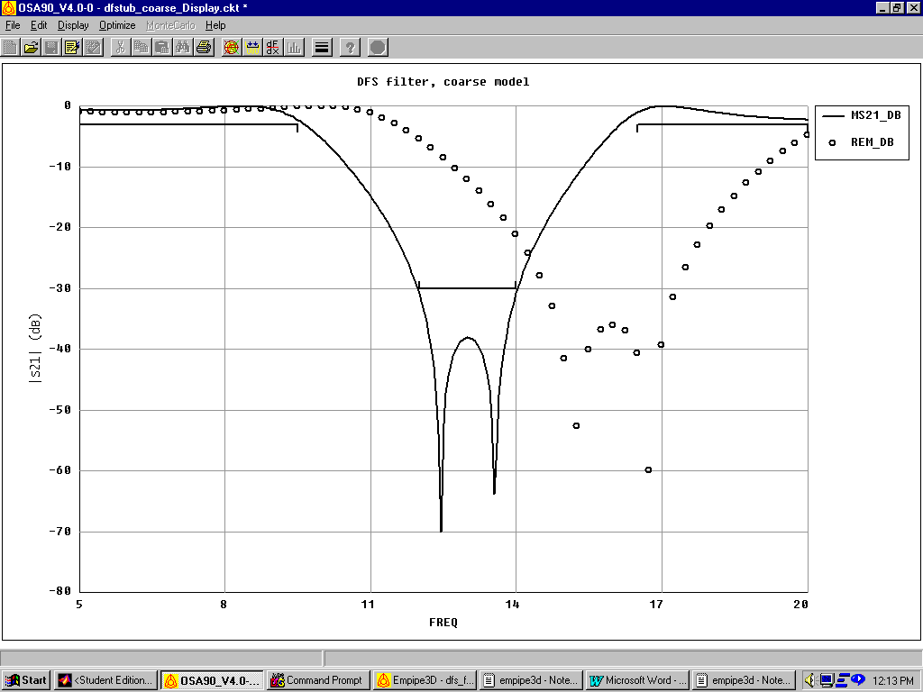
8
11

14
17
20
5
frequency (GHz)
-70
-60
-50
-40
-30
-20
-10
0
⏐S_{21⏐}dB
-80

Fig. 9. The optimal coarse response (⎯) and the fine response at the optimal coarse model design (ο) for the DFS filter.
Appendix A

The Coarse Model of the DFS Filter: OSA90 Netlist File

! Example dfs_filter.ckt: COARSE MODEL FOR THE DOUBLE FOLDED STUB FILTER
! Fri May 07 16:18:55 1999. Minimax Optimizer. 15 Iterations. 00:00:00 CPU.

Model

FSTEP = 0.02GHz;
MILMM=0.0254; ! mil -> mm
VL=2.99792458; ! velocity of light,*1e+11 mm/s
MU0=4*PI*1e-1; ! nH/mm
EPS0=1/(4*PI*(VL^2)); ! pF/mm
ER=9.9;HSUB=5;
WW=4.8;

S :? 1.5 4.55518 30?;
L1:?70 81.8876 120?;
DL12:? 3.98176 ?;
L2=L1-DL12;

D=S+WW;
WS=(WW*1mil);HS=(HSUB*1mil);
LS1=(S*1mil);
QLS2=((L2/4)*1mil);
LCSM=((L1-(L2/2))*1mil);
! effective dielectric constant, infinitesimally thin strip, non-dispersive
WOH=WW/HSUB;
A=1+LOG((WOH^4+(WW/(52*HSUB))^2)/(WOH^4+0.432))/49+LOG(1+(WW/(18.1*HSUB))^3)/18.7;
B1=0.564*((ER-0.9)/(ER+3))^0.053;
EREF=0.5*(ER+1)+0.5*(ER-1)*((1+10/WOH)^(-A*B1));
! mutual capacitance/unit lenght
Z0: if (WOH <= 1) (60*LOG(8/WOH+WOH/4))
else (120*PI/(WOH+2.42-0.44/WOH+(1-1/WOH)^6));
KL=120*PI/(Z0*WOH);
KC=KL*(EREF/ER);
CMI=(EPS0*ER/(4*PI))*KC*KL*(WOH^2)*LOG(1+(2*HSUB/D)^2); ! pF/mm
CM=CMI*((L2/2)*MILMM)*1e-3; ! nF -> LS2/2

! LMI=(MU0/(4*PI))*LOG(1+(2*HSUB/D)^2); ! nH/mm
! LM=LMI*((L2/4)*MILMM); ! nH -> L2/4
! ZM=2*PI*FREQ*LM;

CBEND=0.001*(HSUB*(1mil)/(1mm))*((10.35*ER+2.5)*(WOH^2)+(2.6*ER+5.64)*WOH);
LBEND=0.22*(HSUB*(1mil)/(1mm))*(1-1.35*EXP(-0.18*(WOH^1.39)));
SUBCIRCUIT MOSTAFA 1 3 0 {
IND 1 2 L=(LBEND*1nH);
CAP 2 0 C=(CBEND*1pF);
IND 2 3 L=(LBEND*1nH);
};
MSUB EPSR=ER H=HS;
! 1st stub
MTEE 1 2 21 W1=WS W2=WS W3=WS;
MSL 21 22 W=WS L=LS1;
MOSTAFA 22 23;
MSL 23 24 W=WS L=QLS2;
CAP 24 3 C=(CM*1nF);
CAP 24 0 C=(-CM*1nF);
MSL 24 25 W=WS L=(2*QLS2);
CAP 25 4 C=(CM*1nF);
CAP 25 0 C=(-CM*1nF);
MOPEN 25 W=WS L=QLS2;
! mstrip
MSL 2 3 W=WS L=QLS2;
CAP 3 0 C=(-2*CM*1nF);
MSL 3 4 W=WS L=LCSM;
CAP 4 0 C=(-2*CM*1nF);
MSL 4 5 W=WS L=QLS2;
! 2nd stub
MTEE 5 6 31 W1=WS W2=WS W3=WS;
MSL 31 32 W=WS L=LS1;
MOSTAFA 32 33;
MSL 33 34 W=WS L=QLS2;
CAP 34 4 C=(CM*1nF);
CAP 34 0 C=(-CM*1nF);
MSL 34 35 W=WS L=(2*QLS2);
CAP 35 3 C=(CM*1nF);
CAP 35 0 C=(-CM*1nF);
MOPEN 35 W=WS L=QLS2;

PORTS 1 0 6 0;

CIRCUIT;

MS_DB[2,2] = if (MS > 0) (20 * log10(MS)) else (NAN);
MS21_DB = MS_DB[2,1];
end
Sweep
Ac:freq: from 5GHz to 20GHz step=FSTEP
Ms21 Ms21_dB
{Xsweep Title="Double folded stub filter, coarse model"
Y=MS21.black Y_title="|S21|" Xmin=5 Xmax=20 Ymin=0 Ymax=1 NXticks=15 NYticks=10
SPEC=(from 5 to 9.5, > 0.708).yellow &
(from 12 to 14, < 0.03).yellow &
(from 16.5 to 20, > 0.708).yellow};;
end
Spec
Ac:FREQ: from 12GHz to 14GHz step=FSTEP Ms21<0.03;
Ac:FREQ: from 5GHz to 9.5GHz step=FSTEP Ms21>0.708;
Ac:FREQ: from 16.5GHz to 20GHz step=FSTEP Ms21>0.708;
end
Control
Allow_Neg_Parameters;
end
Report
${$MS21$}$
End

 This work was supported in part by the Natural Sciences and Engineering Research Council of Canada under Grants OGP0007239, STP0201832, Com Dev, Nanowave Technologies and through the Micronet Network of Centres of Excellence. N. Georgieva is supported by an NSERC Postdoctorate Fellowship and M.H. Bakr by an Ontario Graduate Scholarship. J.W. Bandler is also with Bandler Corporation, P.O. Box 8083, Dundas, Ontario, Canada L9H 5E7.

