Neuromodeling of Microwave Circuits Exploiting
Space Mapping Technology

J.W. Bandler, M.A. Ismail, J.E. Rayas-Sánchez and Q.J. Zhang

SOS-99-19-V

June 1999

© J.W. Bandler, M.A. Ismail, J.E. Rayas-Sánchez and Q.J. Zhang 1999

No part of this document may be copied, translated, transcribed or entered in any form into any machine without written permission. Address enquiries in this regard to Dr. J.W. Bandler. Excerpts may be quoted for scholarly purposes with full acknowledgement of source. This document may not be lent or circulated without this title page and its original cover.
Neuromodeling of Microwave Circuits
Exploiting Space Mapping Technology

J.W. Bandler, M.A. Ismail, J.E. Rayas-Sánchez and Q.J. Zhang*

Simulation Optimization Systems Research Laboratory
and Department of Electrical and Computer Engineering
McMaster University, Hamilton, Canada L8S 4K1

* Department of Electronics
Carleton University, Ottawa, Canada K1S 5B6

bandler@mcmaster.ca
www.sos.mcmaster.ca

presented at

1999 IEEE MTT-S International Microwave Symposium, Anaheim, CA, June 14, 1999
Artificial Neural Network (ANN) Modeling

Artificial Neural Networks are suitable in modeling high-dimensional and highly nonlinear problems

ANN models are computationally efficient and can be more accurate than empirical models

multilayer feedforward networks can approximate any measurable function to any desired level of accuracy, provided a deterministic relationship between input and target exists
(White et al., 1992)

ANNs that are too small cannot approximate the desired input-output relationship

ANNs with too many internal parameters perform correctly in the learning set, but give poor generalization ability

ANNs are suitable models for microwave circuit optimization and statistical design (Zaabab, Zhang and Nakhla, 1995, Gupta et al., 1996, Burrascano and Mongiardo, 1998, 1999)

Classical Neuromodeling of Microwave Components

many learning samples are usually needed to ensure model accuracy

the number of learning samples needed to approximate a function grows exponentially with the ratio of the dimensionality to the function’s degree of smoothness
(Stone, 1982)

even with sufficient training data, the reliability of MLPs for extrapolation may be very poor
The Aim of Space Mapping
(Bandler et al., 1994-)

Neural Space Mapping

using a three layer perceptron (3LP)

Space Mapped Neuromodeling (SMN) Concept

once the ANN is trained

Frequency-Dependent Space Mapped Neuromodeling (FDSMN) Concept

once the ANN is trained

Frequency Space Mapped Neuromodeling (FSMN) Concept

once the ANN is trained

Frequency Mapped Neuromodeling (FMN) Concept

once the ANN is trained

Frequency Partial-Space Mapped Neuromodeling
(FPSMN) Concept

once the ANN is trained

Training the ANN

the neuromapping can be found by solving the optimization problem

$$\underset{w}{\text{min}} \left\| [\begin{matrix}e_{1^{T}} & e_{2^{T}} & ⋯ & e_{l^{T}}\end{matrix}] ^{T} \right\|$$

w contains the internal parameters of the ANN (weights, bias, etc.) selected as optimization variables

l is the total number of learning samples

e_{k} is the error vector given by

for SMN
$$e_{k} = R_{f}(x_{f_{i}}, {\text{freq}}_{j}) − R_{c}(x_{c}, {\text{freq}}_{j})$$

$$x_{c} = P (x_{f_{i}})$$

for FDSMN
$$e_{k} = R_{f}(x_{f_{i}}, {\text{freq}}_{j}) − R_{c}(x_{c}, {\text{freq}}_{j})$$

$$x_{c} = P (x_{f_{i}}, {\text{freq}}_{j})$$

for FSMN
$$e_{k} = R_{f}(x_{f_{i}}, {\text{freq}}_{j}) − R_{c}(x_{c}, f_{c})$$
Training the ANN (continued)

$$\left[\begin{matrix}x_{c} \\ f_{c}\end{matrix}\right] = P (x_{f_{i}}, {\text{freq}}_{j})$$

for FMN
$$e_{k} = R_{f}(x_{f_{i}}, {\text{freq}}_{j}) − R_{c}(x_{f_{i}}, f_{c})$$

$$f_{c} = P (x_{f_{i}}, {\text{freq}}_{j})$$

for FPSMN
$$e_{k} = R_{f}(x_{f_{i}}, {\text{freq}}_{j}) − R_{c}(x_{f}^{s_{i}}, x_{c}^{s}, f_{c})$$

$$\left[\begin{matrix}x_{c}^{s} \\ f_{c}\end{matrix}\right] = P (x_{f_{i}}, {\text{freq}}_{j})$$

with

$$i = 1,…, B_{p}$$

$$j = 1,…, F_{p}$$

$$k=j+F_{p}(i−1)$$

Starting Point and Learning Samples

we chose a unit mapping (x_{c} ≈ x _{f} and f_{c} ≈ freq) as the starting point for the optimization problem

to keep a reduced set of learning data samples, we consider an n-dimensional star distribution for the learning base points (Bandler et al., 1989)

the number of learning base points for a microwave circuit with n design parameters is B_{p} = 2n + 1

Microstrip Right Angle Bend

region of interest
20mil  W  30mil
8mil  H  16mil
8  ε_{r}  10
1GHz  freq  41GHz

“coarse” model: Gupta model (Gupta, Garg and Bahl, 1979)

“fine” model: Sonnet’s em™

learning set: 7 base points with “star” distribution

testing set: 50 random base points in the region of interest
Microstrip Right Angle Bend Response Errors

comparison before neuromodeling between em™ and Gupta model at 50 random test points

SMN Model for the Right Angle Bend (3LP:3-6-3)

SMN Model Results for the Right Angle Bend

comparison between em™ and the SMN model

FDSMN Model for the Right Angle Bend (3LP:4-7-3)

FDSMN Model Results for the Right Angle Bend

comparison between em™ and the FDSMN model

FSMN Model for the Right Angle Bend (3LP:4-8-4)

implementation: an OSA90/hope™ child program simulates the coarse model at a different frequency variable through Datapipe

FSMN Model Results for the Right Angle Bend

comparison between em™ and the FSMN model

HTS Quarter-Wave Parallel Coupled-Line Microstrip Filter
(Westinghouse, 1993)

SM Based Neuromodeling of the HTS Filter

region of interest

175mil ≤ L₁ ≤ 185mil
190mil ≤ L₂ ≤ 210mil
175mil ≤ L₃ ≤ 185mil
18mil ≤ S₁ ≤ 22mil
75mil ≤ S₂ ≤ 85mil
70mil ≤ S₃ ≤ 90mil
3.901GHz ≤ freq ≤ 4.161GHz

L₀ = 50mil
H = 20mil
W = 7mil
ε_{r} = 23.425
loss tangent = 3×10⁻⁵

“coarse” model: OSA90/hope™ empirical models

“fine” model: Sonnet’s em™ with high resolution grid

learning set: 13 base points with “star” distribution

testing set: 7 random base points in the region of interest (not seen in the learning set)
HTS Filter Responses Before Neuromodeling

responses using em™ (•) and OSA90/hope™ (−) at three learning and three test points

HTS Filter Response Errors Before Neuromodeling

coarse model error w.r.t. em™ at the learning and testing sets

FMN Model for the HTS Filter (3LP:7-5-1)

responses using em™ (•) and FMN model (−) at the three learning and three testing points

FMN Model Response Errors for the HTS Filter

FMN model error w.r.t. em™ at the learning and testing sets

FPSMN Model Responses for the HTS Filter (3LP:7-7-3)

taking x^{s}_{c} = [L_{1c} S_{1c}] ^{T} and x^{s}_{f} = [L₂ L₃ S₂ S₃] ^{T}

responses using em™ (•) and FPSMN model (−) at the three learning and three testing points

FPSMN Model Response Errors for the HTS Filter

FPSMN model error w.r.t. em™ at the learning and testing sets

FPSMN Model for the HTS Filter: Fine Frequency Sweep

comparison between em™ (•) and FPSMN model (−) at two learning and one testing points

New Realizations in NeuroModeler

SM based neuromodels of several microstrip circuits have been developed using NeuroModeler Version 1.2b (1999)

they are entered into HP ADS Version 1.1 (1999) as library components through an ADS plugin module

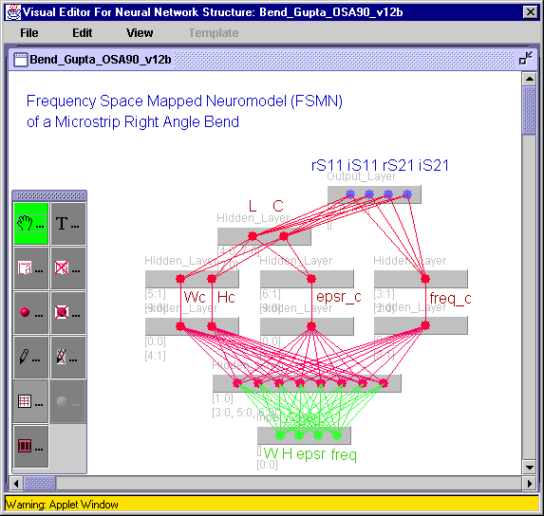
Conclusions

we present novel applications of Space Mapping technology to the neuromodeling of microwave circuits

five powerful SM based neuromodeling techniques are described and illustrated
Space Mapped Neuromodeling (SMN)
Frequency-Dependent Space Mapped Neuromodeling (FDSMN)
Frequency Space Mapped Neuromodeling (FSMN)
Frequency Mapped Neuromodeling (FMN)
Frequency Partial-Space Mapped Neuromodeling (FPSMN)

these techniques
exploit the vast set of empirical models already available
decrease the fine model evaluations needed for training
improve generalization ability
reduce complexity of the ANN topology
w.r.t. the classical neuromodeling approach

frequency-sensitive neuromappings expand the usefulness of empirical quasi-static models

FMN effectively aligns frequency-shifted responses

Huber optimization efficiently trains the neuromappings, exploiting its robust characteristics for data fitting

