MODELING OF MICROWAVE CIRCUITS EXPLOITING

SPACE DERIVATIVE MAPPING

M.H. Bakr, J.W. Bandler and N. Georgieva

SOS-99-22-V

June 1999

© M.H. Bakr, J.W. Bandler and N. Georgieva 1999

No part of this document may be copied, translated, transcribed or entered in any form into any machine without written permission. Address enquiries in this regard to Dr. J.W. Bandler. Excerpts may be quoted for scholarly purposes with full acknowledgement of source. This document may not be lent or circulated without this title page and its original cover.
MODELING OF MICROWAVE CIRCUITS EXPLOITING

SPACE DERIVATIVE MAPPING

M.H. Bakr, J.W. Bandler and N. Georgieva

Simulation Optimization Systems Research Laboratory
and Department of Electrical and Computer Engineering

McMaster University, Hamilton, Canada L8S 4K1

bandler@mcmaster.ca
www.sos.mcmaster.ca

presented at

1999 IEEE MTT-S International Microwave Symposium, Anaheim, CA, June 15, 1999
The Aim of Space Mapping
(Bandler et al., 1994-)

The Derivative Space Mapping

assume that $x_{c}$ corresponds to $x_{f}$ through a parameter extraction process

the Jacobian $J_{f}$ of the fine model response at $x_{f}$ and the Jacobian $J_{c}$ of the coarse model response at $x_{c}$ are related by

$$J_{f}=J_{c}B$$

where B is a valid mapping at $x_{c}$ and $x_{f}$

consequently

$$B={\left(J_{c}^{\text{ T}}J_{c}\right)}^{\text{ -}1}J_{c}^{\text{ T}}J_{f}$$

The Algorithm

suppose we need a fast and accurate approximation to the fine model response near a particular point $x_{\text{em}}^{}$

we denote by $J_{\text{em}}^{}$ the Jacobian of the fine model responses at $x_{\text{em}}^{}$ w.r.t. $x_{\text{em}}^{}$

the point ${\overline{x}}_{\text{os}}$ corresponding to $x_{\text{em}}^{}$ is obtained through the parameter extraction step
$${\overline{x}}_{\text{os}}=\text{arg}\left\{\underset{x_{\text{os}}}{\text{min}}\left\|R_{\text{em}}(x_{\text{em}}^{})−R_{\text{os}}(x_{\text{os}}^{})\right\|\right\}$$

the Jacobian ${\overline{J}}_{\text{os}}$ of the coarse model responses at ${\overline{x}}_{\text{os}}$ may be estimated by perturbation

the matrix B is then estimated by

$$B={\left({\overline{J}}_{\text{os}}^{\text{ T}}{\overline{J}}_{\text{os}}\right)}^{\text{-1}}{\overline{J}}_{\text{os}}^{\text{ T}}J_{\text{em}}^{}$$

the Space Derivative Mapping (SDM) model is simply given by

$$R_{\text{em}}(x_{\text{em}})≈R_{\text{os}}({\overline{x}}_{\text{os}}+B(x_{\text{em}}−x_{\text{em}}^{}))$$

the SDM model should enjoy a wide region of validity as the two models are assumed to share the same physical structure
Two-Section WaveguideTransformer
(Bandler, 1969)

the coarse model is an “ideal” analytical model which neglects the junction discontinuity effects

the fine model is a more accurate “nonideal” analytical model which includes the junction discontinuity effects

optimizable parameters are the height and the length of each waveguide section.

the fine model is optimized using the OSA90/hope minimax optimizer

an estimate for the Jacobian of the fine model response is then obtained

parameter extraction is applied to get ${\overline{x}}_{\text{os}}$ and the Jacobian of the coarse model ${\overline{J}}_{\text{os}}$ is obtained using perturbation

the matrix B is estimated using SDM

the established mapping can be utilized in SDM statistical analysis
Two-Section WaveguideTransformer
(Bandler, 1969)

5.7
5.8
5.9
6.0
6.1
6.2
6.3
6.4
6.5
6.6
6.7
frequency (GHz)
1.00
1.01
1.02
1.003
1.04
VSWR

fine model response (ο) and coarse model response (⎯) at
the corresponding points

Statistical Analysis Using the SDM Model

1.0% tolerance

-
5.8
5.9
6.0
6.1
6.2
6.3
6.4
6.5
6.6
frequency (GHz)
1.000
1.025
1.050
-
1.075
1.100
VSWR

using Space Derivative Mapping

5.8
5.9
6.0
6.1
6.2
6.3
6.4
6.5
6.6
1.000
1.025
1.050
1.075
1.100
frequency (GHz)
VSWR

using fine model simulations
Statistical Analysis Using the SDM Model

4.0% tolerance

5.8
5.9
6.0
6.1
6.2
6.3
6.4
6.5
6.6
1.00
1.05
1.10
1.15
1.20
frequency (GHz)
VSWR

using Space Derivative Mapping

5.8
5.9
6.0
6.1
6.2
6.3
6.4
6.5
6.6
1.00
1.05
1.10
1.15
1.20
frequency (GHz)
VSWR

using fine model simulations

Six-Section H-Plane Filter
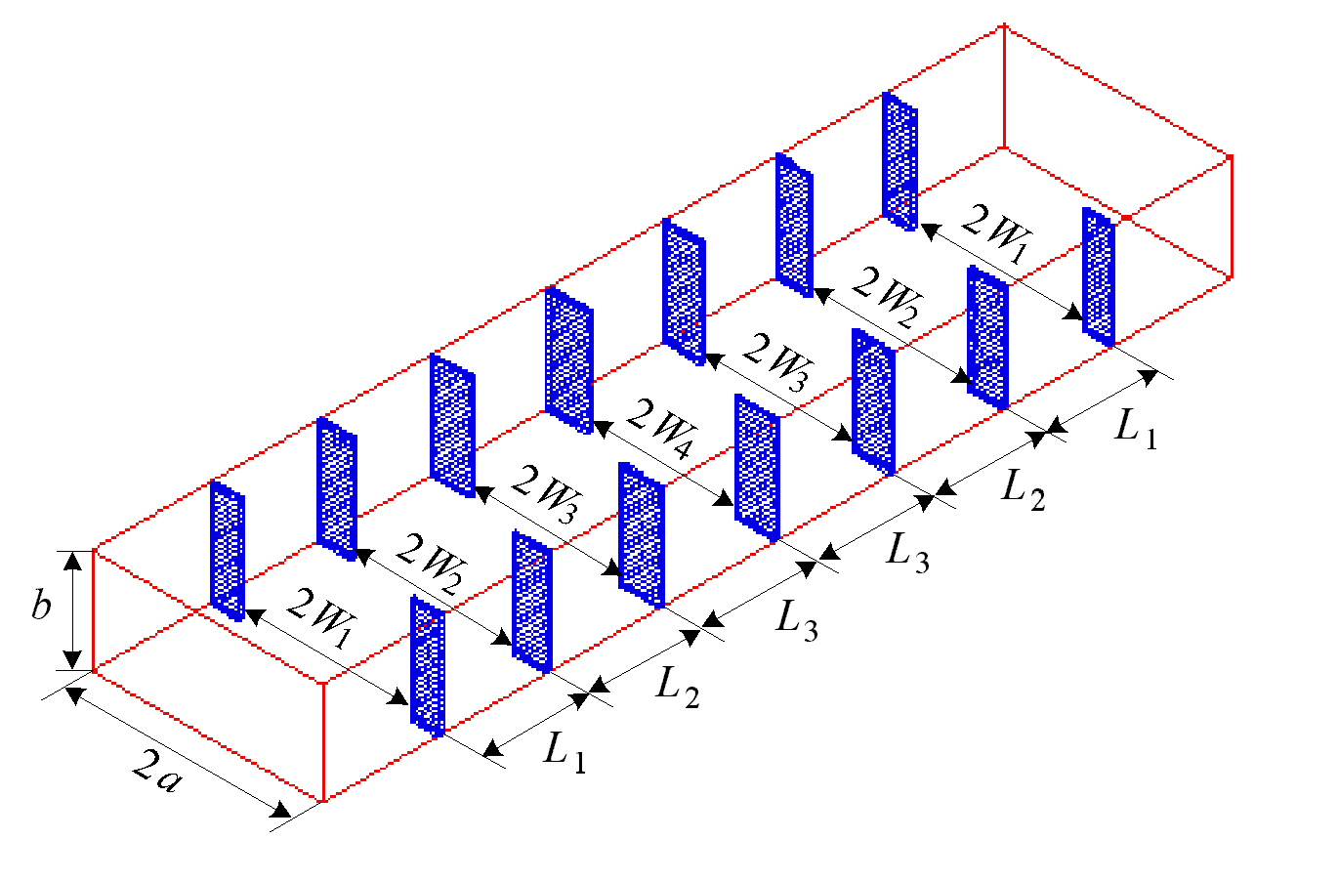(Matthaei et al., 1964, Bakr et al., 1999)
the fine model
the coarse model

optimizable parameters are the septa widths W₁, W₂, W₃ and W₄ and lengths L₁, L₂ and L₃

the fine model exploits HP HFSS through HP Empipe3D

Six-Section H-Plane Filter

the H-plane speta have a finite thickness of 0.02 inches (0.508 mm)

the coarse model consists of lumped inductances and dispersive transmission line sections simulated by OSA90/hope

the equivalent inductances of the H-plane septa are calculated using formulas by Marcuvitz (1951)

the fine point of interest is the optimal fine model design

parameter extraction is then applied to obtain ${\overline{x}}_{\text{os}}$

linear interpolation formulas (Bandler et al., 1997) are utilized to estimate $J_{\text{em}}^{}$ using the database generated during optimization

${\overline{J}}_{\text{os}}$ is estimated by perturbation

the estimated matrix B is utilized in statistical analysis
Six-Section H-Plane Filter

5.200
6.275
7.350
8.425
9.500
frequency (GHz)
0
0.2
0.4
0.6
0.8
1.0
⏐S_{11⏐}

fine model response (ο) and coarse model response (⎯) at
the corresponding points

Statistical Analysis of the H-Plane Filter

1.0% tolerance

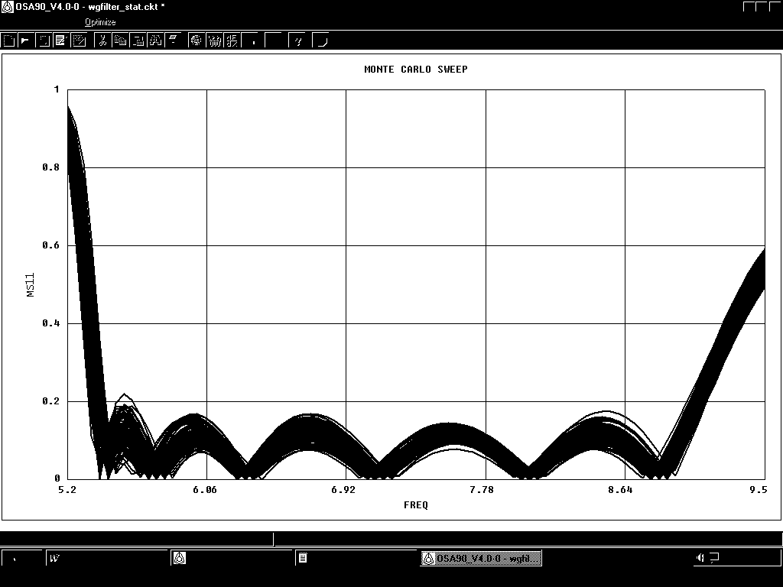
5.20
6.06
6.92
7.78
8.64
9.50
0
0.2
0.4
0.6
0.8
1.0
frequency (GHz)
⏐S_{11⏐}

using Space Derivative Mapping
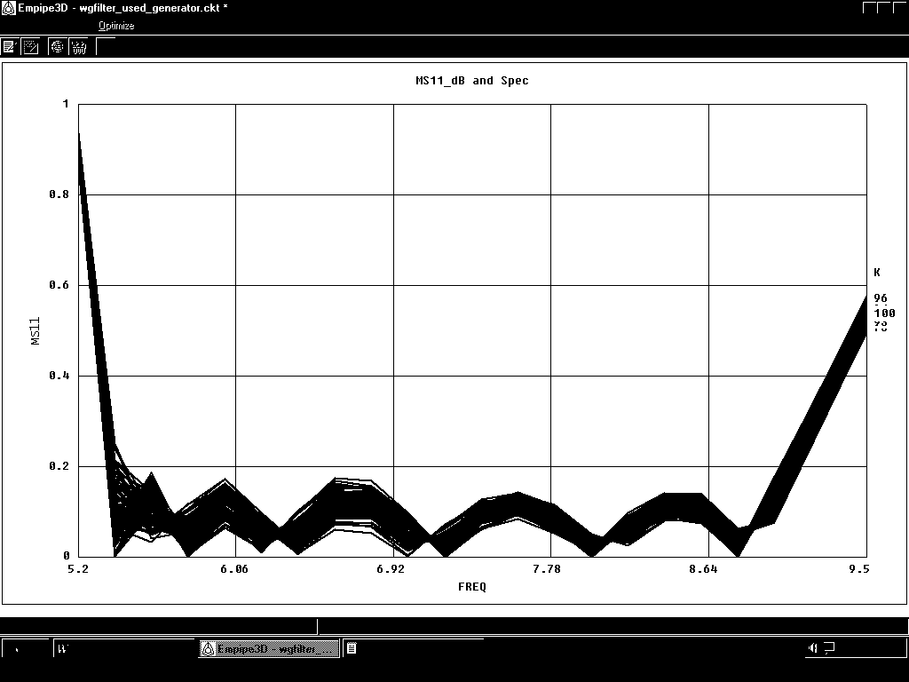
5.20
6.06
6.92
7.78
8.64
9.50
0
0.2
0.4
0.6
0.8
1.0
frequency (GHz)
⏐S_{11⏐}

using fine model simulations
Statistical Analysis of the H-Plane Filter

4.0% tolerance
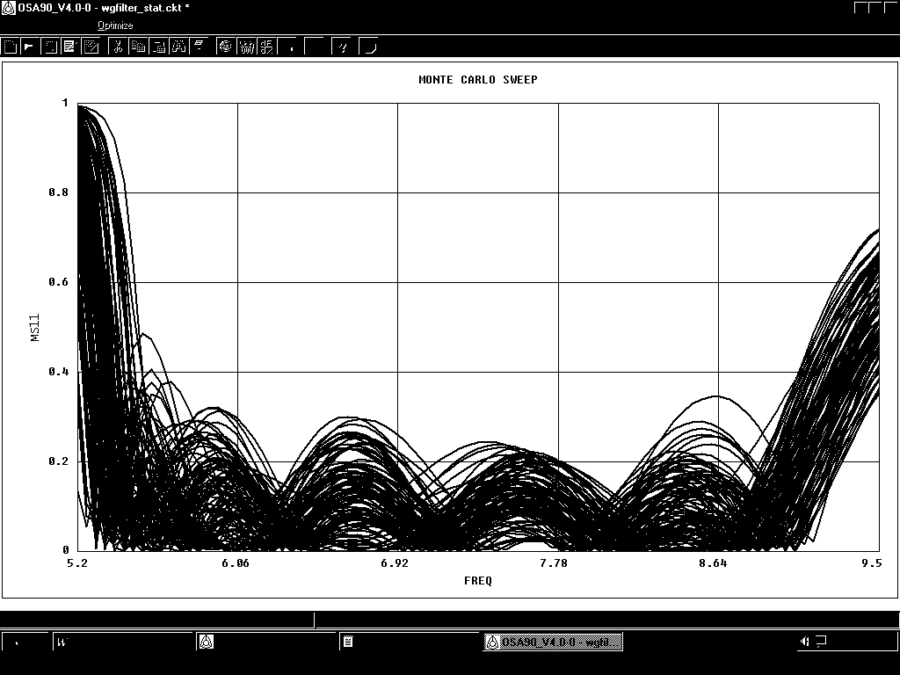
5.20
6.06
6.92
7.78
8.64
9.50
0
0.2
0.4
0.6
0.8
1.0
⏐S_{11⏐}
frequency (GHz)

using Space Derivative Mapping
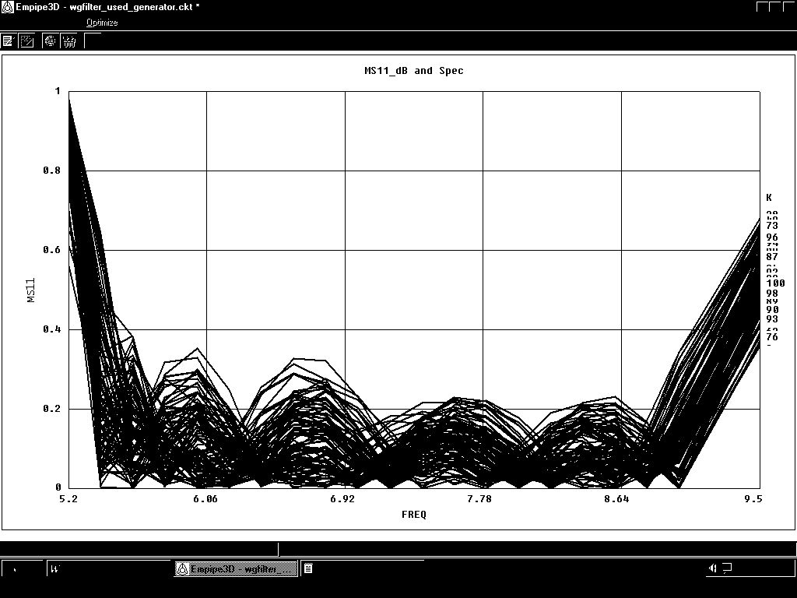
5.20
6.06
6.92
7.78
8.64
9.50
0
0.2
0.4
0.6
0.8
1.0
frequency (GHz)
⏐S_{11⏐}
frequency (GHz)

using fine model simulations
Three-section Rounded Edge Waveguide Transformer
(HP Empipe3D Manual, 1998)

the fine model of this circuit exploits HP HFSS through HP Empipe3D

the coarse model exploits an ideal empirical model that does not take into account the rounding of the corners

designable parameters for this problem are the height and length of each waveguide section

the fine point of interest is the optimal fine model design

linear interpolation formulas (Bandler et al., 1997) are utilized to estimate $J_{\text{em}}^{}$ using the database generated during optimization

${\overline{J}}_{\text{os}}$ is estimated by perturbation

Three-section Rounded Edge Waveguide Transformer

fine model response (ο) and coarse model response (⎯) at
the corresponding points

Three-section Rounded Edge Waveguide Transformer

2.0% tolerance

10
11
12
13
14
15
0
-20
-40
-60
-80
frequency (GHz)
|S₁₁ | dB

using Space Derivative Mapping

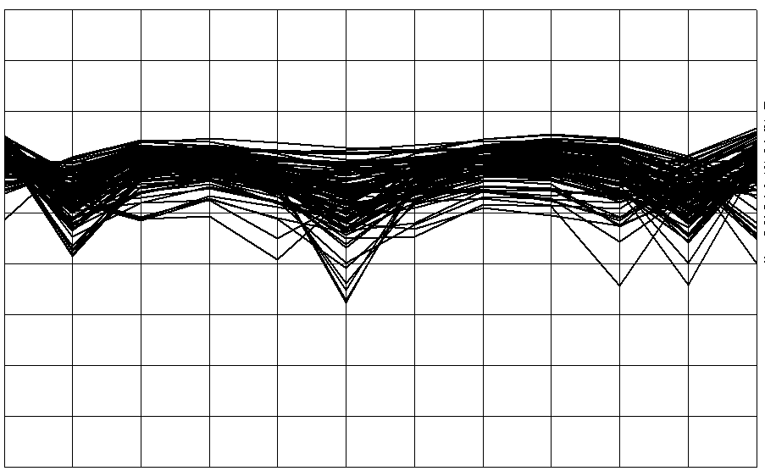
10
11
12
13
14
15
0
-20
-40
-60
-80
frequency (GHz)
|S₁₁ | dB

using fine model simulations
Three-section Rounded Edge Waveguide Transformer

4.0% tolerance
10
11
12
13
14
15
0
-20
-40
-60
-80
frequency (GHz)
|S₁₁ | dB

using Space Derivative Mapping

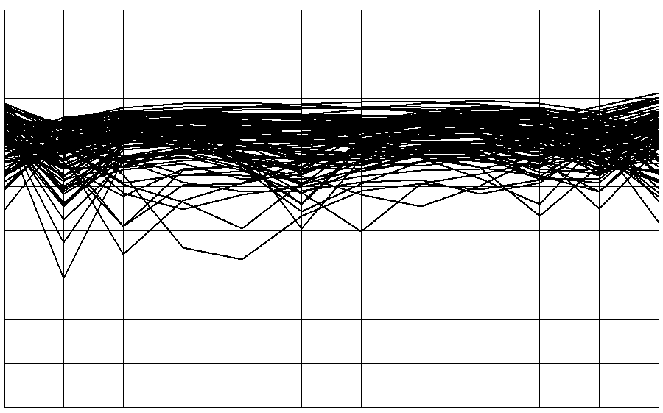
10
11
12
13
14
15
0
-20
-40
-60
-80
frequency (GHz)
|S₁₁ | dB

using fine model simulations

Conclusions

we present a novel technique for the fast and accurate modeling of microwave circuits

the technique exploits a Space Derivative Mapping (SDM) approach in the construction of a space-mapping based model

a novel lemma establishes the mapping between the input parameters to an EM model and the parameters of a corresponding empirical model with no additional overhead of EM simulations

SDM Modeling (SDMM) alleviates the extraction uniqueness problem involved in prior SM algorithms and the necessity of applying SM optimization in the ASM algorithm

statistical analysis of microwave circuits exemplifies our technique

