Software Implementation of Space Mapping Based Neuromodels of Microwave Components
J.W. Bandler, J.E. Rayas-Sánchez and Q.J. Zhang
Simulation Optimization Systems Research Laboratory and Department of Electrical and Computer Engineering
McMaster University, 1280 Main St. West, Hamilton, Canada L8S 4K1
Tel: 905 628 9671 E-mail: j.bandler@ieee.org

Space Mapping Based Neuromodeling
In modeling microwave components using Artificial Neural Networks (ANN), the learning data is obtained from a detailed or “fine” model (typically an EM simulator), which is accurate but slow to evaluate. This is aggravated because simulations are needed for many combinations of input parameter values. We use available equivalent circuits or “coarse” models to overcome this limitation.
In the Space Mapping (SM) based neuromodeling techniques [1] an ANN is used to implement a suitable mapping from the fine to the coarse input space. The implicit knowledge in the coarse model not only allows us to decrease significantly the number of learning points needed, but also to reduce the complexity of the ANN and to improve the generalization performance. Once the ANN is trained, an SM based neuromodel for fast, accurate evaluations is available.

Including Frequency in the Neuromapping
Many empirical models are based on quasi-static analysis: they usually yield good accuracy over low frequencies. We overcome this limitation through a frequency-sensitive mapping from the fine to the coarse parameter space. This is realized by considering frequency as an extra input variable of the ANN that implements the mapping. The Frequency Space-Mapped Neuromodeling (FSMN) technique establishes a frequency-sensitive mapping not only for the design parameters but also for the frequency variable, such that the coarse model is simulated at a mapped frequency f_{c} to match the fine model response. This is realized by adding an extra output to the ANN that implements the mapping. Three additional techniques to efficiently create frequency-sensitive neuromappings are proposed in [1].

SM Based Neuromodel of a Microstrip Right Angle Bend
Consider a microstrip right angle bend with conductor width W, substrate height H, substrate dielectric constant ε_{r}, and operating frequency freq. An FSMN model is developed for the following region of interest: 20mil ≤ W ≤ 30mil, 8mil ≤ H ≤ 16mil, 8 ≤ ε_{r} ≤ 10, and 1GHz ≤ freq ≤ 41GHz.
Sonnet’s em™ [2] is used as the fine model. To evaluate the generalization performance of our neuromodel, 50 random test base-points with uniform statistical distribution within the region of interest are generated using a frequency step of 2 GHz (1050 test samples). Following a star distribution for the learning points [1], only 7 base points are used for learning (147 learning samples).
Gupta’s model is taken as the “coarse” model [1]. Fig. 1a illustrates the FSMN neuromodeling strategy for the microstrip bend, which was implemented using NeuroModeler [3] as shown in Fig. 1b. The FSMN model as implemented in NeuroModeler consists of a total of 6 layers. The first layer, shown in green color, has the input parameters of the neuromapping (W, H, ε_{r}, and freq), which are scaled to ±1 to improve the numerical behavior during training. The second layer from bottom to top corresponds to the hidden layer of the ANN implementing the mapping (see Fig. 1b): optimal generalization performance is achieved with 8 hidden neurons with sigmoid non-linearities. The third layer is linear and contains the coarse design parameters and the mapped frequency f_{c} before de-scaling. The fourth layer is added to simply de-scale the parameters. Gupta’s formulas to calculate L and C are pro-grammed as the internal analytical functions of the fifth hidden layer, using the built-in MultiSymbolicFixed function. Finally, the output layer, shown in blue color, contains a simple internal circuit simulator that computes the real and imaginary parts of S₁₁ and S₂₁ for the lumped LC equivalent circuit. This layer uses the built-in CktSimulatorPS function.
Fig. 2 shows the learning and testing errors of the bend FSMN model after training using NeuroModeler. Conjugate Gradient and Quasi Newton built-in training methods are used. The average and worst case learning errors are 0.43% and 1.00%, while the average and worst-case testing errors are 1.04% and 10.94%. Excellent generalization performance is achieved.
The FSMN model of the right angle bend can now be used in Agilent ADS for fast and accurate simulations within the region of interest: it can be entered as a user-defined model through the plug-in module NeuroADS [4].

Conclusions
We present novel realizations of SM based neuromodels of practical passive components using available software. A Frequency Space-Mapped Neuromodel (FSMN) of a microstrip right angle bend is implemented using NeuroModeler, and entered into ADS as a library component through an ADS plug-in module.

Acknowledgement
The authors thank Dr. J.C. Rautio, President, Sonnet Software, Inc., Liverpool, NY, for making em™ available.

References
[1] J.W. Bandler, M.A. Ismail, J.E. Rayas-Sánchez and Q.J. Zhang, “Neuromodeling of microwave circuits exploiting space mapping technology,” IEEE Trans. Microwave Theory Tech., vol. 47, 1999, pp. 2417-2427.
[2] em™ Version 4.0b, Sonnet Software, Inc., 1020 Seventh North Street, Suite 210, Liverpool, NY 13088, 1997.
[3] NeuroModeler Version 1.2b, Prof. Q.J. Zhang, Dept. of Electronics, Carleton University, 1125 Colonel By Drive, Ottawa, Ontario, Canada, K1S 5B6, 1999.
[4] ADS Version 1.1, Agilent Technologies, 1400 Fountaingrove Parkway, Santa Rosa, CA 95403-1799.

(a) | 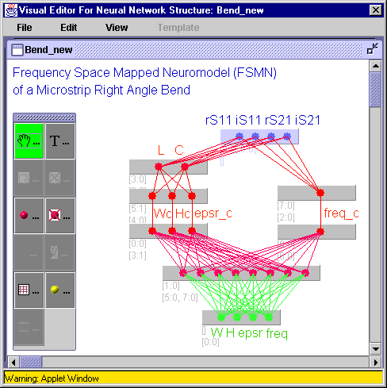
 | (b)
Fig. 1. Frequency Space-Mapped Neuromodel (FSMN) of a microstrip right angle bend:
(a) strategy, (b) implementation in NeuroModeler.

(a) | (b)
(c) | (d)
Fig. 2. Learning and testing errors of the FSMN model after training: (a) histogram of learning errors,
(b) histogram of testing errors, (c) correlation to learning data, and (d) correlation to testing data.

