SPACE MAPPING OPTIMIZATION OF MICROWAVE CIRCUITS
EXPLOITING SURROGATE MODELS

M.H. Bakr, J.W. Bandler, K. Madsen, J.E. Rayas-Sánchez and J. Søndergaard

SOS-00-16-V

June 2000

© M.H. Bakr, J.W. Bandler, K. Madsen, J.E. Rayas-Sánchez and J. Søndergaard 2000

No part of this document may be copied, translated, transcribed or entered in any form into any machine without written permission. Address enquiries in this regard to Dr. J.W. Bandler. Excerpts may be quoted for scholarly purposes with full acknowledgement of source. This document may not be lent or circulated without this title page and its original cover.

SPACE MAPPING OPTIMIZATION
OF MICROWAVE CIRCUITS EXPLOITING SURROGATE MODELS

M.H. Bakr, J.W. Bandler, K. Madsen, J.E. Rayas-Sánchez and
J. Søndergaard

Simulation Optimization Systems Research Laboratory
and Department of Electrical and Computer Engineering
McMaster University, Hamilton, Canada L8S 4K1

bandler@mcmaster.ca
www.sos.mcmaster.ca

presented at

2000 IEEE MTT-S International Microwave Symposium, Boston, MA, USA, June 15, 2000

Problem Definition

it is required to optimize a detailed or “fine” model of a microwave circuit

utilizing traditional direct optimization is not possible because of intensive simulation time

Space Mapping (SM) optimization exploits the existence of a coarse model of the circuit

we present a novel SM algorithm that integrates SM optimization and “surrogate model” optimization

the algorithm utilizes a surrogate model expressed as a convex combination between a mapped coarse model and a linearized fine model

we also present a novel approach for utilizing a frequency-sensitive mapping

a number of examples illustrate the algorithm
Basic Definitions and Notation

n : number of designable parameters
$x_{f}^{(i)}∈ℜ^{n×1}$: fine model design at the ith iteration
$x_{f}∈ℜ^{n×1}$ : a fine model point in the vicinity of $x_{f}^{(i)}$, $Δx_{f}$=$x_{f}$−$x_{f}^{(i)}$
$R_{f}(x_{f},ω)∈$$ℜ^{N_{r}×1}$: fine model response vector at a point $x_{f}$ and frequency ω
$ω$: set of simulation frequencies, where $ω\overset{Δ}{=}\left\{ω_{1},ω_{2},…\text{, }ω_{N_{ω}}\right\}$
$R_{f}(x_{f})∈$$ℜ^{m×1}$: fine model response vector at the point $x_{f}$ for all frequencies where $m=N_{ω}N_{r}$
$J_{f}^{(i)}∈ℜ^{m×n}$: approximation to the Jacobian of fine model responses at the ith iteration
$B^{(i)}$, $s^{(i)}$, $t^{(i)}$, $σ^{(i)}$, $c^{(i)}$ and $γ^{(i)}$: the mapping parameters at the ith iteration

SM Optimization vs. Surrogate Model Optimization
the optimal fine model design $x_{f}^{}$ is obtained by solving
$$x_{f}^{}=\text{arg}\left\{\underset{x_{f}}{\text{min}} U(R_{f}(x_{f}^{}))\right\}$$

solving this problem using direct optimization methods can be prohibitive

SM optimization algorithms efficiently solve this design problem

they exploit the existence of a less accurate but fast coarse model of the circuit under consideration

a mapping $x_{c}=P(x_{f})$ is established between the two spaces such that $R_{f}(x_{f})≈R_{c}(x_{c})$

the space-mapped design ${\overline{x}}_{f}$ is a solution of the nonlinear system
$f(x_{f})=P(x_{f})−x_{c}^{}$=0

the mapping $P(x_{f})$ is approximated through Parameter Extraction (PE)

SM Optimization vs. Surrogate Model Optimization (Continued)

the ASM algorithm solves this problem using a quasi-Newton method

the TRASM algorithm integrates a trust region methodology with the ASM technique

surrogate model optimization approximates the fine model at the ith iteration by a surrogate model $R_{s}^{(i)}(x_{f})∈ℜ^{m×1}$

the step suggested is obtained by solving
$h^{(i)}=\text{arg}\left\{\underset{h^{(i)}}{\text{min}} U(R_{s}^{(i)}(x_{f}^{(i)}+h^{(i)}))\right\}$, $\left\|h^{(i)}\right\|≤δ^{(i)}$

$h^{(i)}$ is validated using fine model simulation

the accuracy of the surrogate model is improved in every iteration using the simulated fine model points
The Surrogate Model
our surrogate model is a convex combination of a mapped coarse model and a linearized fine model

the ith iteration surrogate model is

$R_{s}^{(i)}(x_{f})=λ^{(i)}R_{m}^{(i)}(x_{f})+(1−λ^{(i)})(R_{f}(x_{f}^{(i)})+J_{f}^{(i)}Δx_{f}),$$λ^{(i)}∈\left[\text{0,}1\right]$

the mapped coarse model utilizes the frequency-sensitive mapping

$R_{f}(x_{f},{ω_{j})≈R}_{m}^{(i)}(x_{f},ω_{j})$=$R_{c}(P^{(i)}(x_{f},ω_{j}),P_{ω}^{(i)}(x_{f},ω_{j}))$
where
$$\left[\begin{matrix}P^{(i)}(x_{f},ω_{j}) \\ P_{ω}^{(i)}(x_{f},ω_{j})\end{matrix}\right]=\left[\begin{matrix}B^{(i)} & s^{(i)} \\ t^{(i)T} & σ^{(i)}\end{matrix}\right]\left[\begin{matrix}{Δx}_{f} \\ ω_{j}\end{matrix}\right]+\left[\begin{matrix}c^{(i)} \\ γ^{(i)}\end{matrix}\right]$$

the parameters $B^{(i)}∈ℜ^{n×n}$, $s^{(i)}∈ℜ^{n×1}$, $t^{(i)}∈ℜ^{n×1}$, $c^{(i)}∈ℜ^{n×1}$, $σ^{(i)}∈ℜ^{1×1}$ and $γ^{(i)}∈ℜ^{1×1}$ are obtained such that the mapped coarse model approximates the fine model over a given set of fine model points $V^{(i)}$ and frequencies ω

The Surrogate Model (Continued)

the mapping parameters are obtained through the optimization process

$\begin{aligned}[B^{(i)},s^{(i)},{t^{(i)},σ^{(i)}\text{, }c}^{(i)},γ^{(i)}]= \\ \text{ arg}\left\{\underset{B,s,t,\text{ σ, }c,\text{ γ}}{\text{min}} \left\| [\begin{matrix}e_{1^{T}} & e_{2^{T}} & ⋯ & e_{N_{p}^{T}}\end{matrix}]^{T} \right\|\right\}\end{aligned}$where
${e_{k}=}_{}R_{m}^{(i)}(x_{f}^{(k)})−R_{f}(x_{f}^{(k)})$ ∀$x_{f}^{(k)}∈V^{(i)}$

The Motivation for Utilizing a Frequency-Sensitive Mapping

utilizing a frequency sensitive mapping makes the parameter extraction problem better conditioned

(a)
ω
,
ω, ω_{c}
(b)
The Motivation for Utilizing a Frequency-Sensitive Mapping
(Continued)

utilizing a frequency-sensitive mapping enables indirect estimation of fine model derivatives

the Jacobian of the mapped coarse model responses at a point $x_{f}^{(k)}$ and frequency $ω_{j}$ is given by

$$\begin{aligned}J_{f}(x_{f}^{(k)},ω_{j})≈J_{m}(x_{f}^{(k)},ω_{j})={{\left(\frac{∂R_{m}^{T}(x_{f},ω)}{∂x_{f}}\right)}_{}^{T}|}_{\begin{matrix}x_{f}=x_{f}^{(k)} \\ ω=ω_{j}\end{matrix}}= \\ {{\left(\frac{∂P^{T}}{∂x_{f}}\frac{∂R_{c}^{T}(P,P_{ω})}{∂P}+\frac{∂P_{ω}}{∂x_{f}}\frac{∂R_{c}^{T}(P,P_{ω})}{∂P_{ω}}\right)}_{}^{T}|}_{\begin{matrix}P=P^{(i)}(x_{f}^{(k)},ω_{j}) \\ P_{ω}=P_{ω}^{(i)}(x_{f}^{(k)},ω_{j})\end{matrix}}\end{aligned}$$
Updating the Trust Region Size

predicted reduction in the objective function

r_{p} =U($R_{s}^{(i)}(x_{f}^{(i)})$)−U($R_{s}^{(i)}({x_{f}^{(i)}+h}^{(i)})$)

actual reduction in the objective function

r_{a} = U($R_{f}^{}(x_{f}^{(i)})$)−U($R_{f}^{}(x_{f}^{(i)}+h^{(i)})$)

define $ρ=\frac{r_{a}}{r_{p}}$

if $ρ≥0\text{.}\text{75}$, let $δ^{(i+1)}=π_{1}δ^{(i)},π_{1}>1\text{.}0$

if $ρ≤0\text{.}\text{10}$, let $δ^{(i+1)}=π_{2}δ^{(i)},0<π_{2}<1\text{.}0$

Updating the Surrogate Parameter

the mapped coarse model error

$$E_{m}^{(i)}=R_{m}^{(i)}(x_{f}^{(i)}+h^{(i)})−R_{f}(x_{f}^{(i)}+h^{(i)})$$

the linearized fine model error

$$E_{l}^{(i)}=R_{f}(x_{f}^{(i)})+J_{f}^{(i)}h^{(i)}−R_{f}(x_{f}^{(i)}+h^{(i)})$$

the surrogate model parameter update is given by

$λ^{(i+1)}=\frac{{\left\|E_{l}^{(i)}\right\|}_{}}{{\left\|E_{l}^{(i)}\right\|}_{}+{\left\|E_{m}^{(i)}\right\|}_{}}$ if $\left\|E_{l}^{(i)}\right\|≤ε_{l}$ otherwise $λ^{(i+1)}$=1

The Stopping Criterion

the algorithm terminates if the step size becomes sufficiently small or if the algorithm fails to make any progress for n+1 consecutive iterations
Illustration of One Iteration of the Algorithm
θ
r_{p}
r_{a}

0
1

r_{p} = predicted reduction in the objective function using the surrogate model

r_{a} = actual reduction in the objective function
The Algorithm

Step 1. Given $x_{f}^{(1)}=x_{c}^{}$, $λ^{(1)}=1$, $δ^{(1)}$, $α$, $J_{f}^{(1)}=J_{c}^{}$ and i=1
Step 2. Construct $V^{(i)}$
Step 3. Obtain the mapping parameters through optimization
Step 4. Obtain the suggested step $h^{(i)}$ using the surrogate model
Step 5. If $U(R_{f}(x_{f}^{(i)}+h^{(i)}))<U(R_{f}(x_{f}^{(i)}))$, set $x_{f}^{(i+1)}=x_{f}^{(i)}+h^{(i)}$ else $x_{f}^{(i+1)}=x_{f}^{(i)}$

Step 6. Update $J_{f}^{(i)}$, $δ^{(i)}$ and $λ^{(i)}$
Step 7. If the stopping criterion is satisfied stop
Step 8. Set i=i+1 and go to Step 2
The Algorithm Flowchart
INITIALIZATION
MAPPING PARAMETERS
EXTRACTION
SURROGATE
MODEL OPTIMIZATION
SUCCESS CRITERION SATISFIED?

ACCEPT SUGGESTED ITERATE

REJECT SUGGESTED ITERATE

UPDATE PARAMETERS
STOPPING CRITERION SATISFIED
YES
NO
NO
END
YES

Two-Section 10:1 Capacitively-Loaded Impedance Transformer (Bandler, 1969)

“fine model”

R_{L}=10Ω
L₁
L₂
Z_{in}
C₁
C₂
C₃

“coarse model”
R_{L}=10Ω
L₁
L₂
Z_{in}
Two-Section 10:1 Capacitively-Loaded Impedance Transformer (Continued)

design specifications are

⏐S₁₁⏐≤ 0.50 for 0.5 GHz ≤ ω ≤1.5 GHz

the designable parameters are the electrical lengths of the two transmission lines at ω =1.0 GHz

the characteristic impedances are kept fixed at their optimal values

both the coarse and fine models make use of the ideal transmission line model available in OSA90/hope

eleven frequency points are simulated per sweep

five iterations are executed (only two successful)

number of fine model simulations is seven

the real and imaginary parts of S₁₁ are used in extracting the mapping parameters

initial trust region size is $δ^{(1)}=0\text{.}\text{09}{\left\|x_{c}^{}\right\|}_{∞}$

the extraction radius is $α=0\text{.}\text{09}{\left\|x_{c}^{}\right\|}_{∞}$
Two-Section 10:1 Capacitively-Loaded Impedance Transformer (Continued)

the final mapping

$B^{(6)}=\left[\begin{matrix}1\text{.}\text{12886} & 0\text{.}\text{19245} \\ −0\text{.}\text{17669} & 1\text{.}\text{19167}\end{matrix}\right]$, $c^{(6)}=\left[\begin{matrix}\text{84}\text{.}\text{52643} \\ \text{87}\text{.}\text{95123}\end{matrix}\right]$,

$s^{(6)}=\left[\begin{matrix}−0\text{.}\text{06863} \\ \text{ 0}\text{.}\text{06035}\end{matrix}\right]$, $t^{(6)}=\left[\begin{matrix}−0\text{.}\text{00026} \\ −0\text{.}\text{00212}\end{matrix}\right]$, $σ^{(6)}=\text{ 1}\text{.}\text{03243}$,

$γ^{(6)}=0\text{.}\text{00983}$ and $λ^{(6)}=\text{ 0}\text{.}\text{58473}$

Parameter | $$x_{f}^{(1)}$$ | $$x_{f}^{(2)}$$ | $$x_{f}^{(3)}$$
L₁ | 90.0000 | 81.9000 | 81.59880
L₂ | 90.0000 | 81.9000 | 74.38324
all values are in degrees

Two-Section 10:1 Capacitively-Loaded Impedance Transformer (Continued)

the initial design

the second design
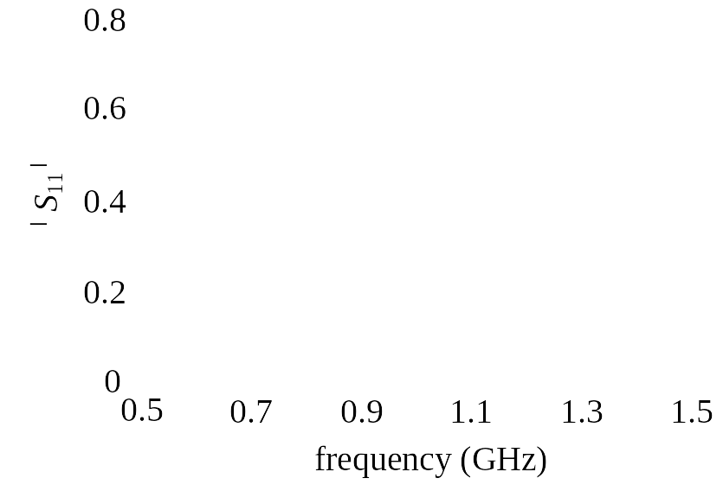

Two-Section 10:1 Capacitively-Loaded Impedance Transformer (Continued)

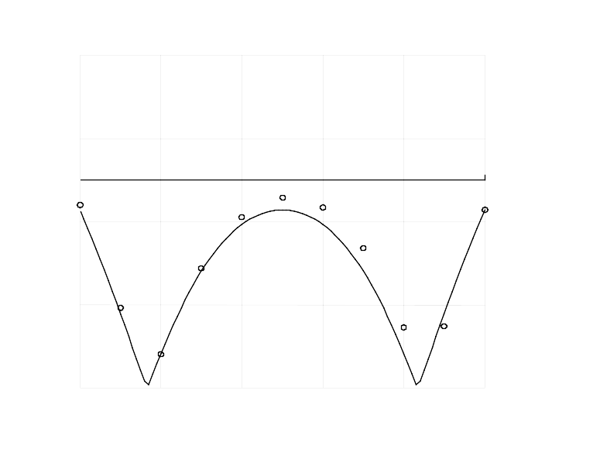
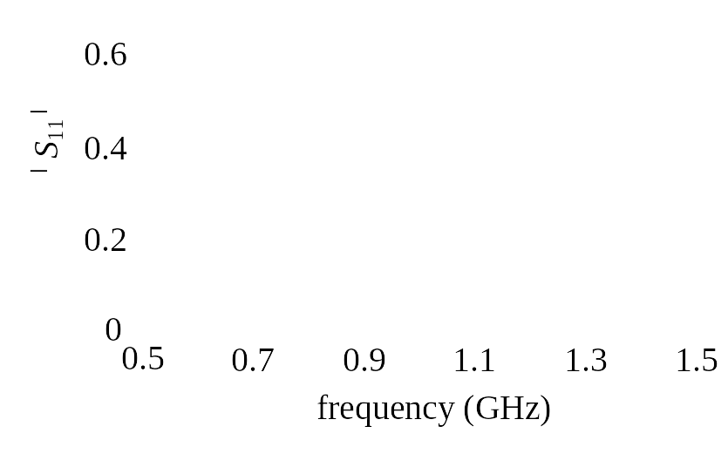
the final design
Two-Section 10:1 Capacitively-Loaded Impedance Transformer (Continued)

the objective function in each iteration

iteration
U

The Double-Folded Stub Filter
(Rautio, 1992)

the fine model utilizes Sonnet’s em

S
W₂
L₁
L₂
W₁

the coarse model exploits the microstrip line and microstrip T-junction models available in OSA90/hope

the coupling between the folded stubs and the microstrip line is simulated using equivalent capacitors

the values of these capacitors are determined using Walker’s formulas (Walker et al., 1990)

Jansen’s microstrip bend model is used to model the folding effect of the stub (Jansen et al., 1983)
The Double-Folded Stub Filter (Continued)

the coarse model

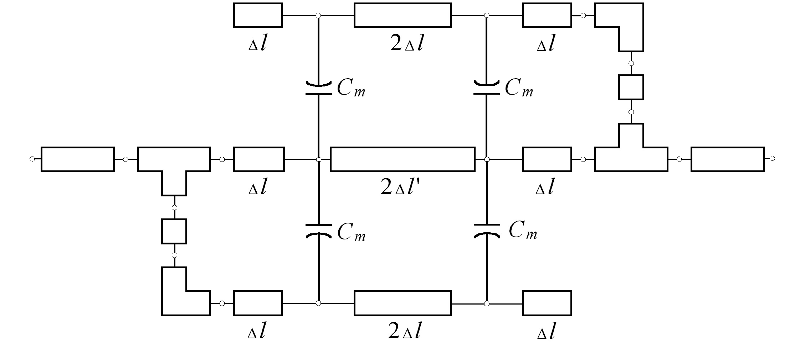

design specifications are

⏐S₂₁⏐≥ −3 dB for ω ≤ 9.5 GHz and 16.5 GHz ≤ ω

⏐S₂₁⏐≤ −30 dB for 12 GHz ≤ ω ≤ 14 GHz

designable parameters are L₁, L₂ and S

W₁ and W₂ are fixed at 4.8 mil

the real and imaginary parts of S₂₁ are used in extracting the mapping parameters

The Double-Folded Stub Filter (Continued)

eleven frequency points per sweep are utilized

initial trust region size is $δ^{(1)}=0\text{.}\text{09}{\left\|x_{c}^{}\right\|}_{∞}$

extraction radius is $α=0\text{.}\text{09}{\left\|x_{c}^{}\right\|}_{∞}$

the width is scaled by a factor of 6.0 to make the problem better conditioned

the interpolation option of Empipe is disabled for this example

The Double-Folded Stub Filter Results

the grid size used is 1.6 mils for each parameter

the algorithm required 11 successful iterations (16 total iterations) with a total of 18 calls to Empipe (18 em simulations)

$B^{(\text{17})}=\left[\begin{matrix}1\text{.}\text{03074} & 0\text{.}\text{11174} & 0\text{.}\text{00031} \\ −0\text{.}\text{20595} & 0\text{.}\text{96384} & 0\text{.}\text{00365} \\ −0\text{.}\text{35144} & 0\text{.}\text{34204} & 0\text{.}\text{78257}\end{matrix}\right]$, $c^{(\text{17})}=\left[\begin{matrix}\text{236}\text{.}\text{1134} \\ \text{21}\text{.}\text{5218} \\ \text{74}\text{.}\text{8218}\end{matrix}\right]$,

$s^{(\text{17})}=\left[\begin{matrix}0\text{.}\text{44639} \\ 0\text{.}\text{70939} \\ 0\text{.}\text{50045}\end{matrix}\right]$, $t^{(\text{17})}=\left[\begin{matrix}0\text{.}\text{03854} \\ −0\text{.}\text{01167} \\ 0\text{.}\text{00439}\end{matrix}\right]$, $σ^{(\text{17})}=1\text{.}\text{13771}$,

$γ^{(\text{17})}=−0\text{.}\text{55168}$ and $λ^{(\text{17})}=0\text{.}\text{03526}$

Parameter | $$x_{f}^{(1)}$$ | $$x_{f}^{(\text{17})}$$
S | 9.60 | 6.4
L₂ | 60.80 | 84.8
L₁ | 67.2 | 86.4
all values are in mil

The Double-Folded Stub Filter Results (Continued)

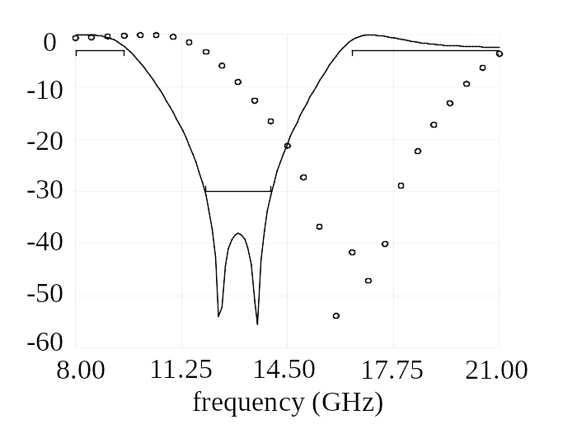
initial response
⏐S_{21⏐}dB

final response
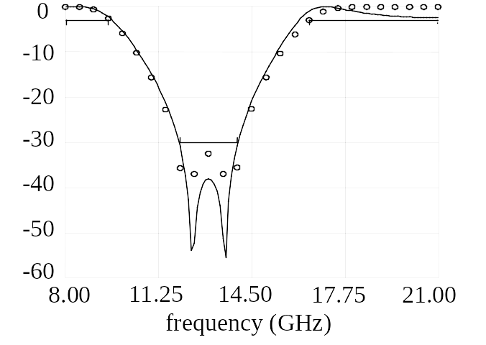
⏐S_{21⏐}dB
The Double-Folded Stub Filter Results (Continued)

the objective function in each iteration
iteration
U

The HTS Filter
(Bandler et al., 1995)

L₀
L₁
L₂
L₃
L₂
L₁
L₀
S₁
S₂
S₃
S₂
S₁
W
x
y

design specifications are

⏐S₂₁⏐ ≤ 0.05 for ω ≤ 3.967 GHz and 4.099 GHz ≤ ω

⏐S₂₁⏐ ≥ 0.95 for 4.008 GHz ≤ ω ≤ 4.058 GHz

designable parameters are L₁, L₂, L₃, S₁, S₂ and S₃

we take L₀ = 50 mil and W = 7 mil

the coarse model exploits the empirical models of microstrip lines, coupled lines and open stubs available in OSA90/hope

the fine model employs Sonnet’s em through Empipe

The HTS Filter (Continued)

the coarse model
microstrip coupled
lines
microstip open
line
microstrip line

the real and imaginary parts of both S₁₁ and S₂₁ are utilized in extracting the mapping parameters

the initial trust region is $δ^{(1)}=0\text{.}\text{20}{\left\|x_{c}^{}\right\|}_{∞}$

the interpolation option of Empipe is disabled to make the optimization time reasonable

The HTS Filter (The First Case)

the problem is solved for two different cases

first, the substrate is assumed lossless and a relatively coarse grid size is used (1.0mil×1.75mil)

the fine model is simulated at 16 frequency points per sweep

starting from the snapped optimal coarse design, the final design is reached in 7 iterations only

a total of 7 fine model simulations are used

The HTS Filter (The First Case)

the initial and final response of the fine model
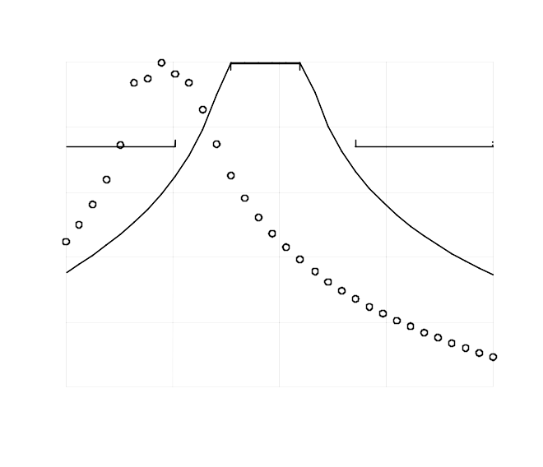
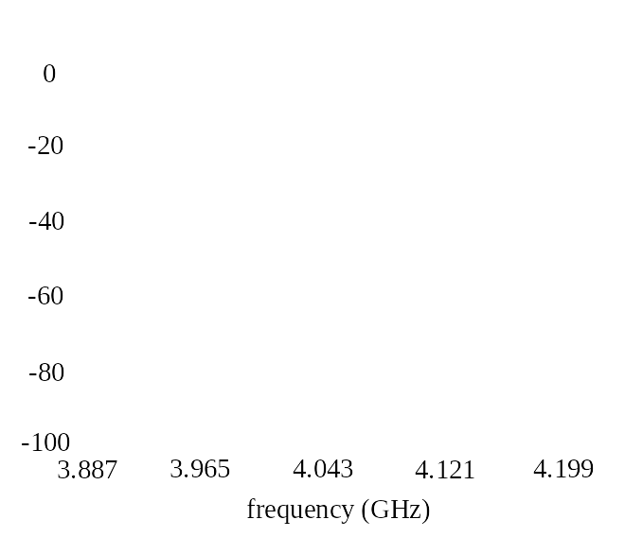
 S_{21}dB
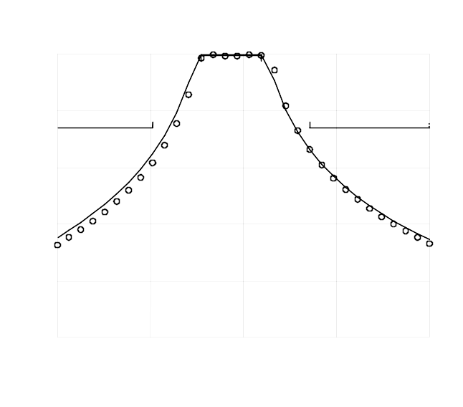
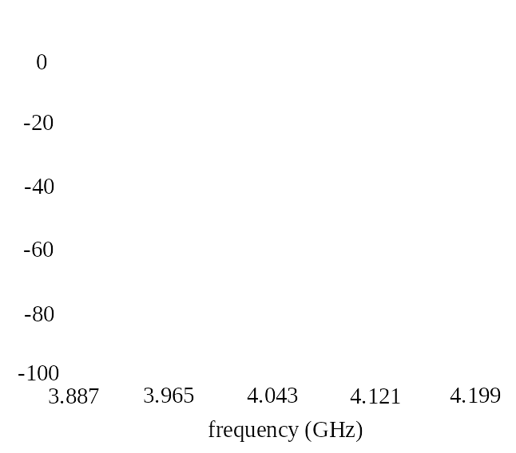
 S_{21}dB
The HTS Filter (The First Case)

the fine model response at the end of the first iteration
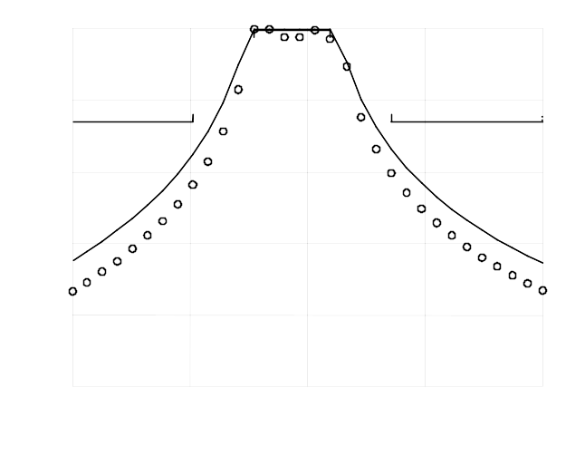
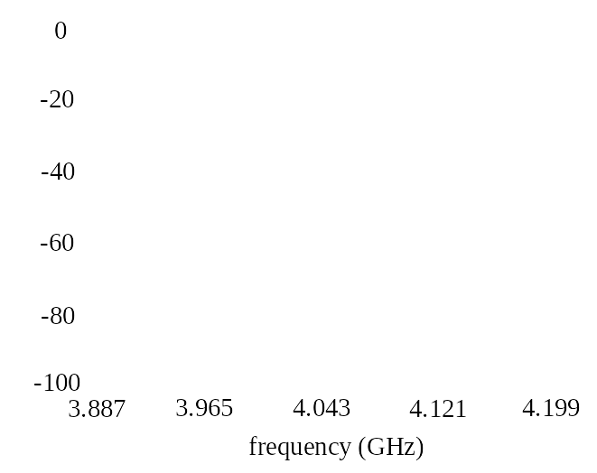
 S_{21}dB

the objective function in every iteration
U
iteration

The HTS Filter (The Second Case)

the problem is resolved assuming a lossy substrate (loss tangent=3.0e-5) and a finer grid (1.0mil×1.0mil)

the fine model is simulated at 9 frequency points per sweep

starting from the snapped optimal coarse design, the final design is reached in 4 iterations only

a total of 5 fine model simulations are used
The HTS Filter (The Second Case)

the final fine model response
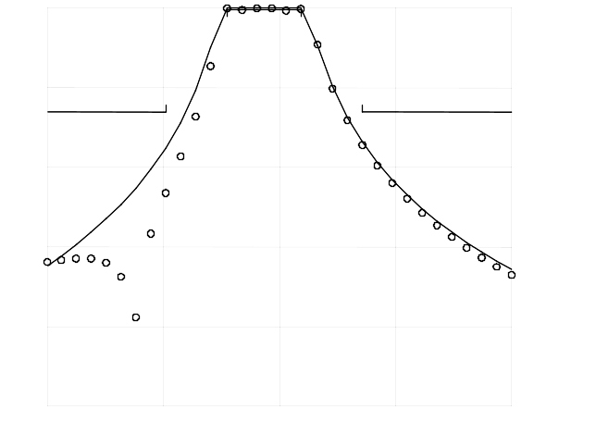
3.887
3.965
4.043
4.121
4.199
frequency (GHz)
-100
-80
-60
-40
-20
0
 S_{21}dB

the objective function in each iteration
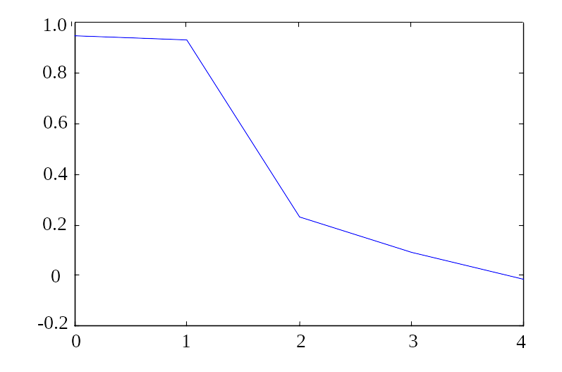
iteration
U
Conclusions

we present a novel SM optimization algorithm for microwave circuits

SM optimization is formulated as a general optimization problem of a surrogate model

the surrogate model utilized is a convex combination of a linearized fine model and a mapped coarse model

we also integrated, for the first time, a linearized frequency-sensitive mapping with SM optimization

frequency-sensitive mappings make the parameter extraction problem better conditioned

the algorithm is illustrated through a number of examples

the new SMX system incorporates our results

