Fig. 1. Illustration of some basic engineering optimization concepts; (a) the responses at a feasible design x₁ and an infeasible design x₂, (b) the error functions at sampled values of the independent parameter ω and (c) a possible location of the two designs with respect to the feasible region for a two-dimensional case.
R
ω
S_{u1}
S_{l1}
R(x₁, ω)
R
ω
S_{u1}
S_{l1}
R(x₂, ω)
(a)
e
ω
0
e
ω
0
(b)
x₁
x₂
parameter space
feasible region
(c)

parameter space
feasible region
Δx₁
Δx₂
yield=0
0<yield<1
yield=1

Fig. 2. Illustration of design centering and yield for a two-dimensional problem with manufacturing tolerances of Δx₁ and Δx₂. Three different designs are shown; a centered design where all possible outcomes are feasible (yield=1), an infeasible design where possible outcomes are infeasible (yield=0) and non centered feasible design where possible outcomes may be feasible or infeasible (0<yield<1).

x_{f,1}
x_{f,2}
x_{c,1}
x_{c,2}
Fig. 3. Illustration of the SPE procedure for a two-dimensional problem.
(a)
x_{c,2}
x_{c,1}
x_{f,2}
x_{f,1}

(b)
x_{c,2}
x_{c,1}
x_{f,2}
x_{f,1}

(c)
x_{c,2}
x_{c,1}
x_{f,2}
x_{f,1}

Fig. 4. Illustration of the original SM optimization algorithm; (a) a new point $x_{f}^{(m_{j}+1)}$is obtained using the current mapping approximation $P^{(j)}$, (b) the point $x_{f}^{(m_{j}+1)}$ does not satisfy the stopping criterion and the sets $S_{f}^{(j)}$ and $S_{c}^{(j)}$ are augmented by $x_{f}^{(m_{j}+1)}$ and $x_{c}^{(m_{j}+1)}$, respectively, and (c) a new mapping $P^{(j+1)}$ is estimated and is used to obtain a new iterate $x_{f}^{(m_{j}+2)}$.
x_{f,1}
x_{f,2}
x_{c,1}
x_{c,2}
x_{c}^{(j+1)}
(c)
(b)
x_{f,1}
x_{f,2}
x_{c,1}
x_{c,2}
x_{c}^{(j+1)}
Fig. 5. Illustration of ASM; (a) a new iterate $x_{f}^{(\text{j+}1)}$ is obtained, (b) by applying parameter extraction we find that the stopping criterion is not satisfied ($\left\|f^{(j+1)}\right\|$>ε) and (c) the updated matrix $B^{(j+1)}$ is used to predict a new iterate $x_{f}^{(\text{j+}2)}$.
x_{f,1}
x_{f,2}
x_{c,1}
x_{c,2}
x_{c}^{(j)}
(a)

L₁
L₂
L₃
W₁
W₃
W₂
Fig. 6. The three-section 3:1 microstrip impedance transformer.

Fig. 7. The optimal coarse model response (⎯) and the fine model response (ο) at the initial design for the three-section microstrip transformer.

Fig. 8. The optimal coarse model response (⎯) and the fine model response (ο) at the space-mapped design for the three-section microstrip transformer.

x_{f,1}
x_{f,2}
x_{c,1}
x_{c,2}
V
Fig. 9. Illustration of MPE at the jth iteration.

x_{c,1}
x_{c,2}
$$x_{c}^{(j)}$$
$$x_{c}^{}$$

D

$$f^{(j)}$$

Fig. 10. The region utilized in the statistical parameter extraction approach for obtaining $x_{c}^{}$.

0
0.4
0.8
1.2
1.6
2.0
0
0.4
0.8
1.2
1.6
2.0
u₁
u₂
minimum

Fig. 11. Illustration of a locally nonunique solution of parameter extraction for a two-dimensional case.

1
2
3
4
5
6
7
1
2
3
4
5
6
7
8
9
10
Z₁
Z₂

Fig. 12. Illustration of a locally unique solution of parameter extraction for a two-dimensional case; three locally unique minima are shown.

x_{f,1}
x_{f,2}
x_{c,1}
x_{c,2}
V

Fig. 13. Illustration of RMPE.
(a)
x_{c,1}
x_{c,2}
x_{f,1}
x_{f,2}

trust region

(b)
x_{c,1}
x_{c,2}
x_{f,1}
x_{f,2}

trust region

x_{c,1}
x_{c,2}
x_{f,1}
x_{f,2}

trust region

(c)

Fig. 14. Illustration of the TRASM algorithm; (a) in the jth iteration the point $x_{f}^{(j)}$ corresponds to a trusted error vector $f^{(j)}$, (b) a new iterate $x_{f}^{(j+1)}$ is taken and SPE is carried out to get $f_{1}^{(j+1)}$ and (c) the vector $f_{1}^{(j+1)}$ does not satisfy the success criterion so a temporary point $x_{t}^{(1)}$ is generated and two-point extraction is carried out to get $f_{2}^{(j+1)}$ which satisfies the success criterion.

L₀
L₁
L₂
L₃
L₂
L₁
L₀
S₁
S₂
S₃
S₂
S₁
W
x
y

Fig. 15. The structure of the HTS filter.
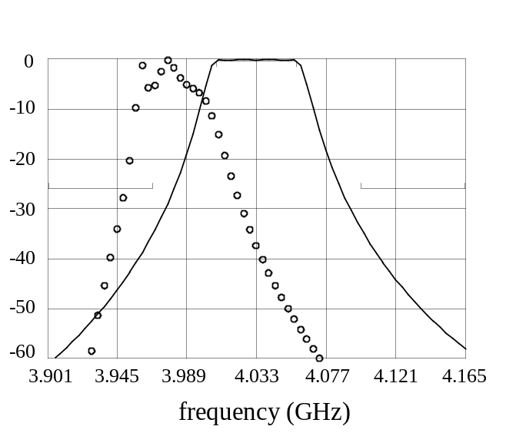
S_{21⏐}dB

Fig. 16. The optimal coarse model response (⎯) and the fine model response (ο) at the initial design for the HTS filter.

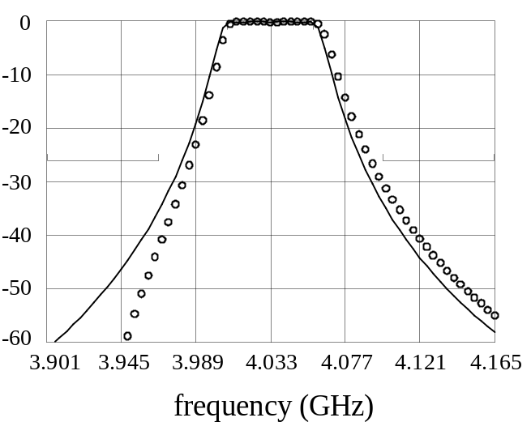
S_{21⏐}dB

Fig. 17. The optimal coarse model response (⎯) and the fine model response (ο) at the space-mapped design for the HTS filter.

Space Mapping
x, f, B
Direct Optimization
x, J_{f}
Fig. 18. Illustration of the connection between SM optimization and direct optimization.

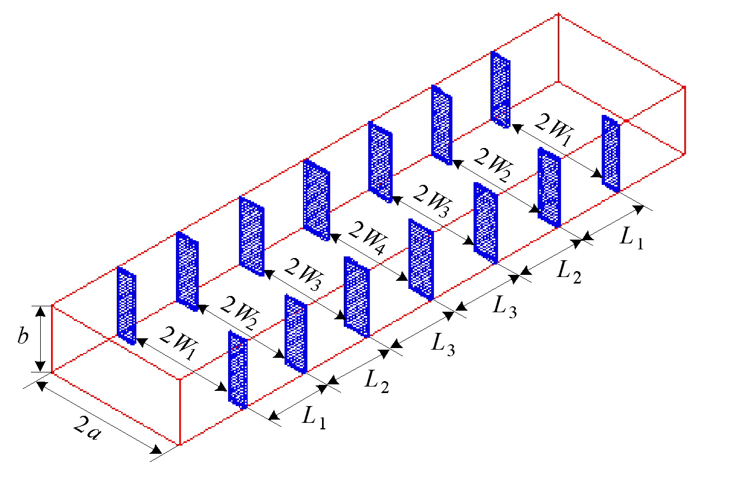

Fig. 19. The fine model of the six-section H-plane waveguide filter.

Fig. 20. The coarse model of the six-section H-plane waveguide filter.

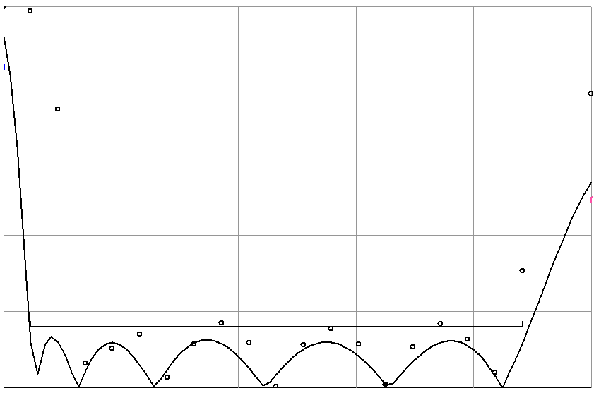
5.20
6.06
6.92
7.78
8.64
9.50
frequency (GHz)
0
0.2
0.4
0.6
0.8
1.0
⏐S_{11⏐}

Fig. 21. The optimal coarse response (⎯) and the fine response (ο) at the initial design for the six-section H-plane waveguide filter.

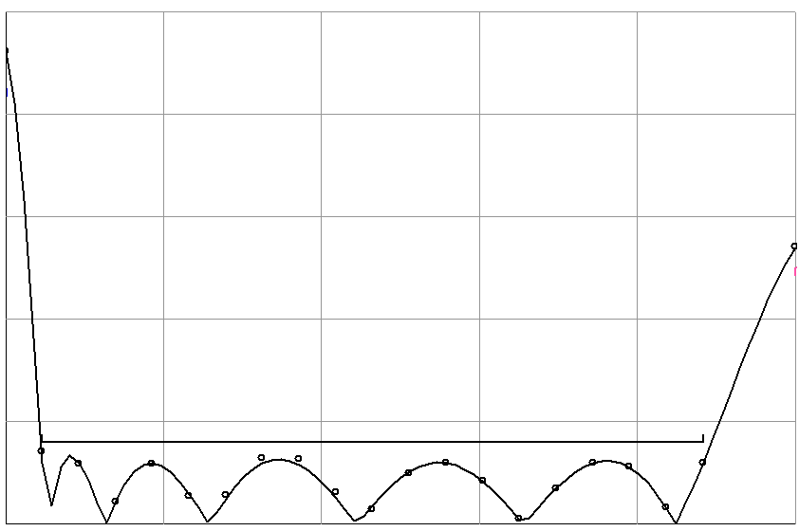
5.20
6.06
6.92
7.78
8.64
9.50
0
0.2
0.4
0.6
0.8
1.0
frequency (GHz)
⏐S_{11⏐}

Fig. 22. The optimal coarse response (⎯) and the fine response (ο) at the end of the second phase for the six-section H-plane waveguide filter.

P(x_{f})
coarse
model
x_{f}
x_{c}
R_{c} ≈ R_{f}

Fig. 23. Illustration of the SM approach to engineering modeling.

x_{f,1}
x_{f,2}
x_{f,3}

Fig. 24. A three-dimensional illustration of the star distribution utilized in GSM and SMN.
x_{f,1}
x_{f,2}
x_{f, n}

Fig. 25. Illustration of the SMN approach.

x_{f,1}
x_{f,2}
x_{f, n}

Fig. 26. Illustration of GSM as a special case of SMN.

