SMX—A Novel Object-Oriented Optimization System

M.H. Bakr, J.W. Bandler, Q.S. Cheng, M.A. Ismail and J.E. Rayas-Sánchez

McMaster University, Hamilton, ON, Canada L8S 4K1, www.sos.mcmaster.ca

Abstract — The novel, object-oriented SMX optimization system implements the powerful Surrogate Model-based Space Mapping (SMSM) algorithm, which is automated for the first time. SMX is capable of driving commercially available EM, circuit and user-supplied simulators. The SMX architecture permits easy integration of new simulators and optimization tools. The power of SMX is illustrated through an optimization example exploiting Momentum.
- Introduction
Space Mapping (SM) aims at efficient engineering optimization [1]. It establishes a mapping between the parameter spaces of a “fine” model, e.g., an electro-magnetic (EM) simulator, and a coarse model. Aggressive Space Mapping efficiently directs the optimization steps.
In the recent SMSM approach [2], a surrogate [3] of the fine model is iteratively used to solve the original design problem. This surrogate model is a convex combination of a mapped coarse model and a linearized fine model. It can exploit a frequency-sensitive mapping.
The state of the art SMX engine implements the SMSM algorithm. Object-Oriented Design (OOD) abstracts the basic behavior of the models and optimizers modules. A universal parameter setting and results retrieval method is utilized for all simulators and optimizers. The SMX architecture integrates these modules.
Another advantage of OOD is reusability and extenda-bility. SMX can support a number of EM and circuit simulators. Here, the basic functionality of simulators and optimizers is abstracted in the two basic classes Simulator and Optimizer. Many commercial simulators and optimizers can be derived from these classes.
The SMX system is described in the Unified Modeling Language (UML) [4]. Using this language, a complicated system can be decomposed into relatively independent small objects without losing readability and intuitiveness. The structure of each object can be represented in UML.
SMX takes full advantage of the multi-thread capability of the Microsoft Windows operating system [5]. The user-friendly interface responds smoothly while the SMX core is running in a different thread in the background. Synchronization and communication between threads are properly arranged. SMX is capable of optimizing while showing intermediate results and interacting with the user.
- The SMSM Algorithm
We denote the fine model responses at a point and frequency ω by . These responses may include the real and imaginary parts of S₁₁, etc. The vector denotes the responses at all the N_{ω} simulation frequencies where m=N_{r}N_{ω}. The vector x_{c} and R_{c}(x_{c}) denote a coarse model point and the corresponding coarse model responses, respectively. The coarse model responses at a frequency $ω_{c}$ are similarly denoted by R_{c}(x_{c},ω_{c}).
The fine model is optimized indirectly by using a surrogate [3] in the form of a convex combination of a mapped coarse model (MCM) and a linearized fine model (LFM). We denote the surrogate model in the ith iteration by (). The ith iteration solves
, $\left\|h^{(i)}\right\|≤δ^{(i)}$ (1)
where U((+)) is the value of the objective function evaluated using the surrogate model at +. The surrogate model is given by
$R_{s}^{(i)}(x_{f})=λ^{(i)}R_{m}^{(i)}(x_{f})+(1−λ^{(i)})(R_{f}(x_{f}^{(i)})+J_{f}^{(i)}Δx_{f})$,
, $λ^{(i)}∈\left[\text{0,}1\right]$, (2)
is an approximation to the Jacobian of fine model responses at . The LFM part in (2) ensures that the algorithm will work if the coarse model is poor or even wrong.
The MCM utilizes
(3)
(4)
a linear frequency mapping, where j=1, 2, …, N_{ω,}
(5)
The parameters , , , , and γ^{(i)} are the mapping parameters. $ω_{j}$ is the jth simulation frequency, j=1, 2, …, N_{ω}. Thus, a fine model point and frequency $ω_{j}$ correspond to a coarse model point and coarse model frequency .
The MCM should approximate the fine model over a region of fine model parameters and frequency. The mapping parameters are obtained through the optimization
(6)
∀$x_{f}^{(k)}∈V^{(i)}$ (7)
where $V^{(i)}$ is a set of fine model points of cardinality $|V^{(i)}|=N_{p}$. $V^{(i)}$ is mainly constructed from previously simulated fine model points as discussed in detail in [2].
- SMX Architecture
SMX automates the algorithm and drives EM/circuit simulators. Object-oriented design is employed to decompose the algorithm into independent modules (objects). Here the module or object is an instance of a certain class. Each module can carry out certain functionality. It includes data structures describing the properties of the object. Using the encapsulation concept, the SMX system is decomposed into 6 modules, as shown in Fig. 1.
The user interface and SMX engine run in two separate threads concurrently. The user chooses the simulators and setup problem specifications through a user interface. The interface initiates the starting point , the constraints and the control signals for the coarse and fine models. The SMX engine performs optimization and returns the progress, the current status, responses and etc., to the user interface. The user interface feeds back the optimization status such as objective function, designable parameters and critical mapping parameters as , , , , and in graphical and numerical format to the user. The engine can optimize a model using either classical optimization methods such as gradient-based minimax or the state-of-the-art SMSM algorithm [2].

Fig. 1. The modules of SMX.

- Algorithm Core: SMX Engine
The SMX engine is abstracted as the SMX_Engine class. After setup, the coarse model is optimized by the member function OptimizeCoarseModel from the starting point . This function uses m_pCoarseModelOptimizer, a pointer to a minimax optimizer object to obtain . Then the member function OptimizeSurrogate is called to optimize the surrogate model $R_{s}^{(i)}(x_{f})$ starting from the optimized coarse model. The Huber optimizer is used for parameter extraction (6) in OptimizeSurrogate. To carry out space mapping, three base classes, Optimizer, Simulator and Model, are abstracted and built.
The Optimizer base class is an abstract class. It provides the interface for standard optimization routines. With override of optimization routines, additional parameter setup and objective function, the Huber, Minimax or other optimization classes can be derived from Optimizer. Some of the important functions in Optimizer are GetNorm, GetErrors, FDF and SetConstraintMatrix. Different optimizers use different norms as their objective functions. The purely virtual function GetNorm is overridden to obtain the appropriate norm. FDF gets the error values and their derivatives by perturbation. It calls GetErrors to evaluate the error used for (7), as well as for minimax design optimization. SetConstrantMatrix sets constraints in matrix form. The inheritance relation of Optimizer is shown in Fig. 2.
Fig. 2. Illustration of the derivation of basic optimizer class.

Similar to Optimizer, the Simulator class is a parent class for different simulators. Commercial simulators and user defined simulators are derived classes. Interface functions are overridden for each new derived simulator class. Additional parameters may also be added. OSA90/hopeTM [6] and Agilent MomentumTM [7] are commercial simulators currently derived from the Simulator class.
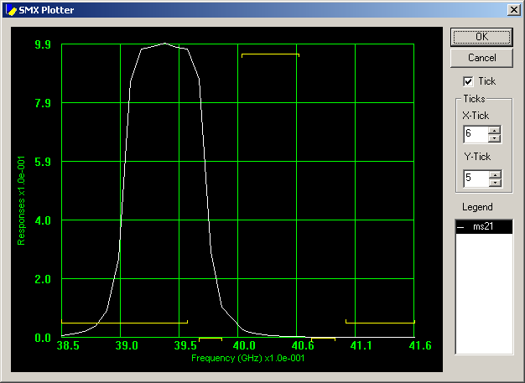
Fig. 3. Case 1: The initial response for the “fine” model (OSA90).
The SMX_Engine utilizes SurrogateModel which is derived from a base Model class. The Model class functions as a wrapper of a simulator. The responses are obtained independent of the simulator. Obviously, Simulator is one of the Model members. The Model class sends data to the simulator and retrieves responses from it. Since Optimizer needs normalized parameters, scaling factors are added.
- HTS Filter Example
We consider two cases of the HTS filter problem [8]. In Case 1, the “coarse” and “fine” models are both empirical models of OSA90/hope. The “coarse” model uses the ideal open circuit for the open stubs while the “fine” model uses empirical models. Design specifications are
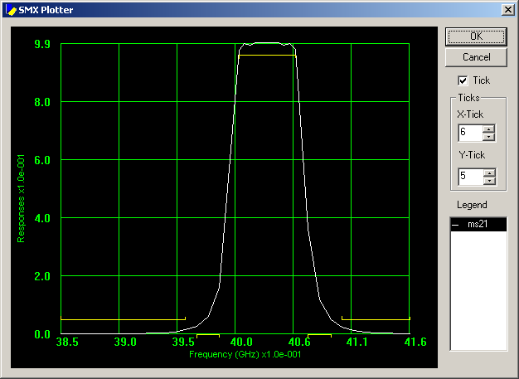
Fig. 4. Case 1: The optimal “fine” model (OSA90) response.
The designable parameters are the lengths L₁, L₂ and L₃ of the coupled lines and their separation S₁, S₂ and S₃.
Here, we use decoupled frequency and space mapping, that is $s^{(i)}=t^{(i)}=$0 in (5). The rest of the mapping parameters are obtained using (6)-(7). The SMX system obtained the optimal solution in 4 iterations. The “fine” model response in the first iteration is shown in Fig. 3 The “fine” model response at the final iteration is shown in Fig. 4. Table I shows the initial and final parameters. obtained by SMX optimization.

TABLE I
The Initial And Final Designs Of The Fine Model (OSA90) For The HTS Filter
Parameter | $$x_{f}^{(1)}$$ | $$x_{f}^{(4)}$$
L₁ | 187.50 | 185.55
L₂ | 198.84 | 191.71
L₃ | 187.91 | 185.82
S₁ | 20.04 | 21.03
S₂ | 98.08 | 99.44
S₃ | 100.90 | 114.21
all values are in mils

In Case 2 we use Momentum as the fine model, while the coarse model is the same as in Case 1. SMX obtains the solution in 4 iterations. Fig. 5 shows the fine model responses at the fourth SMX iteration. Then the minimax optimizer in Momentum is used to refine this solution. It takes approximately 32 hours on an IBM Aptiva computer with AMD-K7 650MHz CPU and 384MB RAM. We use fine interpolation resolution (0.1mil for all parameters). See Fig. 6.

TABLE II
The Initial And Final Designs Of The Fine Model (Agilent Momentum) For The HTS Filter
Para-meter | $$x_{f}^{(1)}$$ | $$x_{f}^{(4)}$$
L₁ | 187.50 | 193.28 | 194.87
L₂  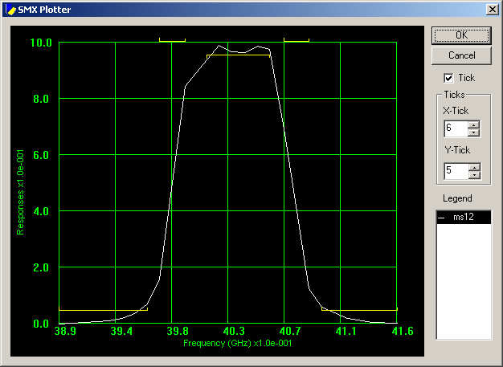  Fig. 5. Case 2: The SMX optimized fine model (Agilent Momentum) response. | 198.84 | 184.95 | 184.95
L₃ | 187.91 | 193.03 | 194.39
S₁ | 20.04 | 18.84 | 18.97
S₂ | 98.08 | 82.72 | 79.60
S₃ | 100.90 | 93.36 | 94.09
all values are in mils
- Conclusions
The SMX system design is formally presented for the first time. State-of-the-art optimization technology is utilized in the design process. Object-oriented program-ming is used to construct the system. This makes the system easy to understand and highly extendable. New optimization methods and new simulators can be plugged in. The SMX methodology makes it suitable for engineering optimization and algorithm research.
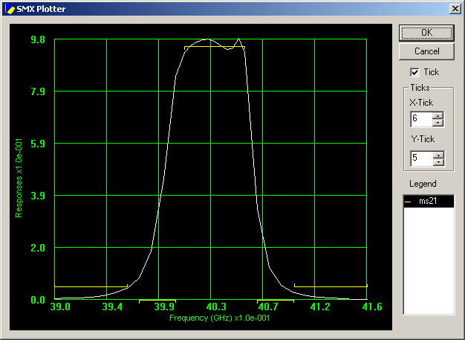
Fig. 6. Case 2: The final Momentum optimized fine model response with a fine interpolation step of 0.1mil.
Acknowledgement
The authors thank K. Madsen and J. Søndergaard of DTU, Denmark, for discussions and A.S. Mohamed for his assistance. The authors thank Agilent Technologies, Santa Rosa, CA, for making Momentum™ available.
References
- J.W. Bandler, R.M. Biernacki, S.H. Chen, P.A. Grobelny and R.H. Hemmers, “Space mapping technique for electromagnetic optimization,” IEEE Trans. Microwave Theory Tech., vol. 42, 1994, pp. 2536-2544.
- M.H. Bakr, J.W. Bandler, K. Madsen, J.E. Rayas-Sánchez and J. Søndergaard, “Space mapping optimization of microwave circuits exploiting surrogate models,” IEEE MTT-S Int. Microwave Symp. Dig. (Boston, MA), 2000, pp. 1785-1788.
- A.J. Booker, J.E. Dennis, Jr., P.D. Frank, D. B. Serafini, V. Torczon and M.W. Trosset, “A rigorous framework for optimization of expensive functions by surrogates,” Structural Optimization, vol. 17, 1999, pp. 1-13.
- UML Training in Object Oriented Analysis and Design page at http://www.cragsystems.co.uk/uml_training_080.htm.
- C. Petzold, Programming Windows, Microsoft Press 1990.
- OSA90/hopeTM Version 4.0, formerly Optimization Systems Associates Inc., P.O. Box 8083, Dundas, Ontario, Canada L9H 5E7, now Agilent Technologies, 1400 Fountaingrove Parkway, Santa Rosa, CA 95403-1799.
- Advanced Design System Release 1.3, Agilent EEsof EDA, November 1999.
- J.W. Bandler, R.M. Biernacki, S.H. Chen, W.J. Gestinger, P.A. Grobelny, C. Moskowitz and S.H. Talisa, “Electromagnetic design of high-temperature super-conducting filters,” Int. J. Microwave and Millimeter-Wave Computer-Aided Engineering, vol. 5, 1995, pp. 331-343.

 This work was supported in part by the Natural Sciences and Engineering Research Council of Canada under Grants OGP0007239 and STP0201832, and through the Micronet Network of Centres of Excellence. J.E. Rayas-Sánchez is funded by CONACYT (Consejo Nacional de Ciencia y Tecnología, Mexico), as well as by ITESO (Instituto Tecnológico y de Estudios Superiores de Occidente, Mexico). J.W. Bandler is also with Bandler Corporation, P.O. Box 8083, Dundas, Ontario, Canada L9H 5E7.

